January 22 – "Bloody Sunday" Anniversary
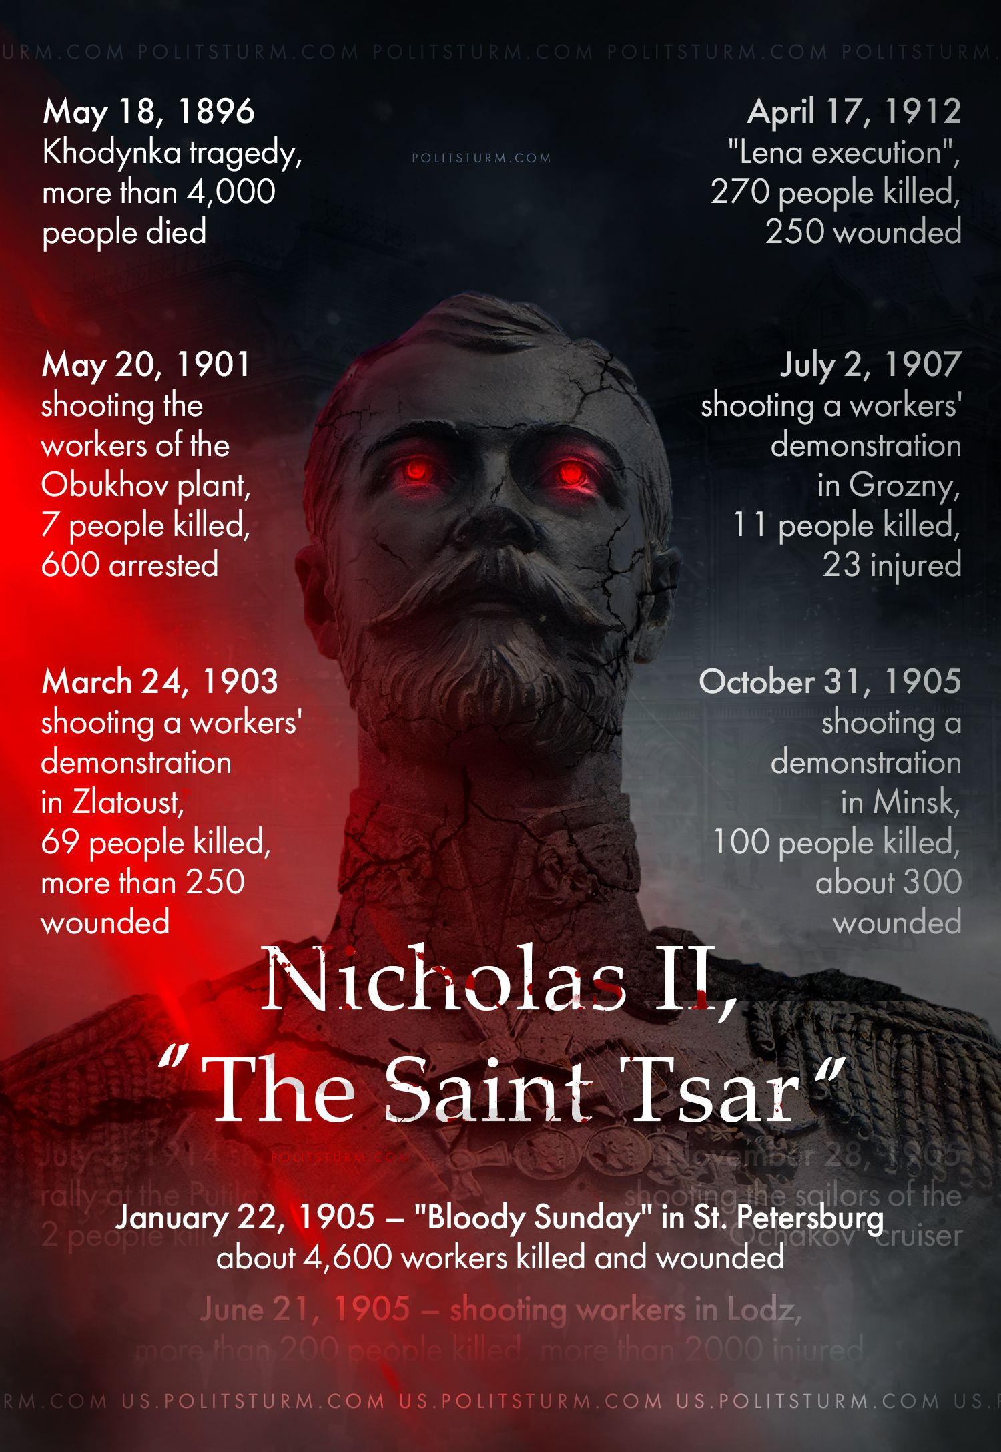

Original article
2023-01-22

On the anniversary of Bloody Sunday in Russia, we recall the crimes of the last Russian monarch. Russian capitalists glorify Nicholas II as a defender of traditional values, and the Orthodox Church made him a saint for murdering workers and peasants.

Original article

