Jack London on Liberation
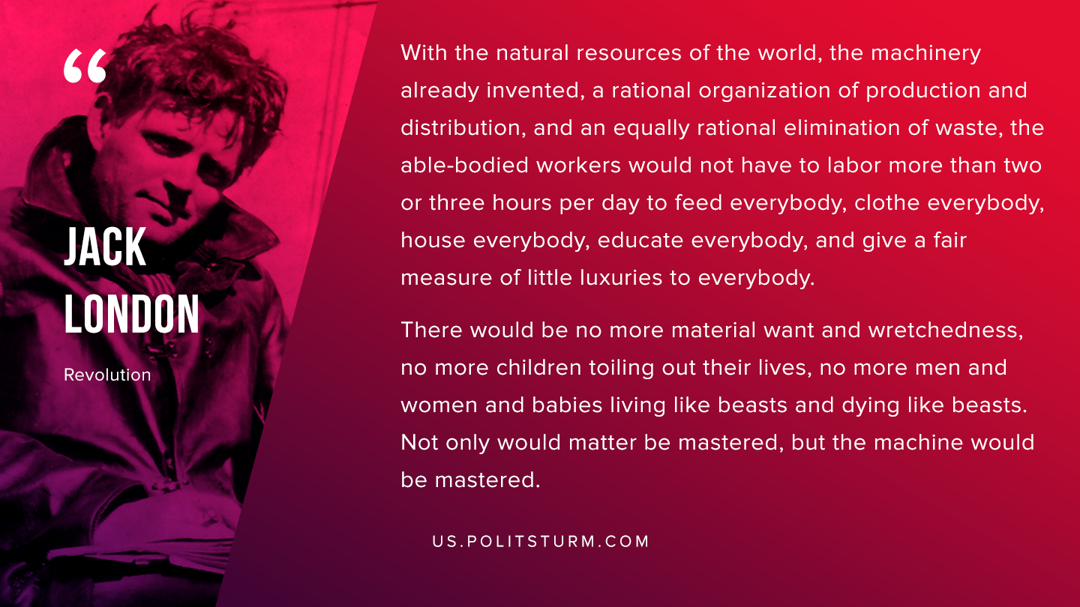

Original article
2019-10-02
1 min read

With the natural resources of the world, the machinery already invented, a rational organization of production and distribution, and an equally rational elimination of waste, the able-bodied workers would not have to labour more than two or three hours per day to feed everybody, clothe everybody, house everybody, educate everybody, and give a fair measure of little luxuries to everybody. There would be no more material want and wretchedness, no more children toiling out their lives, no more men and women and babes living like beasts and dying like beasts. Not only would matter be mastered, but the machine would be mastered.
Jack London, “Revolution”

Original article

