Jack London on Socialism
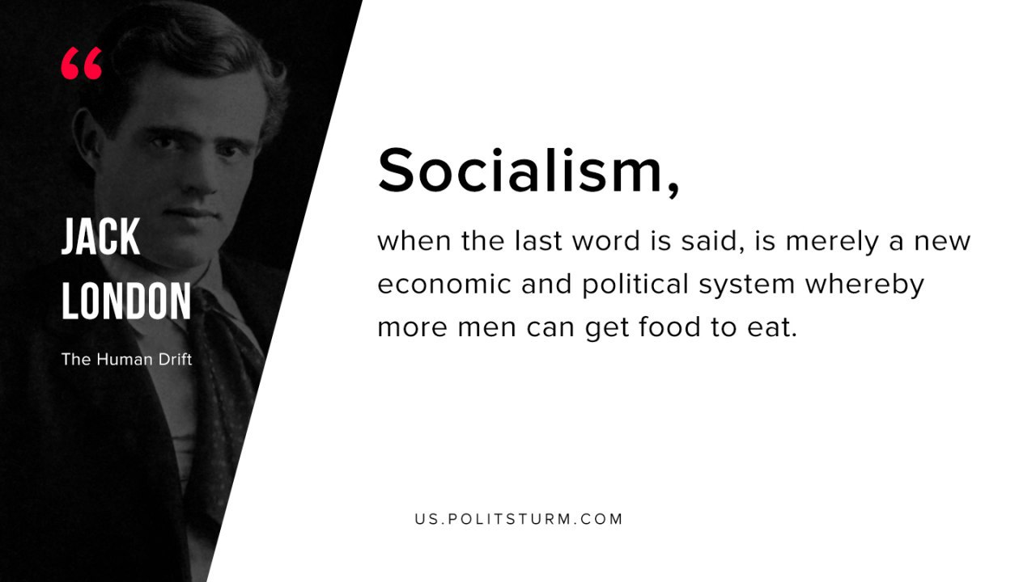

Original article
2019-08-15

Socialism, when the last word is said, is merely a new economic and political system whereby more men can get food to eat.
Jack London “The Human Drift”

Original article

