In Italy, Residents are not Allowed to Get Sick
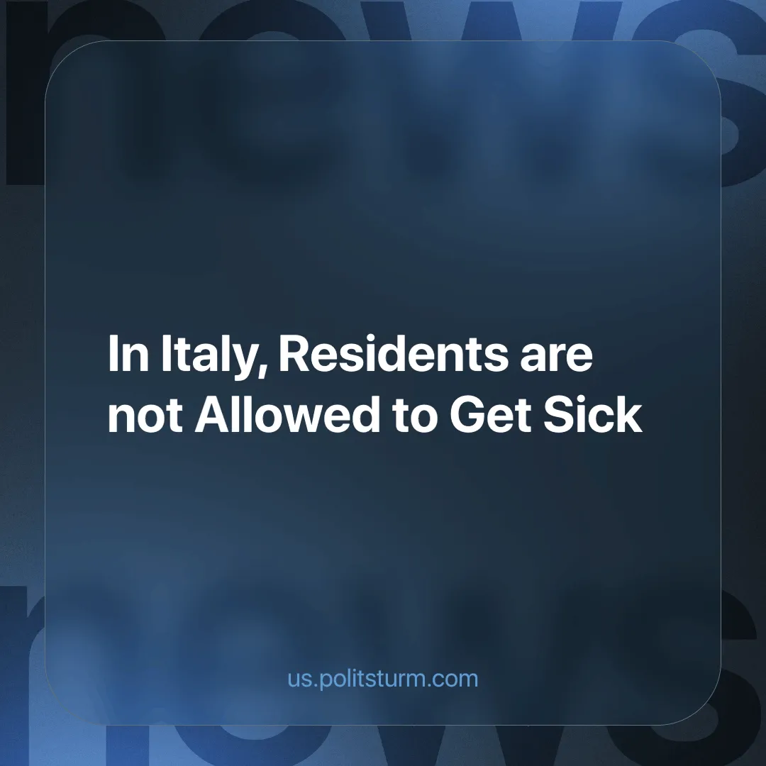

Original article
2025-02-20
4 min read

"Italian hospitals lack beds, medical equipment, and doctors. The doctors are not able to treat all those who need it. First of all, there are not enough artificial lung ventilators. It has even been decided that patients over the age of 60 will not be intubated. On average, one sick person infects 4 healthy people, so the scale of the epidemic is enormous", — livekuban.ru (a Russian regional news site) [1].
This is how Italy faced the coronavirus pandemic. The disease spread massively, engulfing the entire country. The COVID-19 pandemic exposed deep-rooted issues in Italy's healthcare system, highlighting vulnerabilities that had been brewing for years. Within three days, Italy had become the third worst-hit globally. In Lombardy, Veneto Emilia-Romagna, Liguria, and Friuli-Venezia Giulia, schools and universities suspended in-person classes [2].
Italian hospitals faced an unprecedented crisis during the pandemic. A critical shortage of beds, medical equipment, and personnel left doctors unable to treat all those in need. The lack of artificial lung ventilators became particularly dire, leading to the heartbreaking decision not to intubate patients over the age of 60.
There have been several waves of infection. Between September 7–13, Italy recorded 31,000 new infections — a rate of 52 cases per 100,000 residents [3]. The latest data on the number of deaths is almost 200,000 [4]. These numbers revealed not only the severity of the virus but also the systemic weaknesses in Italy's healthcare infrastructure.
Even after the immediate threat of COVID-19 subsided, the underlying problems in Italy's healthcare system persisted — and in some cases, worsened. The recent decree by the mayor of the Italian town of Belcastro to ban its residents from getting sick is a telling example [5]. Residents need to be mindful of their behavior and avoid actions that could cause harm or lead to accidents. They should refrain from going out too often, travelling, or engaging in sports. Instead, they are advised to rest most of the time. What prompted this?
Despite the consequences of the pandemic and the destruction of healthcare, the Italian authorities have not organized either the purchase of equipment or the construction of a rudimentary hospital. For residents, the nearest emergency room is 45 kilometres away, in Catanzaro.
“The mayor explained that he has long been trying to convey the deplorable situation with local health care, but has received no response from regional authorities,” — TASS.
Belcastro is located in one of Italy’s poorest regions — Calabria, CNN reported [6]. In 2021, more than 75% of Calabria’s towns had fewer than 5,000 residents. This situation has raised concerns that some settlements could disappear altogether. In an effort to curb population decline, some towns have even started offering financial incentives for people to move there.
The quality of care varies drastically between regions in Italy. The North generally has better facilities and more resources, while the South suffers from outdated infrastructure and staff shortages [7]. In Southern regions, many hospitals lack sufficient specialists, leading to situations where patients must travel hundreds of kilometers to receive specialized treatment. The lack of emergency medical services in rural areas exacerbates this issue, with some communities relying on only one ambulance for an entire district [8].
Long waiting lists remain a critical issue. Many patients are forced to wait months for essential procedures and specialist visits. The Italian Ministry of Health recently launched inspections and found that 25% of hospitals fail to meet adequate service standards [9].
The government meanwhile has allocated only 6.2% of GDP to healthcare, which is less than 20 years ago. This lack of investment has led to a shortage of personnel and medical resources, making it difficult for hospitals to provide timely treatment. Some hospitals have been forced to limit certain services due to staff shortages, meaning that even those who receive appointments often do not get the full range of necessary care [8].
Another growing issue is the burden of healthcare costs on citizens. Although Italy has a public health system, many essential services require out-of-pocket expenses. In 2025, the registration cost for public healthcare has increased significantly, making access difficult for lower-income groups [10]. Some treatments that were previously covered by the national health service have been removed, forcing more people to rely on private insurance or pay for services themselves [11].
Today some experts warn of the re-emergence of COVID-19 [12]. Given the mutations of the virus and the transmission of its new strains among animals, COVID-19 variants rank second among potential triggers for a new pandemic. Is Europe ready for a new epidemic?
With what words will the bourgeois government "prepare" the citizens for new quarantines and queues in hospitals? The capitalist state continues to “optimize” health care in all countries. Despite the threat of a new pandemic, no measures are being taken to ensure the safety of the masses. This approach has left Italy ill-prepared for future health emergencies, with hospitals still lacking sufficient beds, equipment, and personnel.
The medical staff is fired and the workers are pushed to their limits despite the danger to their health. The capitalist system enriches only the businessmen and their lackeys. The workers, on the other hand, are asked to work without complaint and selflessly to bring profit to "their" master.
Sources:
[1] Живая Кубань — Italy fails to cope with the epidemic — March 14, 2020.
[2] TASS — In search of patient zero. How Italy has become a European hotbed of coronavirus — February 25, 2020.
[3] RIA — Italy's COVID-19 infections rise strongly — September 15, 2023.
[4] Worldometers — Italy COVID - Coronavirus Statistics — April 13, 2024.
[5] TASS — In Belcastro, mayor banned residents from getting sick because of lack of hospital — January 9, 2025.
[6] CNN — Italian town bans residents from falling ill — January 9, 2025.
[7] Live to Italy — Italy's healthcare system: how SSN works and the quality of medical care — November 1, 2021.
[8] 24OreSalute — Healthcare, the Perfect Storm: We have the Oldest Doctors and Few Underpaid Nurses — November 19, 2024.
[9] News&Events Turin — Healthcare in Italy: Why are the queues for medical services getting longer? — September 5, 2024.
[10] Trade & Consulting SAS — How much does it cost to register with the Italian healthcare system in 2025? — January, 2025
[11] 24OreSalute — Integrative health: enrollees no longer grow and meanwhile Italians pay for their own care — January 21, 2025.
[12] Novosibirsk Online — New viruses on the horizon: what epidemics to expect in 2025, and what could lead to a new pandemic — January 6, 2025.

Original article

