Italy Goes on Nationwide Strike Against New Government's Budget
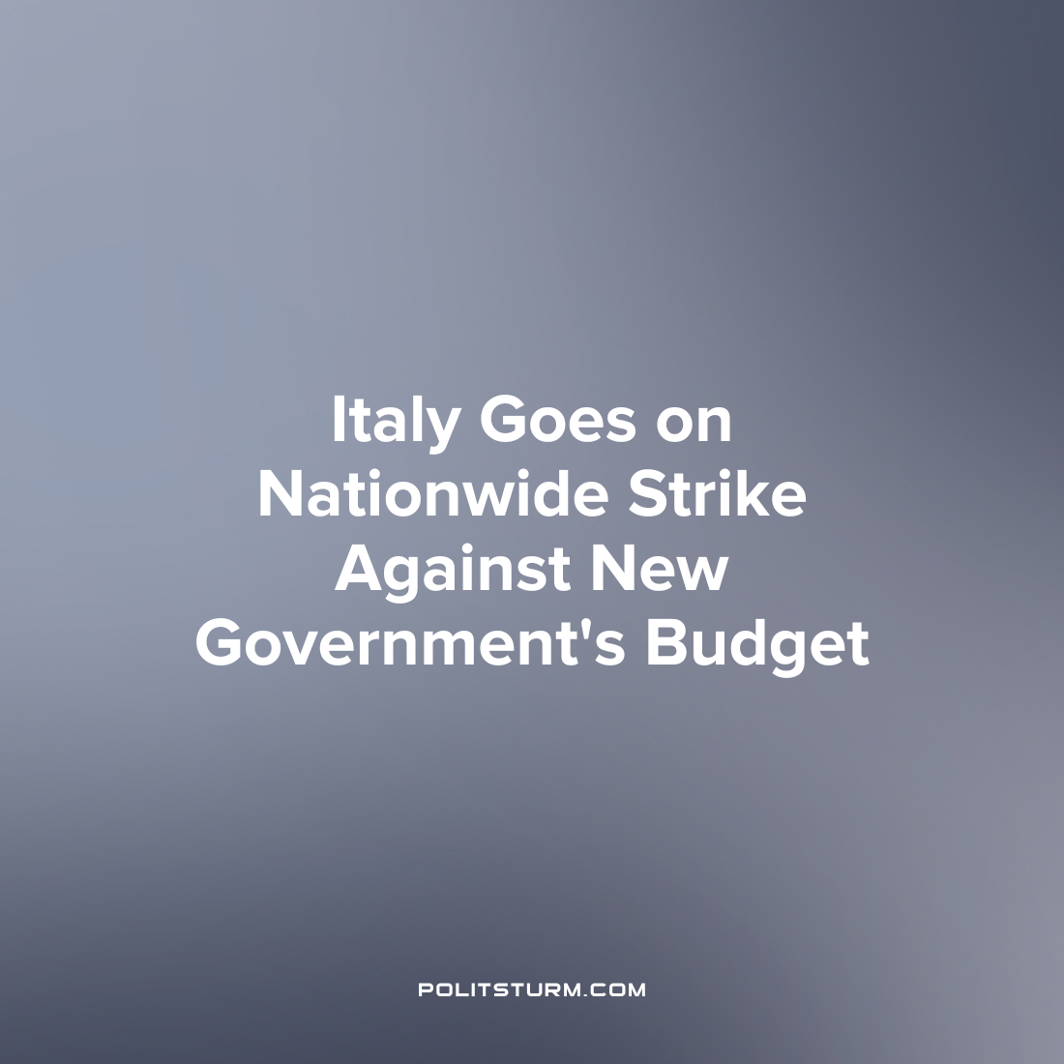

Original article
2022-12-27
2 min read

On December 16, a nationwide strike took place in eleven Italian regions. The main reason for the strike was the debate in parliament on a new budget law. In particular, the workers protested against the reduction of public funding for health care, education and transport. Workers also demanded wage increases, revised social guarantees and the right to work.
The country's two biggest trade unions, the General Italian Confederation of Labour (CGIL) and the Italian Union of Labour (UIL), have organized a major strike action. In a joint communication, the unions explained: "The draft budget law for 2023 is flawed and will lead to disastrous consequences for workers and pensioners who struggle daily with the high cost of living and, after two years of health emergency, face a real 'pandemic' of falling incomes. In response to this violation of rights and repeated insult to the dignity of the people, the unions are launching a nationwide strike".
The majority of those who joined the strike were workers in the transport sector. The strikes caused difficulties in traveling by rail across the country and public transport was suspended for several hours in major cities. In addition to transport workers, doctors, veterinarians and nurses were also on strike, protesting against reduction of public spending on medicine.
Deputy Prime Minister and Minister of Infrastructure and Transport Matteo Salvini condemned the strike as "unmotivated and ideological" and directed against the government. According to him, "problems are not solved by strikes, they are solved by dialogue. Ideological clashes lead nowhere." In other words, the minister argues that the people do not and cannot have a reason to protest against the government or defend their interests - on the contrary, they should obey the state and not cause problems.
Alas, the strikes that have taken place in Italy are not as "ideological" as Salvini has described them. There is no political party to lead the mass protests in Italy and channel them in a constructive direction. Dissatisfaction with the worsening economic crisis continues to grow, but there is not yet a mass awareness that the needs of the people cannot be met under capitalism. Under the present capitalist system sufficient funding will not be allocated to vital sectors such as medicine, education and public transport, because this threatens the profits of the ruling class. Only when power passes into the hands of the workers will the state serve the interests of the people.
Sources:
Today – “Sciopero generale contro la manovra, trasporti a rischio da Nord a Sud: citta e orario” 15th December
ТАСС – «Workers strike in Italy against new government's draft budget» 16th December

Original article

