Italian Prime Minister Meloni Announces Increase in Defense Spending Up to 2% of GDP
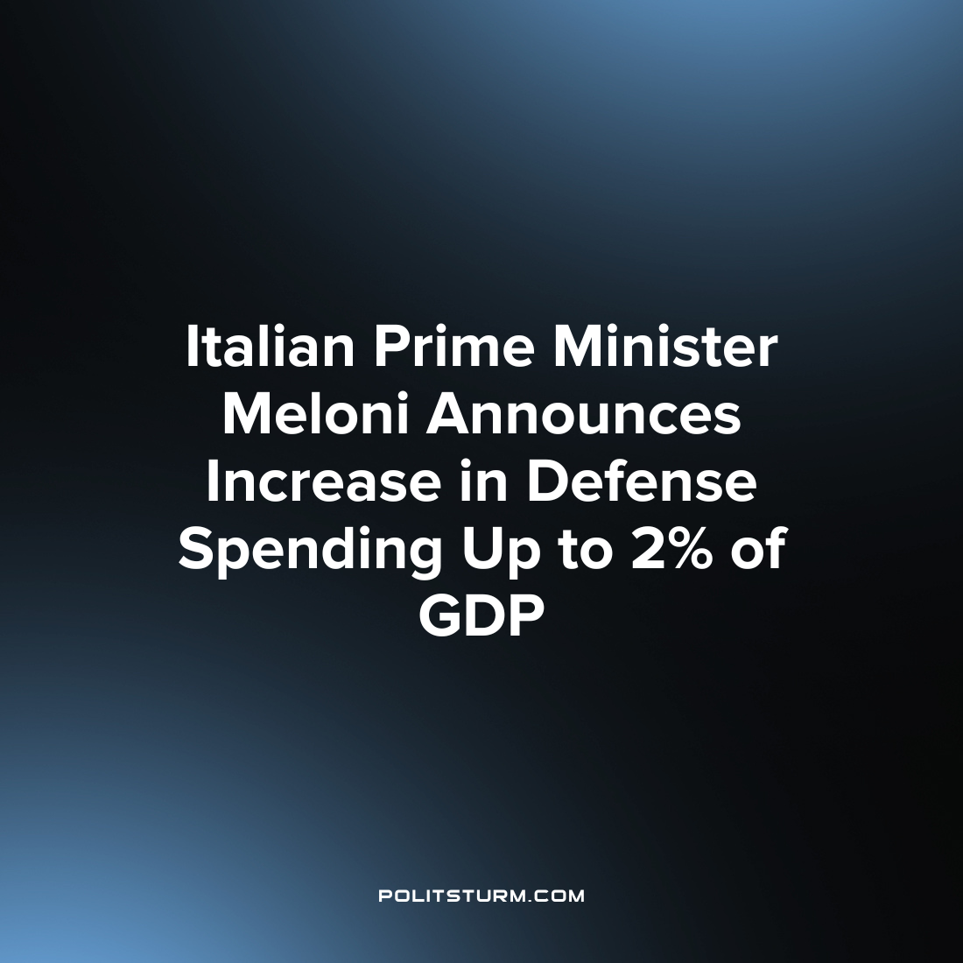

Original article
2023-01-13
1 min read

Italian Prime Minister Giorgia Meloni announced the intention to increase military spending by up to 2% of GDP. This decision was taken by the Italian authorities in accordance with NATO requirements demanding alliance countries to increase defense spending to 2% of GDP by 2024.
“I reaffirm Italy's readiness to honor its commitments. Freedom has a price, if you transfer your protection to someone else, then it will not be free” — Meloni explained.
At the same time, the Italian Prime Minister didn’t mention any specific dates for the implementation of this plan. According to her, everything depends on the geopolitical situation.
At the same time, Meloni announced her readiness to “fully support” the Kyiv regime in the Ukrainian crisis. Despite large-scale protests in Italy against the supply of weapons to Ukraine, the prime minister promised to continue the provision of financial and military assistance to Kyiv.
The new prime minister of Italy built her election campaign on promises to achieve political and economic independence for Italy in the international arena. In fact, however, Meloni, like her predecessors, continues to serve the interests of international capital, for which they are ready to surrender the political and economic sovereignty of the country.
By meeting NATO demands to increase military spending, the Italian government not only acts in favor of big military industry owners, but also contributes to further militarization, aggravation of current military conflicts and sets the ground for new armed clashes in the future. Such a vicious circle of militarization and wars can only be overcome by a transition to socialism.
Sources:
Gazeta.ru – “Italian Prime Minister Meloni supported the increase in defense spending to 2%” from December 29th, 2022
Reuters – “Italy’s Meloni reaffirms support for Ukraine in call with Zelenskiy” from December 27th, 2022
TASS – “NATO expects alliance countries to increase defense spending” from February 15th, 2021

Original article

