Italian President Gives Speech Defending the Free Press
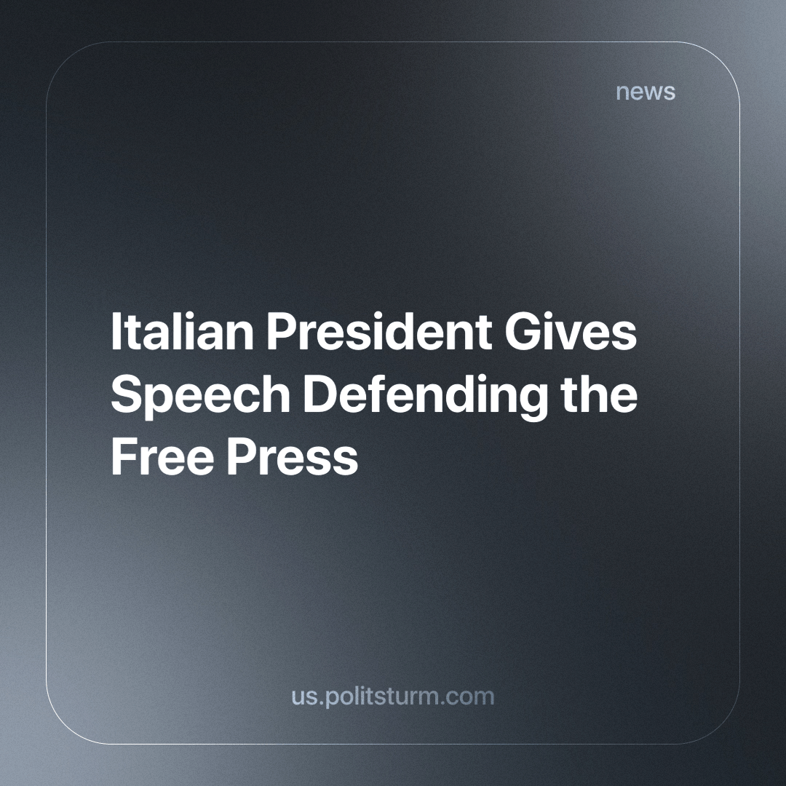

Original article
2024-03-25
3 min read

On March 19th, Italy's president, Sergio Mattarella, speaking at the new foreign press headquarters in Rome announced that:
"The value of the autonomy of the free press is under attack in so many parts of the world. Many journalists pay with their lives for their independence from the powers that be, their search for truth. [...] commitment, to remove obstacles to freedom of information wherever they arise." ^{[1][2]}
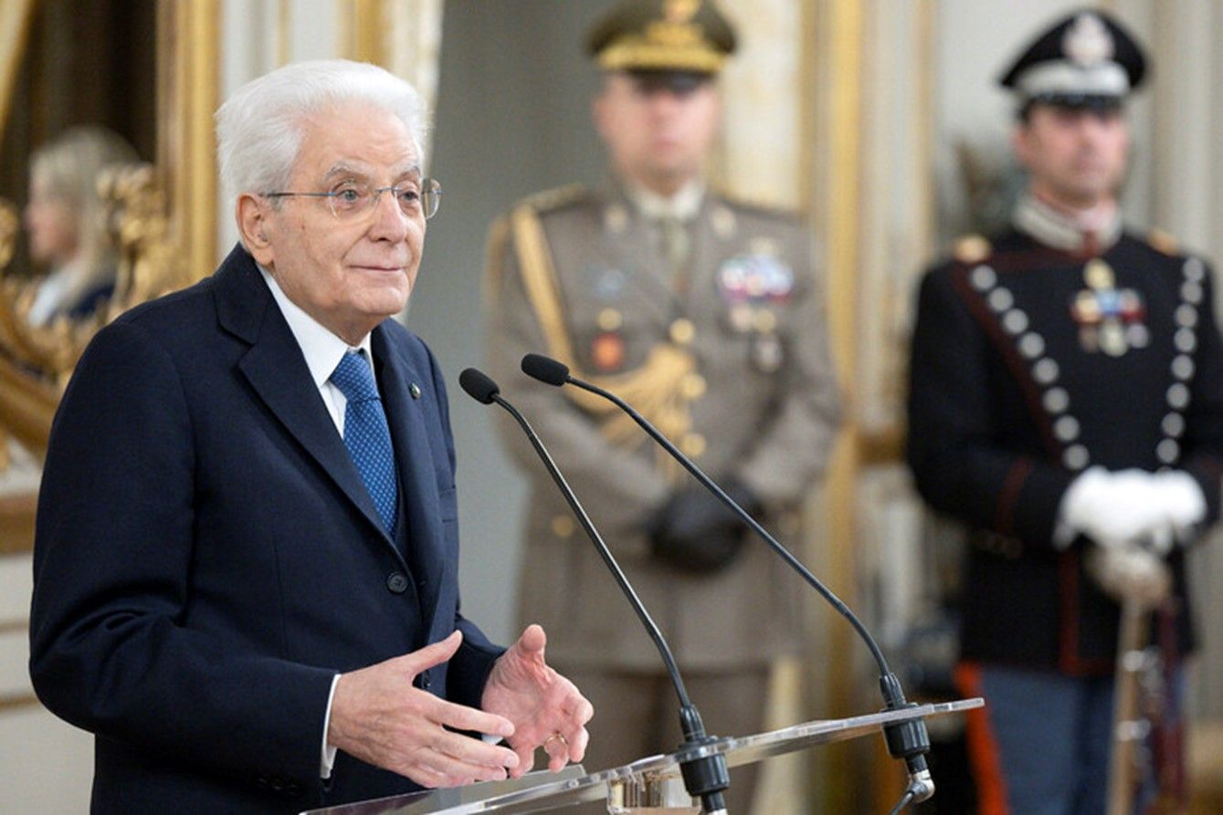
Italian President Sergio Mattarella delivers a speech at the new foreign press headquarters building in Rome on March 19.
This is not limited to certain countries. In Russia, for example, the authorities openly express their dissatisfaction with media figures. Are things better in the United States and Italy? Under capitalism, freedom of the press is under attack because of commercial interests. The media may succumb to pressure or maybe bribed by corporations or political elites, leading to censorship and distortion of information to suit their interests. Under capitalism, many media outlets are controlled by people or corporations with significant capital, which gives them the power to influence the presentation of news and shape public opinion according to the interests of the ruling class or individual members of the ruling class. Lenin put it this way:
«All over the world, wherever there are capitalists, freedom of the press means freedom to buy up newspapers, to buy writers, to bribe, buy and fake “public opinion” for the benefit of the bourgeoisie. » — Lenin, "A Letter to G. Myasnikov"
Marxism has made it short and clear that under capitalism there is no freedom of the press or freedom of speech. Any of these are censored in one way or another, in some places it is done openly — in full view of the public, and in others, capitalists can bribe newspapers or directly own them. It doesn't matter how this censorship is carried out, what matters is people's understanding that freedom under capitalism does not and cannot exist for the worker, otherwise, it wouldn't be capitalism. So, this is not just in China, Russia, or any other country that the media in "democratic" countries believe has dictatorship or individual power, but also in the United States, Italy, and other European countries. Dissenters are often subjected to police repression. A prime example is the event that took place in Pisa on February 24, when student demonstrators were brutally beaten by the police. The demonstration resulted in 17 injured, 11 of whom were minors. However, as stated by the Minister of the Interior, the police should not face any consequences for these actions^{[3] [4]}.
Marxism proves once again that when capital is threatened, the ruling class resorts either to open terrorist dictatorship or to concessions to the working class. In Italy, such a dictatorship was already evident in the 1930s and during the Second World War. After the war, by joining the Western bloc, Italy accepted the terms of concessions to the working class in the form of the creation and enforcement of a "welfare state" policy, which, under pressure from the socialist bloc, granted workers numerous rights and freedoms. These rights were thus preserved only because of the existence of the socialist bloc. Unfortunately, after the fall of the USSR, the capitalist countries, which made concessions to the working class in order to prevent revolutions, are now striving with redoubled energy, frenzied passion and a hundredfold increased hatred to regain the "heavenly kingdom" that was taken away. Not only have they returned to depriving the workers of their rights and freedoms, but they are also implementing policies that are in line with the interests of the Italian ruling elite, enabling them to reap greater profits at the expense of the workers.
The only way to remedy this is for workers to gain power and control over the means of production and the mass media. Only when the means of production and the media are under the control of the working class can their right not only to free speech but to freely act and be master of their own destiny be guaranteed to be protected. This will not only prevent manipulation by distorting information to the benefit of a wealthy minority but will also ensure that events can be reported objectively from a scientific Marxist perspective. Armed with this perspective, which truly reflects their real interests, the workers will be truly free to exert control over themselves and nature. The workers, who own nothing but their capacity to labor, in freeing themselves will also free all mankind by abolishing class distinctions. In doing so, they will create a society where they shall have the freedom and equal opportunity to work the commonly owned means of production - socialism.
Sources:
[1] ansa.it - “Mattarella, il ruolo della libera stampa è decisivo” dated March 19, 2024;
[2] tg24.sky.it - “Mattarella sulla libertà di stampa: molti giornalisti pagano con vita” dated March 20, 2024;
[3] pisatoday.it - “EU court should uphold Google’s $2.7 billion antitrust fine, top adviser says” dated January 11, 2024;
[4] italian.tech - “Gli studenti manganellati, Piantedosi: ‘Corteo fuorilegge, niente processi sommari alla polizia’” dated february 29, 2024.

Original article

