Is The EU Population Dying Out?
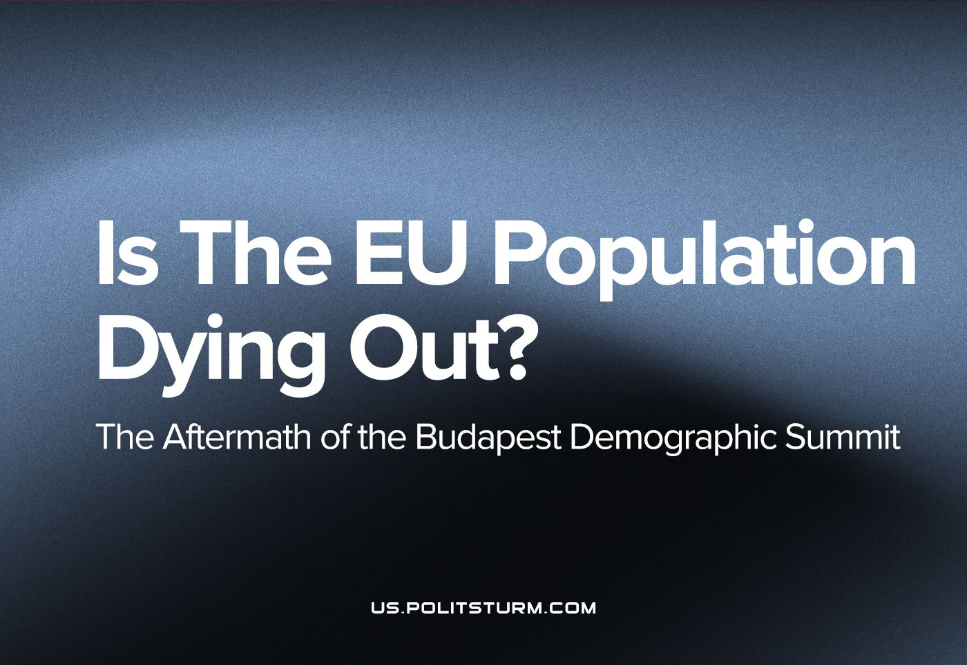

Original article
2023-10-24
8 min read

Within the framework of the Budapest Demographic Summit, the right-wing leaders of Italy, Bulgaria and Serbia were seeking a recipe for saving Europe. But the EU population continues to decline, and the forecasts are not encouraging. The main attention of the forum participants was focused on the role of the family in ensuring the security of the eurozone. The problems addressed by the conference include strengthening traditional communities, ensuring the safety of children and leveling the negative impact of social networks. The concern for maintaining traditional family values was mainly supported by participants who turned out to be representatives of right-wing and conservative views.
The summit was headed by Hungarian Prime Minister Viktor Orban, who has long put ‘traditional values’ at the head of his policy. Budapest believes that it has found a recipe for saving Europe. However, the figures suggest that such optimism is exaggerated: not a single EU country has reached the birth rate necessary to maintain its population. The Statistical Agency of the European Union predicts that by 2100 the EU population will decrease by 27.3 million people, or 6.1%.[1]
Most of the speeches at the two-day event were devoted to analyzing the reasons why many people do not dare to start a family. The President of Hungary, Katalin Novak, focused on the importance of state support for families and traditional values: "Parenting is the right, responsibility and duty of parents… The one who was born a girl should grow up a girl, and the one who was born a boy should grow up a boy ... Those who have children should not be in a worse financial situation than childless… There should be no financial obstacles to the birth of the desired children."
The problem faced by the European Union is not new, developed countries began to experience it much earlier - in 1980s, but compensated for it through migration and the effect of this was not felt. Covid and the economic crises over the past few decade as well as the deterioration of social policy (tax increases, retirement age) have only gradually revealed the real face of capitalism.

Is it just a European, or a global trend?
Taking over the EU presidency in June, the Hungarian authorities named the demographic problem as one of the priorities to work on solving. Officials noted that the crisis in the EU has (and will have) a serious impact on its competitiveness. While the population is growing rapidly in a number of other regions of the world, the opposite trend is observed in the European Union.
In November 2022, the world's population, according to the UN, reached 8 billion people. Also according to the estimates of the UN, in 2030 we will be talking about 8.5 billion, in 2050 - about 9.7 billion, and in the 2080s—2090s the planet will be inhabited by about 10.4 billion people.[2]
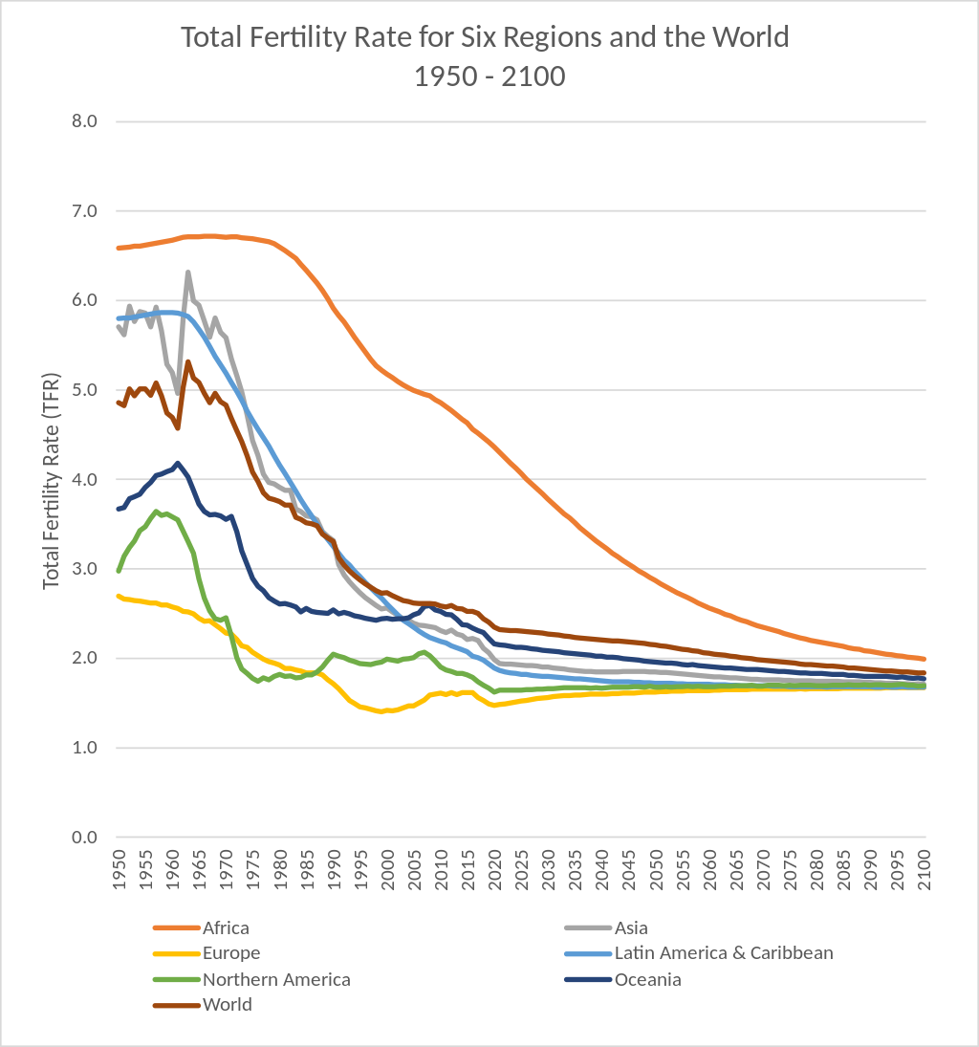
Source: https://en.wikipedia.org/wiki/Total_fertility_rate
According to UN forecasts, by 2050, eight countries, including five African countries: the Democratic Republic of the Congo, Nigeria, Tanzania, Egypt and Ethiopia, will provide half of the world's population growth. On average, women in Africa currently give birth to more than four children. Oceania follows in second place in terms of the total fertility rate, which barely exceeds two births per woman.
However, the situation in Europe is very different. According to the European Statistical Agency, by 2100 the population of the European Union (currently comprising 27 countries) will decrease by 27.3 million people or 6.1% compared to 2022. [3]
In 2020, almost 447.5 million people lived in the European Union, but as a result of the COVID-19 pandemic, this figure began to decline. [4] However, population growth has been observed since the pandemic, and as of August 31, 2023, the population increased from 446.7 million to 448.4 million. This growth is associated with an increase in migration flows and the reception of displaced people from Ukraine who have received temporary asylum in the EU countries. At the moment, about 4.2 million people from Ukraine have temporary protection in the EU, with the largest number in Germany (28%), Poland (24%) and the Czech Republic (9%).[5]
To maintain a stable population level (excluding immigration), 2.1 births per woman should occur. However, in 2021 in the EU, this figure was 1.53. The highest fertility indicators were registered in France (1.84), the Czech Republic (1.83), Romania (1.81) and Ireland (1.78). The lowest fertility rate is observed in Spain (1.19), despite the tradition of large families in this country; for comparison in 1970 the fertility rate was on the rise [3].
As a result, the age composition of the EU population will also change over the upcoming years.
By 2100, people aged 65 and older will make up 32% of the population (now they are 21%). Accordingly, children and youth (aged 0 to 19 years) will become a smaller segment of the population (from 20% to 18%).
Similarly, the proportion of people of working age (20-64 years) will decrease — from 59% to 50%. And the average age of the population will increase from 41.6 to 48.8 years.
So in the near future, we can again expect an increase in the retirement age, greater taxes on the population (and not on top companies earning billions) and other standard charms of capitalism, which will further burden ordinary workers.

What is the real reason for the decline in birthrates?
The devil is in the details, and the real reason for the declining population of developed countries lies in the capitalist system itself. The wealth of society is created with the labour of workers, however it is then appropriated by the capitalists who own the means of production thereby compelling the workers to work for them. As society progresses, new discoveries are made and science advances, leading to an increase of labour productivity on the basis of higher techniques meaning that each worker can then produce more. We live in an era where each worker can produce not only enough to cloth, house and feed themselves (their necessary product), but a huge surplus on top of it. There are far more than enough resources created by working people to support the elderly as well as raise the next generation in society, however because they are privately appropriated by the capitalists, these resources are instead accumulated to an insane degree by a handful of the richest billionaires.
In addition, in developed countries, as machinery and automation plays a greater role in production (i.e. the proportion of constant capital increases), and labour productivity rises the capitalists’ rate of profit falls. This was the reason for them exporting so much production abroad to less developed countries and coincided with the beginning of the decline in population growth in the EU – precisely because both phenomena share this common cause. With a lower rate of profit, the capitalists not only exploit the less developed countries and their workforce, but also began to cannibalise the working class at home to a greater degree. This lead to the dismantling of the welfare state and social-democratic policies at home and increased unemployment due to the loss of jobs, thereby cheapening the price of labour. In their quest to maintain their rate of profit (which will inevitably continue to fall in the long run as a law of capitalism), the capitalists infringe on not only a greater share of the surplus created by the worker, but often on the necessary product itself as well. This can be done directly (e.g. decreasing real wages) or indirectly (e.g. increased healthcare or education costs, increased rent, decreased social services and benefits).
As a result, there is increased economic pressures on families, such as high spending on education, healthcare and housing, which limits people’s decision to have more children. In addition, periodic crises, followed by high unemployment and low incomes also restrain the desire to have children. Capitalism has long ceased to be a progressive force in this world and its decay is evident in the fact that its becoming such a huge burden for ordinary people to start a family.
It is possible to overcome all the problems described above only by changing the social formation to a more progressive one - socialism. Join us in our fight for a better future.
Sources: 1,2,3,4,5

Original article

