Is Russia Capable of "Denazifying" Ukraine?
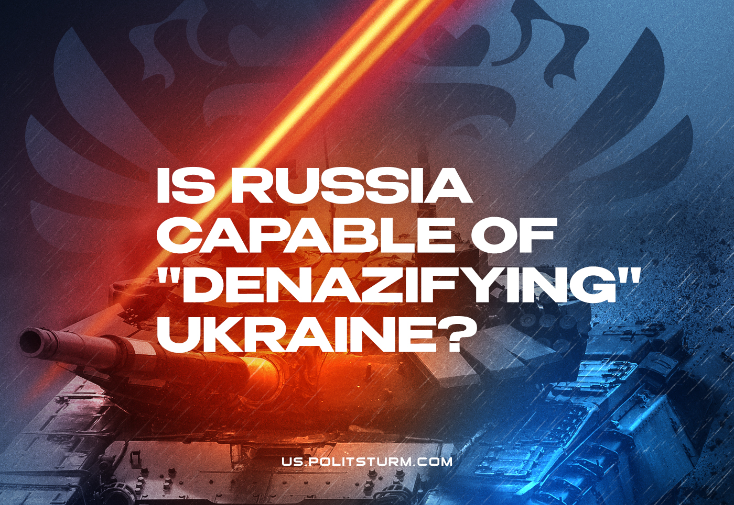

Original article
2022-08-05
17 min read

Denazification has been declared one of the goals of the “special military operation” of the Russian Federation in Ukraine. This Soviet term appeared after WWII and means “measures to cleanse the state, socio-political and economic life of Germany from the consequences of the domination of the fascist regime in order to carry out the democratic transformation of the country.”
Judging by the numerous and contradictory statements of the Russian authorities, Ukraine is supposed to be “cleansed” of ultra-right and openly fascist elements: both in society and in the state
apparatus. Having raised such a slogan, they present their actions as a struggle against fascism. Propaganda trumpets the repetition of the feat of the Soviet people and the historical mission of Russia — the struggle against fascism and Nazism.
However, it is no secret that for more than 20 years Russia has been undergoing a process of gradual decommunization. This is not to mention that, unlike the USSR, modern Russia is a capitalist state. Is it possible to carry out denazification at the same time?

I. The roots of fascism and Nazism
Once the goal of cleansing Ukraine of Nazism and fascism has been declared, first it is necessary to find out what fascism and Nazism are.
Nazism is one of the forms of fascism. Fascism, in turn, is a certain form of organization of the capitalist state. Following the well-known definition of fascism given by the Bulgarian communist Dimitrov, it is an open terrorist dictatorship of financial capital.
In addition, fascism is characterized by a number of distinctive features:
– the use of extreme forms of violence to suppress the working class;
– chauvinism and racism;
– widespread use of state-monopolistic methods of regulating the economy;
– an “autocratic” government, i.e. not controlled by the people in any way;
– maximum control over all manifestations of public and private life of citizens;
– the ability to mobilize and politically activate the masses in the interests of the exploitative system through nationalist and social demagogy.
Militant anti-communism should also be added to what has been said. This is not an accident: the most important place in fascism as a political thought and state system, in addition to the voiced features, is the uncompromising struggle against communism.
The historical conditions of its emergence are the period after the First World War, associated with the victory of the socialist revolution in Russia, the formation of the Communist International, and the growth of the revolutionary movement around the world. Under these conditions, fascism appears as a response from big capital to the threat of the revolutionary labor movement.
If we look at the history of the establishment of fascist regimes, we will certainly notice one common point. It lies in the presence of a deep political and economic crisis in the country, the growth of revolutionary sentiments that immediately preceded the coming to power of the fascists and their close connection with large capital.
This was the case in Italy in the first half of the 1920s – the first fascist country in history, in which fascism as a political thought originated. After coming out of the war, the country was going through a difficult economic crisis, all the hardships of which fell on the shoulders of the workers. The unfulfilled territorial demands of Italy contributed to the growth of discontent and
revolutionary sentiments: the Entente allies left them unsatisfied.
Italian society, having experienced enormous human losses in the war and, as a result, significantly impoverished, was torn by class contradictions. The workers’ movement grew rapidly and became politicized, especially under the influence of the victories of the October Revolution and the actions of the Soviet government.
In the end, this resulted in the so-called “red two-year period”: a period of the rise of the labor movement, during which workers organized mass strikes, seized factories and factories
and created workers’ councils. In fact, a revolutionary situation was developing in Italy.
Against this background, the famous “march on Rome” takes place — the movement of members of Mussolini’s fascist party and its paramilitary formations (detachments of “blackshirts”) on the capital of Italy, accompanied in fact by the seizure of power on the ground. Its result is the fascists gaining power in the country.
This was the case in Germany in the 1930s: an incredibly war-ravaged country, the horror of hyperinflation in 1921-1923, an acute political crisis and the enormous growth of the revolutionary movement of the German proletariat and the influence of the Communist Party of Germany. With the open support of German and Western capitals, Hitler’s Nazis came to power precisely during the intensified struggle with the Communists, which did not subside throughout the 20s of the XX century.
As you know, back in 1919, the German bourgeoisie bloody suppressed the socialist revolution that had begun with the forces of the Freikorps — volunteer military formations. Then, she “limited herself” to the defeat of the Bavarian Soviet Republic and the murder of the leaders of the German Communists: Rosa Luxemburg and Karl Liebknecht, generally preserving the established bourgeois-democratic regime. Until the early 30s, there were periodic clashes between the Communists and the right.
But after a little over 10 years, the situation worsens again for German capital, and then it brings to power the extremely aggressive Nazi party of Adolf Hitler.
In January 1933, Hitler was appointed Reich Chancellor of Germany, and in February, extreme political restrictions were introduced (including a ban on the activities of the Communist Party), the reason for which was the accusation of Communists in the arson of the Reichstag. The Nazis quickly seized power in the country, tried to publicly condemn the Communists during the Leipzig process, and launched mass repressions of revolutionaries.
So it was in Spain: the fascist Franco regime was established during an open armed clash with the government of the Popular Front — a coalition of bourgeois democrats, leftist parties and communists — the civil War of 1936-1939.
With the most active support of the Spanish capital, as well as the fascist regimes of Germany and Italy, Franco’s fascists overthrow the coalition government during a fierce struggle, and carry out the most severe repressions against their opponents. Another fascist regime is being established in Spain, which will last much longer than the Italian and German ones.
The same can be said about many other fascist regimes and the historical conditions in which they were established.
Thus, fascist coups have always been accompanied by a fierce hatred of revolutionary communist movements and the active support of big capital.
Similarly, modern fascists call communists “the main threat to a civilized society.” Ultra-right parties, movements and organizations of all countries have one thing in common: they all build their ideology on the basis of ardent anti-communism, seek to establish ties with representatives of big capital and receive financial support from them, and are used in one form or another by the ruling
class to protect their interests.
From this it is necessary to draw the following conclusions about the nature of fascism:
1. Fascism is a product of capitalism;
2. Capitalists resort to the establishment of a fascist regime at a time when their dominance is threatened by the workers’ movement, which, under the leadership of communists and with the broad support of the people, is waging a revolutionary struggle for the overthrow of capitalism and the establishment of Soviet power.
The goal of fascism within the country is the workers’ and communist movement, and in the foreign policy arena — socialist states, other imperialist powers and dependent
countries. In this sense, fascism is inextricably linked with capitalism, with the monopolistic stage of its development. In short, fascism is a natural and historically conditioned product of capitalism.
Accordingly, without the elimination of capitalism, it is impossible to carry out such denazification, which could be called complete and final, i.e. to defeat fascism. By preserving the source of exploitation and predatory politics, which divides peoples into unequal antagonistic classes and causes class struggle, we preserve the source of fascism.
The deeper capitalism plunges into crisis, i.e., the more the contradictions of capitalism and the class struggle of the working people for their liberation become more acute, the stronger the process of fascization will proceed: the gradual degeneration of bourgeois democracy into a fascist dictatorship. The closer will be the moment when big capital abandons the screen of bourgeois democracy and the transition to terrorist methods of exercising its dictatorship.
In this sense, it is appropriate to recall the words of Georgy Dimitrov himself, said by him in a report at the VII Congress of the Comintern:
“It is characteristic of the victory of fascism precisely that this victory… expresses the weakness of the bourgeoisie itself, which is afraid of the realization of the unity of the struggle of the working class, fear of revolution and is no longer able to maintain its dictatorship over the masses by the old methods of bourgeois democracy and parliamentarism.”
The only way to end fascism and Nazism once and for all is to destroy capitalism and build a socialist society. Without these profound transformations, any words about denazification will remain just words.

II. Is Russia an exception?
Perhaps modern Russia is an exception? Can the memory of the Great Patriotic War, Soviet upbringing and culture of Russia serve as a protection against fascism? Therefore, can Russia carry out
denazification?
The modern Russian Federation is an ordinary capitalist state, the signs of which we can clearly observe. The country is dominated by the power of monopolistic capital, there is private property and wage labor, which is subjected to the most severe exploitation by direct and indirect methods.
Despite the active use in Russian propaganda of the achievements and symbols of the USSR, as well as the image of the “victorious people”, since 1991 the ruling class has been gradually decommunizing — fighting against the very communist legacy in ideology, philosophy, education, culture.
The spread of anti—communism through the popularization of the enemies of Soviet power – Solzhenitsyn, Ilyin, Dovlatov, Brodsky; through the spread of anti-Soviet myths in cinema and literature; the creation of documentaries denigrating the history of the revolution and the USSR, substituting conspiracy theory for real history; the struggle against the symbols of communism: renaming streets, creeping dismantling of monuments, mashing Soviet symbols, covering Lenin’s mausoleum with cardboard on May 9. Finally, the ardent anti-communist statements of the president himself, as well as smaller politicians and journalists. There are enough facts.
Thus, the Russian bourgeoisie systematically fights against communism, distorts it and discredits it.
For capitalist Russia, communism is as hostile an idea as for any other capitalist state. Communism explains to the workers the reasons for their plight and oppressed situation. He points out the existence of exploitation, gives a scientific explanation of the facts of social life, reveals the patterns of development. But what is most important: it offers a program for the liberation of the working class through class struggle and the construction of a socialist society.
By doing so, he arouses the hatred of all capitalists in the world, as well as their agents.
For this reason, the bourgeoisie of the Russian Federation, like any other capitalist country, only verbally opposes fascism, and only declares denazification.
In fact, it will always consider the use of fascists and the far–right in politics, or even the direct establishment of a fascist regime, as a likely and effective way to preserve its position – as a way to fight the workers’ and communist movement. In this case, the presence of the Soviet past in the modern Russian state plays absolutely no role.
The ideological legacy of the Soviet Union, as well as the people’s memory of the Great Patriotic War (distorted and spat upon in every possible way) cannot in any way protect against the use of the ultra-right and degeneration into a fascist regime. This is based not on ideological attitudes, but on objective socio-political processes.
Actually, this is what we can observe in modern Russia.
The state replaces the communist ideology with conservatism, nationalism, religion and bourgeois patriotism. Replaces communist symbols and meanings with pre—revolutionary ones, discredits
and denigrates revolutionary and Soviet figures – on the contrary, elevates and idealizes tsarist ones in every possible way.
Capital consistently feeds right-wing and ultra-right figures. Everyone knows the public activities of the “Orthodox oligarch” Konstantin Malofeev and his society “Double-headed Eagle”. The authorities do not prevent them from openly conducting White Guard propaganda, even standing up for them when YouTube blocks the Tsargrad channel, a media controlled by the oligarch. It does not stop the activities of outspoken fascists, such as the publication “Black Hundred”, the nationalist media “Sputnik and Pogrom”, the apologist of “Eurasianism” Dugin and others.
One way or another, through its cadres, the government promotes and implements their ideas in domestic and foreign policy. Vladislav Surkov, a former assistant to the President of the Russian Federation and a “court” ideologue, was actually the unofficial herald of corporatism in the Russian Federation, and besides, he led the policy of the Russian Federation in Ukraine.
The Russian state protects and cherishes them in every possible way in case they have to resort to a reaction in the future.
For these reasons, the modern Russian Federation cannot denazify Ukraine. The capitalist state, which is also led by militant anti—communism, cannot defeat fascism in any way – in any of its manifestations. Fascism is a direct product of capitalism, which is in a state of acute crisis. A crisis that is inevitable for Russia due to the insolubility of the contradictions of capitalism.
The sign will certainly change, but nothing will fundamentally change and the very declared cleansing of the country from nationalists and “radicals in the government”, from fascist-minded figures and groups will not happen.
The genuine program of the Russian bourgeoisie does not imply a change of the socio-economic system of Ukraine from regressive to progressive, but a change of the dominant capital in this country: from the local pro-Western to its own, pro-Russian.

III. How should denazification be carried out?
We have already indicated in the introduction that denazification is a Soviet term. It was created to denote the post-war policy of the USSR in relation to the occupied part of Germany. Post-war German society had to be cleansed of the consequences and influence of the ten-year existence of the fascist regime in this country, in order to thus exclude the possibility of relapse.
It is this experience of the USSR in denazification that should serve as an example, a “manual” on how to purify society from the influence of fascist ideology and figures.
It consisted not only in the fact that the USSR (unlike Western capitalist countries) pursued a consistent policy of prosecuting Nazi criminals and purging the state apparatus of the old officials of the Third Reich. In this sense, the Soviet Union set an example to the Allies how former Nazis should be persecuted and punished. But this is not the main thing.
The most important thing in the Soviet definition of the term denazification lies in this moment: purification “in order to carry out the democratic transformation of the country.” Not just the capture and punishment of all Nazis, but a deep transformation of the country in a democratic spirit in order to deprive fascism of material soil.
In the Soviet sense, democratization undoubtedly meant a socialist transformation. This is what the Soviet Union did: it helped the German workers and communists to establish a workers’ government in the GDR, which, with the support of the USSR, began to build socialism. The elimination of the carriers of fascist ideology, supported by a radical restructuring of society and the
education of workers in the spirit of the ideals of communism, very soon created a completely new society.
East Germans differed not only from the people who lived under Nazi rule, but also from their Western brothers. In their minds and public life, they did not carry the contradictions of post-war West Germany, in which such transformations were not carried out, in which they not only retained many Nazis on the ground, but also did not affect the capital loyal to the Nazi regime at all.
Thus, the Soviet Union destroyed the very material basis of all fascism — capitalist socio-economic relations. And once again there is a need for denazification, it cannot be carried out otherwise than in the Soviet way: only such denazification — the replacement of capitalism with socialism — can be considered as such.
The fight against fascism means not only and not so much the persecution and punishment of specific supporters of fascism, fascist leaders, and neo-Nazi militants, although this is also important. But the real struggle against fascism and fascists is not limited to this alone; it is primarily a struggle against the elements that give rise to them, against the capitalist organization of society.
Fascism or Nazism cannot be defeated by maintaining the division of society into antagonistic classes: exploiters and exploited. The antagonistic economic interests of these two classes will always inevitably cause the struggle of theexploited masses for their liberation. The class struggle, in turn, will sooner or later force capitalist exploiters to resort to the services of fascists.
Moreover, fascism cannot be defeated by denying communism — its sworn enemy and the only force capable of destroying fascism as a social phenomenon. Only through the recognition of the slogans and program of communism, i.e. through the class struggle against the main source of fascism — capitalism — can denazification be carried out.
By denying this program , it is absurd to talk about genuine denazification. There is no capitalist state that is capable of this and cannot be.
Only with the establishment of a socialist system throughout the world is it possible to completely rid the world of the threat of fascism and Nazism.

Original article

