Is Putin "Insane"? On the Nature of "Putinism"
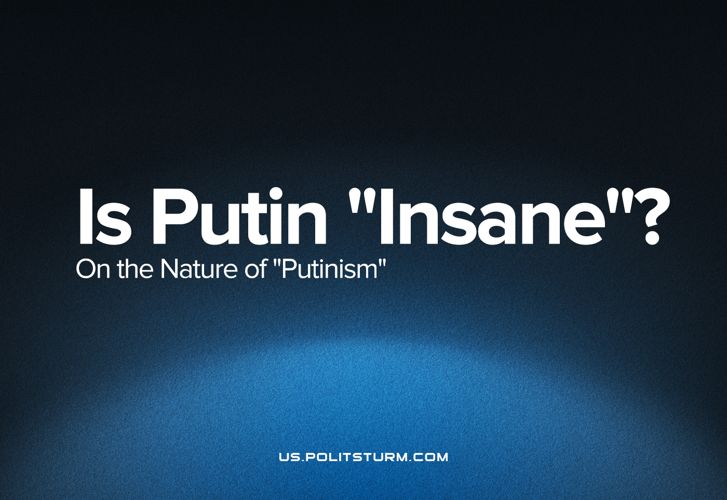

Original article
2022-10-07
8 min read

In liberal circles there has long been a widespread myth about the alleged inadequacy of the top leadership of the Russian Federation, particularly President Vladimir Putin. Ministers and other top officials are presented as a collection of incompetent people who should have been retired long ago. Liberals see no objective external and internal upheavals taking place other than the actions of the authorities.
With the “special military operation”, the heat of absurdity has increased. The liberal opposition is now saying that the country is being run by a “mentally deranged dictator” who is completely disconnected from reality and lives in a world of surrealistic reports from his servants. This has allegedly led Russia to unleash a senseless conflict. The most ardent apologist for this position is liberal blogger Maxim Katz.
To understand how the peoples of the former Soviet Union have lived to see military clashes with each other and how the figure of Vladimir Putin relates to this, it is necessary to examine the historical events of recent decades in detail.
I. Bourgeois Philosophy
For liberals, the answer to the question “who is to blame” is as simple as possible. As a rule, they see the root of the problems in the “will of the dictator”, the schemes of political technologists, the corruption of certain members of the Russian top leadership and so on.
But this is the position of subjective idealism, the philosophy of the bourgeoisie, which regards the will of individuals as the root cause of everything. It diverts us from considering social phenomena as they develop, in their connection and interconnection, as they really are.
Using such a philosophy, one could conclude that history is driven by heroes or anti-heroes, such as Alexander the Great, Napoleon, or Putin. It is equally true that the nation’s leader lifted Russia out of its knees in the 2000s and that he led the country into the worst crisis of recent years.
But of course, the conventional liberal blogger will by no means consistently use the logic of idealism. On the question of the causes of the country’s economic growth at the beginning of the 21st century they are forced to take a position of spontaneous materialism, telling us about the high price of oil, about recovery growth, etc.
Thus the consistent pursuit of subjective idealism leads us only to absurd conclusions. This, of course, does not worry the liberal public, for them this philosophy is just a convenient tool to fool the masses rather than a way of knowing objective reality.
II. Capitalism in the post-Soviet space
If we look at Russian society from a dialectical materialist point of view, we can find a completely different picture.
The counterrevolution of 1991 led to the disintegration of the USSR and the restoration of capitalism on its territory. Private property triumphed and, after a brief period of free competition, monopolistic capital grew out of it and got the economic and political dominance in its hands.
Since its aim was profit and not the satisfaction of the needs of the people, the old productive forces in the republics were destroyed. Most of the industry has been scrapped, in Russia only the highly profitable raw material industries have been left. Plants and factories were replaced by the service sector.
But the appetite of the bourgeoisie is not limited to the territory of the largest state in the world. Having quickly subjugated its own market, young Russian imperialism wanted to participate in the redivision of the world market.
The question of an “equitable” redistribution of the Soviet economic inheritance has become particularly acute for him. One of the main markets for the capitalists in the Russian Federation has been, and still is, Ukraine. This country has not only a large market, but also a developed industry capable of generating unprecedented profits for its masters.
That is the reason for all the political turmoil going on around the richest region in what was once the European part of the USSR. The international bourgeoisie – European, American, and Russian capitals – have been vying for control of the best assets for decades. The country’s political fragmentation into pro-Western and pro-Russian parts has been driven by the desire of the interested parties to acquire as much of Ukraine’s wealth as possible by controlling the privatization policies of the local authorities.
Contradictions between capitalists have never been resolved amicably. A cold conflict between them always leads to an open confrontation with weapons, because their interests are very different and neither of them wants to cede markets, factories, or plants to the other. This is why the Maidan era has been replaced by a conflict in eastern Ukraine, which has escalated into a military confrontation between the Russian and Ukrainian armies.
In order to explain to the workers what their blood is being shed for, the leaders of both sides are using the ideology of nationalism and chauvinism. This is why Putin puts forward the conspiracy theory of the formation of the Ukrainian nation, puts the liberation of Donbass on the agenda, and accuses the Ukrainian authorities of having a penchant for fascism.
In fact, he is only saying that the Ukrainian market and its wealth should belong not to European, American, and Ukrainian capitalists, but to Russians. By demanding the “real decommunisation” of Ukraine, he is only expressing the interests of the big Russian monopolies, for whom “independent Ukraine”, like “Great Russia”, is merely a source of profit, just like for any other capital.
If the veil of bourgeois ideology sewn from Russian nationalism is cast aside, if behind “any moral, religious, political, social phrases, statements, or promises, one learns to look for the interests of certain classes”, then Putin’s logic becomes painfully simple and all doubts about his sanity disappear.
III. The aims of the liberal activists
Regardless of whether liberal bourgeoisie figures understand the real background of the observed events or not, the obscuring of the class basis of the political processes and replication of false notions about them plays an important role in their propaganda. The myth of the “Russian world”, with which the Russian monopolistic bourgeoisie justifies its imperialism, is countered by the liberals with their own.
It is the myth of a bloody dictator, disconnected from reality, and inadequate corrupt bureaucrats, who long ago should have been replaced by a people`s president and honest officials. This is the long-worn myth of “wrong capitalism”, which needs to be demolished and rebuilt.
Behind this myth is the struggle of the petty and middle bourgeoisie, whose interests are represented by various liberal bloggers and politicians, with the big monopolistic capital. None of them cares about the interests and aspirations of the common people.
While some want to maintain their dominance and pursue aggressive and invasive policies under imperial flags, others seek to break the back of the monopolies, to carry out new privatisation under the flags of NATO and the European Union, to change the existing relations of domination and subordination in the domestic market, to become the new big masters of the Russian land.
In order to lead the workers, the liberals need a myth to make Putin’s monopoly capital programme look like madness, and the demands of small shopkeepers and middle businessmen look like a reasonable and modern programme of reform.
IV. Conclusion
The idea of the insanity of Russia’s top leadership is the brainchild of liberal ideologists. Its purpose is to discredit the Russian leadership and the Russian ruling class in order to overthrow them at the hands of the workers and begin to oppress the people of Russia themselves. They need to lie about the true cause of the events to protect the bourgeois society from the encroachment of the workers on the power and property of capital.
The real cause of the armed conflict is the struggle between the big bourgeoisie of various countries for the redistribution of markets, which has developed from its cold phase into a hot one. A change of faces and signboards will not eradicate this capitalist contradiction. It will only be a new escalation of the crisis of capitalism.
The proletariat should by no means trust liberal politicians. It is necessary to confront them with a Marxist analysis of the situation and a programme of action. Instead of joining their disparate ranks, it is necessary to expose the mouthpieces of the ruling class, to raise the consciousness of the workers to the level of Marxism-Leninism. Everything must be done to organize them around the sole spokesman of the people’s interests – the genuine Communist Party.

Original article

