Is Communism a Religion?
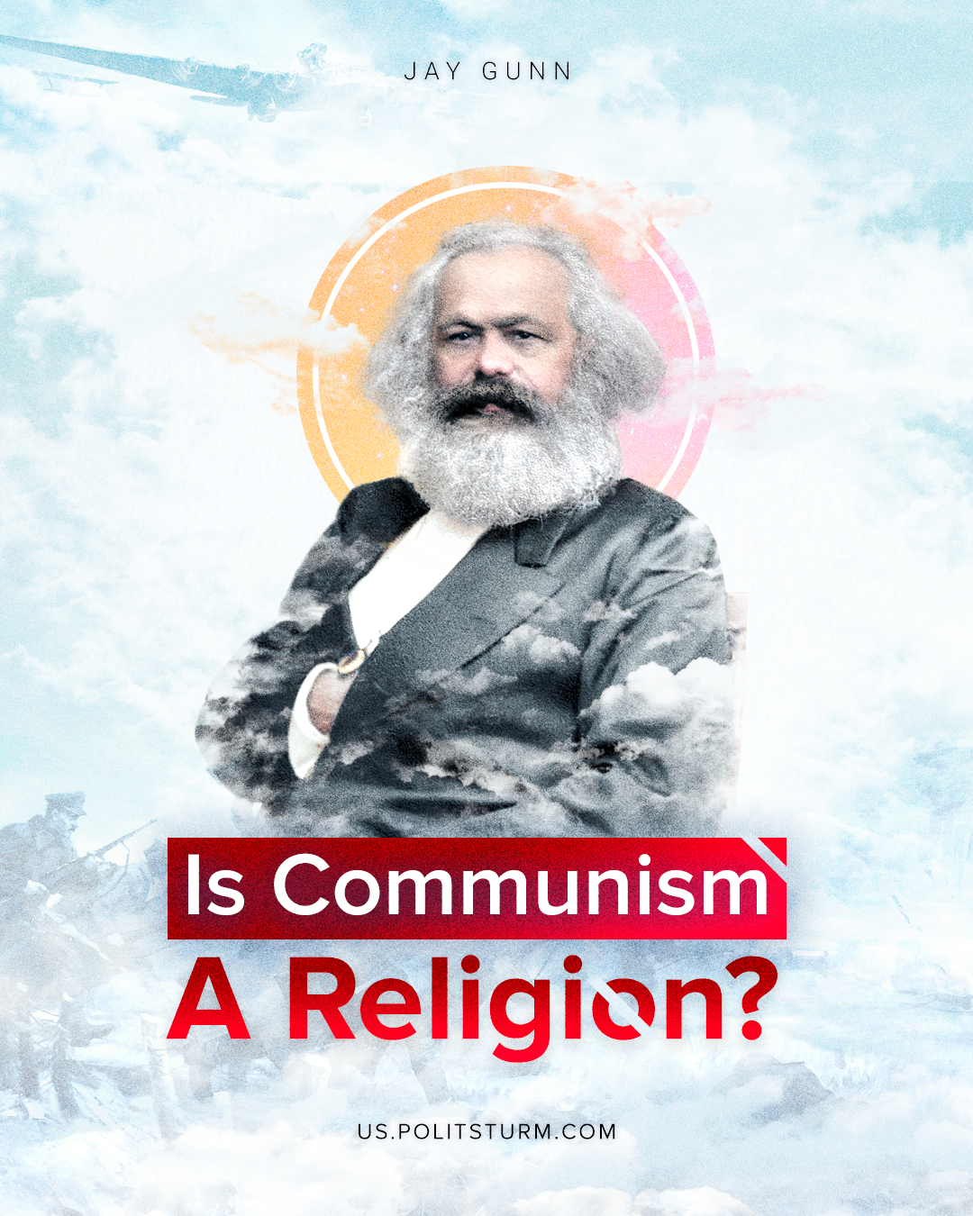

Original article
2022-01-18
11 min read

“We want to sweep away everything that claims to be supernatural and superhuman… For that reason we have once and for all declared war on religion and religious ideas…’.¹

Is Communism a Religion?
There are simple and uncritical attempts to equate the philosophical, political, and social characteristics and prominent figures of Communism, or more specifically Marxism, with religious organizations and figures.
In a July 2021 article in the ironically titled online publication The Article, contributor Laszlo Solymar puts little intellectual effort in making comparisons between religion and Communism. Here he writes: “Let us make a few comparisons. Although Communism is more similar to Islam, here we tend to be more familiar with the tenets of Christianity, so I shall use mainly that religion (especially Catholicism) to compare the two. Both have sacred scripts. Marx’s writings correspond to the Old Testament, Lenin’s to the New Testament. These are prescribed reading. As for biblical personages, Marx is the Moses who never made it to the Promised Land. Lenin is the Redeemer of the proletariat who died and left his disciples behind at a relatively early age. Stalin, we may compare with a much more malevolent Lucifer…”.²
Subjective opinions, such as Laszlo’s, are not sufficient as a basis for useful comparisons.

Materialism Versus Idealism
The underlying philosophical differences between Communism and religion, that is, the driving ideological and practical forces, concern the origins of ideas and the outworking of those ideas. Communism concerns material realities rather than the subjective, metaphysical, esoteric, mythological, and abstract composition of religion.
For a Communist, the basis for making sense of and understanding the world, society, and history is set upon the foundation of material dialecticism. What this means is that everything that exists is material and can be accessed by our senses or with the help of the instruments we develop for research and discovery. Furthermore, Marxists understand that all human ideas arise out of our evolving situation and interaction with the material realities at any given time. Even abstract ideas such as gods, spirits, and the like, are developed due to certain historical and circumstantial human experiences at different times of human social development. Thoughts, concepts, ideas, even esoteric or mystical considerations, are derived from the influences of material social conditions and influences. All the conceptions of things like angels, heaven, souls, etc., are the products emanating from the locus of material neurological functions within the human brain. The philosophical ground of Communism is material reality and the consequences of the human social experience and interaction with it.
The basis for religious thought and action, however, is birthed out of primitive assumptions and superstitions about the origins of the universe and the relationship between humankind and the forces of nature, material conditions and forces, and from social intercourse. Religion, with its gods, ideas, and icons, are human constructs and are not of any revelation external to humanity. Religion directs humanity toward a distorted ontology and fantastical subjective ideas about the eternal future without any supporting empirical evidence.
Apologists for religion make the claim that Communism is a substitute for religion. This misses the point entirely. Communism is the form of social order wherein the exploitation of Man by Man is eliminated; this includes the exploitation, manipulation, and prejudices inherent in many religious doctrines, dogmas, and practices.

Rituals and Icons
Religious practices include various rituals, liturgies, fetishism, and reverence for icons such as crucifixes, idols, saints, and artifacts. Many religious people make regular pilgrimages to local places of worship as well as to those which are distant such as the Vatican or Mecca. Additionally, each religious faction celebrates holidays which are unique to their denomination and sect that commemorates some non-historical event concerning the activities of one of their gods, prophets, or deistic avatars. Exceptions to this, of course, would be commemoration of recorded historical events such as the birthday or activities of certain religious scholars, writers, or leaders.

Error loading image
It is from these examples of religious rituals and holidays that some draw an equivalency to Communists, or those with Communist sympathies, who erect statues, visit the tombs and graves of notable Communists such as Marx, Lenin, and Stalin. Additionally, comparisons of holidays have been drawn to the commemoration of significant revolutionary battles for liberation such as Dien Bien Phu in Vietnam, the battle for Santa Clara in Cuba, and the Bolshevik victory of the Russian Civil War with the commemorations of religious holidays.
Such comparisons, however, beg the questions, “How can visiting historical locations, celebrating the contributions of Communist theorists and warriors, and commemoration of the struggles for independence and liberation, be considered a religious act when thousands of citizens throughout the world, the religious and atheists alike, flock to their respective national historical sites such as the Washington, Jefferson, and Lincoln memorials? Citizens of nations participate in and enjoy the celebrations and rituals of respective significant historical moments such as Bastille Day or the Fourth of July. Are these pilgrimages, commemorations, and celebrations also to be considered expressions of religion?

The Question of Efficacy
The comparisons between religion and Communism must include the efficacies of idealistic faith and dialectical materialism; that is, understanding that gods, spirits, etc. are vivified and empowered ONLY through the power of humans. Non-existent gods and spirits are mere ideas and concepts in the human mind and can only find expression through the efforts of human beings. Expressing Communism, on the other hand, cuts out the “middleman” of gods and spiritual powers and correctly identifies human efforts as the efficacious power to change the material conditions of humanity.
Communists place no faith in external divine forces to change the world and the material conditions of humanity. They make no appeals or petitions to mystical concepts or mental totems. The “faith” of the Communist is grounded in material realities and in human activities. Communists know that so-called “acts of god” are the result of uncontrollable natural forces and not the result of some farcical and capricious divine force. Communism is void of superstition.

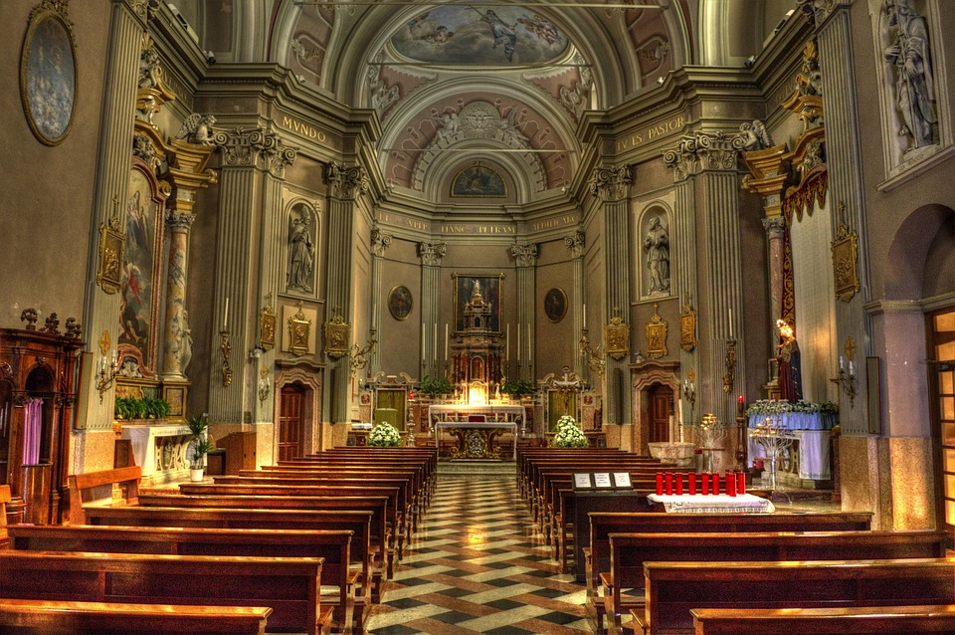
In an article within The Irish Monthly, dated March 1937, Brenda Duncombe, an Irish Catholic nun, provides a thoughtful and useful contrast stating that, “Defying an urge which is as old as human nature itself, it [Communism] declares that there is no need for religion, no necessity for worship; it ignores the existence of God. Why, then, do some hold that Communism is a religion? Simply because certain of its characteristics are similar to those produced by religious conviction. But intensity of feeling and devotion to a cause do not prove that cause to be a religious one.”³
It is an ironic twist that the devotees of Capitalism are, themselves, captivated by a set of abstract articles of faith such as the emancipatory power of the so-called free market, trickle-down prosperity, or that anyone and everyone could enjoy a higher standard of living if they just worked a little harder, gained more skills, and “pulled themselves up by their bootstraps.” These tenants of the abstract faith in Capitalism also include the ideological tropes that there are no viable alternatives to the Capitalist system, that Capitalism provides the superior pathway to freedom, and that somehow, in some mysterious way, Capitalism will eventually raise the global living standards to a point of relative economic equality. The evidence, of course, dispels these myths.
Religion works against the revolutionary class consciousness of those exploited by Capital in that it encourages a view of liberation that lies far off in the imaginary netherworld after death rather than a liberation gained and defended through revolutionary struggle and success in improving the material conditions of society for all people in the present. Faith in a better world after one’s death can dull revolutionary class consciousness and pervert the psychology of the proletariat.
In the introduction to Marx’s “A Contribution to the Critique of Hegel’s Philosophy of Right”⁴ there is an often-misinterpreted phrase which declares that religion “is the opium of the people.” Yet nowhere is it found that Communism serves the same function as a means of psychological comfort for the people within the suffering, injustice, exploitation, inhumanity, insecurity, and alienation of Capitalism. Communism, more specifically Marxism-Leninism, is not palliative but curative in that it removes the causes for which people turn to religion for solace. When Marx stated that “Religion is the heart of a heartless world, the soul of soulless conditions, the opium of the people” he was indicating the place and role that religion occupies in an oppressed people. That is, religion offers mental and emotional succor and hope, though a false one, to those who regard their conditions as mortally and temporally hopeless. Religion is a form of emotional and psychological booze or anesthesia.
Religion, however, was not, and is not, a solution to exploitation, misery, inequalities, and immorality of the Capitalist ordering of society. It was, and is, merely a means of emotional and mental comfort without giving the working class the ideology, the strategy, and the tools for their liberation. In this, Communism transcends religion as the way to real material salvation of humanity.
The power of religion over masses of people often incites anti-social behavior setting one sect against another, thus serves as an effective tool of the bourgeois ruling class for the alienation and division of the forces of the working class. Religion preserves archaic, discriminatory, prejudicial, and socially deleterious structures of authority and power which mirror those of the dominant political ideology and socio-economic orders where various religions are established. Simply stated, religion is an ideological tool in the hands of the ruling class as one means of manipulating and alienating the working class and preserving its hegemony over society. By contrast, Communism, as developed through Marxism-Leninism, is a tool in hands of the proletariat as the means of breaking the hegemony and the chains of Capitalism to effect real liberation and to build a new, just, free, and democratic Communist world community.
Any serious attempt of a sincere critical comparison of Communism with religion would soon reveal that these two social groups only have minor and coincidental things in common and are teleologically opposed and philosophically incompatible with each other. The epistemological and practical underpinnings of Communism concern material and scientific realities while those of religion are grounded upon legend, mythology, metaphysics, fantasies, and wishful thinking. The two philosophical tracks lead humankind to irreconcilable destinations.
The differences between religion and Communism could not be clearer.
References:
¹ Karl Marx and Frederick Engels, Collected Works, Volume 3 (Moscow, 1975), p 463
² https://www.thearticle.com/communism-as-a-religion
³ Brenda Duncombe, Communism and Religion, The Irish Monthly, Vol. 65, No. 765 (Irish
Jesuit Province, March 1937), pp. 155-160
⁴ https://www.marxists.org/archive/marx/works/1843/critique-hpr/intro.htm

Original article

