Major Iranian Allies Provided No Material Support During Conflict
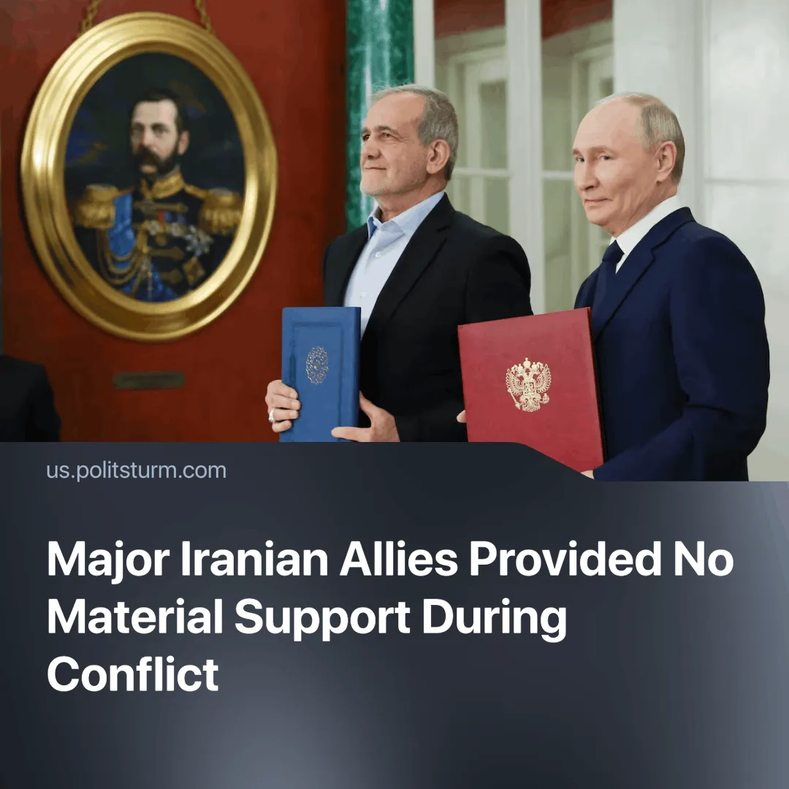

Original article
2025-06-29
1 min read

Russia and China condemned U.S. and Israeli strikes on Iran but offered no material support, marking Russia’s third consecutive defeat in the Middle East.
Details. Officials of Russia and China condemned the recent Israeli and U.S. strikes on Iran and called for a ceasefire to take effect.
► Russia’s UN Ambassador Vassily Nebenzia warned that U.S. strikes risked nuclear catastrophe. President Vladimir Putin said that U.S. involvement pushed the world “to a very dangerous line”.
► The PRC Chairman Xi Jinping declared, “If the Middle East is unstable, the world cannot be at peace”.
► Despite their proclamations, China and Russia have not been decisive in providing any material support for their ally.
Context. Even though Iran is a separate imperialist power in the region, its economy is severely dependent on China, as it buys around 90% of Iran’s oil exports and helped to build Isfahan’s nuclear site.
► Russia maintains close ties with Iran through transport, trade, and joint infrastructure projects. Both are members of the Eurasian Economic Union, with a 2025 agreement pledging joint military exercises and no support for an attacker of either party.
► This is Russia’s third major setback in the region. In 2022, Azerbaijan captured Nagorno-Karabakh, formally annexed in 2025. In 2024, Syria’s Russian-aligned Assad regime was overthrown.

Original article

