Iranian Push for Commodifying Education
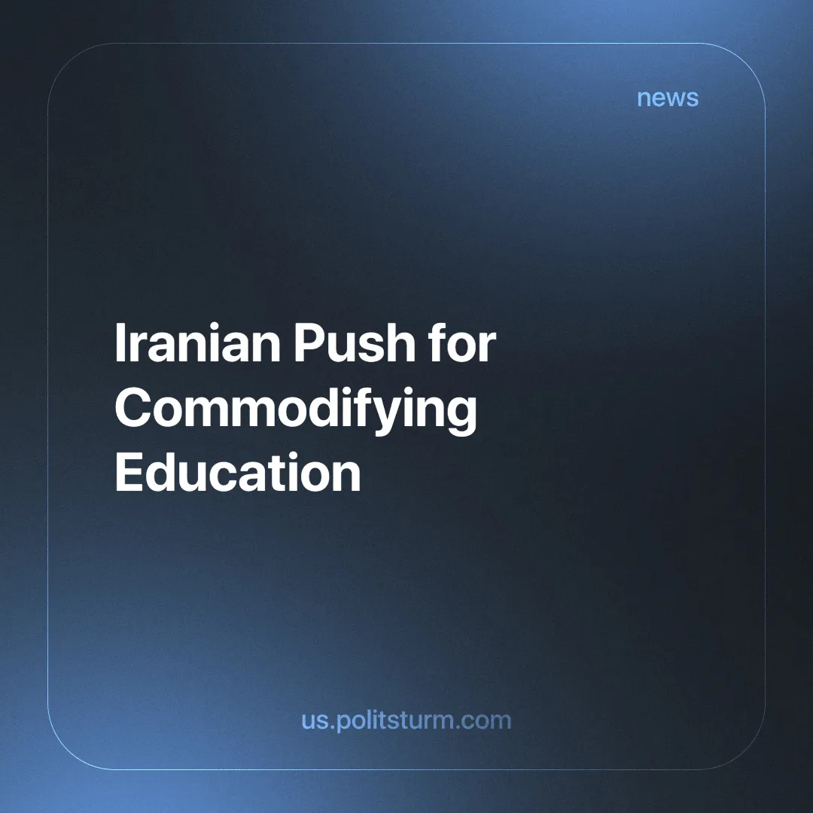

Original article
2024-10-24
3 min read

In his most recent speech in Tehran University, Iranian President Masoud Pezeshkian has once more exposed the hypocrisy at the heart of the ruling regime. Confronting a wave of protests by students, Pezeshkian resorted to nebulous appeals for "economic logic" and the business-like operation of foreign universities without addressing core issues. This is merely a smokescreen to blindside the people from what the government is trying to do: control and exploit the Iranian working class, enabling the enrichment of a small circle of elites [1].
The promotion of universities generating their own income in lieu of state funding by the president manifests the real priority of the government. They would like the youth – the future of society – to bear the costs of education and for it to become a commodity freely bought and sold. In this way, it becomes unreachable for people from backgrounds of lesser means. This is very frankly a renunciation of any commitment to free, high-quality education, and it shows how the regime is shamelessly disdainful of the welfare of its ordinary working citizens.
In tandem with Pezeshkian's remarks, controversial cases have surfaced that have caught the public's attention. A mother in Tehran who couldn't afford her daughter's enrollment fee was asked to clean classrooms as payment; in another case, a father from Khorasan Razavi province was told that if he couldn't afford the enrollment fee, he would also have to clean classrooms [2].
The commodification of education continues to emerge as one more instrument of oppression, despite free education supposedly being a right afforded by the (bourgeois) Iranian constitution. It is profoundly ironic that this regime, which is portrayed as one of sponsoring "liberation" from external foes (see our material: The Axis of Resistance) by some, demonstrates such haste in oppressing its people domestically. This rhetoric of resistance rings hollow; it only serves to further justify the regime's continued exploitation of workers while enriching the capitalists.
Iranian workers toil in very miserable conditions and for very low wages while absolutely reaping far less than the value they create for the capitalists. Instead, the results of their work are diverted to furthering a corrupt system that gives them crumbs in return. The government’s rhetoric on national development and empowerment is mere lies as they hold back development by making education less accessible while making the employment prospects for workers worse and worse.
With the deepening crisis of profitability, the capitalist class in all countries has besieged its own domestic working class. Therefore, the Iranian bourgeoisie has to cut the funding for education, sabotaging the future of working class youth and limiting their development. In this way they hold back the development of the country, clearly acting as a fetter on production and historic and social progress.
Furthermore, an over-educated, critical workforce is a danger to the monopolies, and by throttling education they hope to keep their grip on power.
This hypocrisy is fairly overt. While masquerading as the saviors of the country, Iran's ruling class is even now pillaging the natural resources of the land, repressing the proletariat, and reneging on its pledges for a better tomorrow for the populace. This is, of course, no accident; much like the rest of the capitalist regimes in the world, the regime in Iran is based upon a system fundamentally and intrinsically set up against the majority who get by with the sale of their ability to labor and for the benefit of the exploiting few.
While the socialist states have proved that quality education can indeed be provided and should be provided to every citizen collectively. They regarded it as not a commodity but a fundamental social right of the people, which socialist systems have historically upheld. In the USSR, German Democratic Republic, and other socialist countries, it was considered a means of democratization for the working class – the method by which all citizens would and could have contributed to, and benefit from, the collective development of society.
These socialist states understood that education is not a purely individual benefit but a social one. They invested labor-time into the production of free (at the point of use) education to ensure the fruits of social production, produced by the common effort of the people, would be distributed among all.
Degrading the working class through the denial of education by the Iranian bourgeoisie underpins the deep contradictions within a regime claiming to resist imperialism. A contradiction that could only be resolved by the working class, the only anti-imperialist class in our epoch, through its vanguard party. Help us constitute such a party: Join Politsturm!
Sources:
[1] Iran International – "Iranian President faces protests at Tehran University, avoids key issues" - October 13, 2024
[2] EtemadOnline – "Repeating the sad tragedy of school cleaning by parents this time in Tehran and Taibad" - October 19, 2024.

Original article

