Interview with the General Secretary of the CP of Sweden
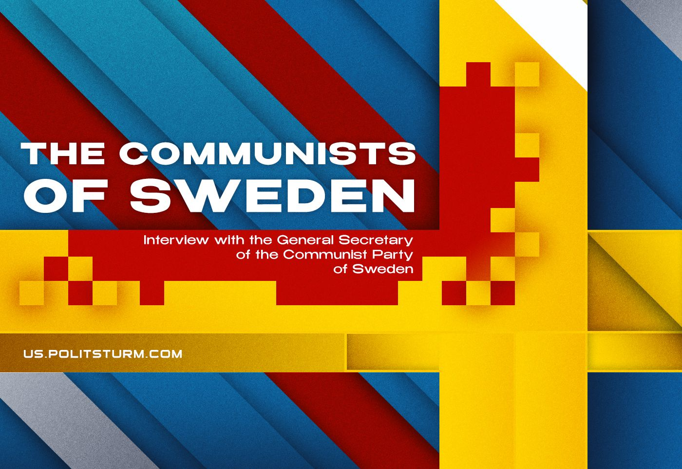

Original article
2023-12-25
34 min read

We present an interview with Andreas Sörensen, the leader of the Communist Party of Sweden. Previously we published many of his articles on current issues of the international communist movement. This interview touches on the history of the Swedish communists, current work and the challenges the communists face at the present time.
Politsturm: The history of the communist movement in Sweden remains little known to communists in other countries. Historically, several organisations bore the name "Communist Party of Sweden". Could you describe the highlights of your organisation's history?
Andreas Sörensen: We have a very long history, dating back to 1917 when the first revolutionary socialist party was created in Sweden. This occurred against the backdrop of the October Revolution and the First World War, which forced contradictions to a head.
After the split (from the “Swedish Social Democratic Party” – PS), the newly formed “Socialist Left Party of Sweden” went through more than a decade-long process of Bolshevization – the party split again in 1921 when it joined the Comintern and adopted the name “Communist Party of Sweden”, and then again in 1924, and in 1929. During these splits, most of the leading cadre left the party and in one way or another ended up back in the Social Democratic Party.
When the last split, in 1929, was completed, the party assumed a leadership position within the strike movement, but the momentum of the party slowed down after the 7th Congress of the Comintern when the strategy and tactics of the communist movement were changed, which in turn changed the focus of the communist parties in the world.
During the second half of the 1930s, the SKP played a leading role in the solidarity movement with Spain, but never managed to do this from a purely revolutionary position but from a compromise position resulting from the goal of building a popular front, with the result that the support that had been built during this time evaporated when contradictions sharpened in the beginning of the 1940s.
The war never came to Sweden, but the communists still faced repression. Thousands of communists were jailed and put in concentration camps; raids were conducted against communist party offices; an attack against the press office of the party resulted in five people dying in Luleå; the newspaper of the party faced a near ban and a ban against the party was prepared but never enacted.
Coming out of the war, the party rode on the wave of the Soviet victory in the war and achieved its best electoral results ever in 1944-45 and led its last major strike – the Metal Workers’ Strike of 1945, which was sabotaged by the social democrats.
When the change in the strategy and tactics of the communist movement was carried out in 1934-35, it set a new course for the communist parties of the world and opened the door to their adaptation to capitalism – of course, as we highlight in our pamphlet The Communist Movement in Sweden during and after World War II, this was not the only factor, but it was an important one. Continuing on this path, the previously revolutionary party eventually adopted a Eurocommunist position and in the 1960s changed its name to the “Left Party Communists”.
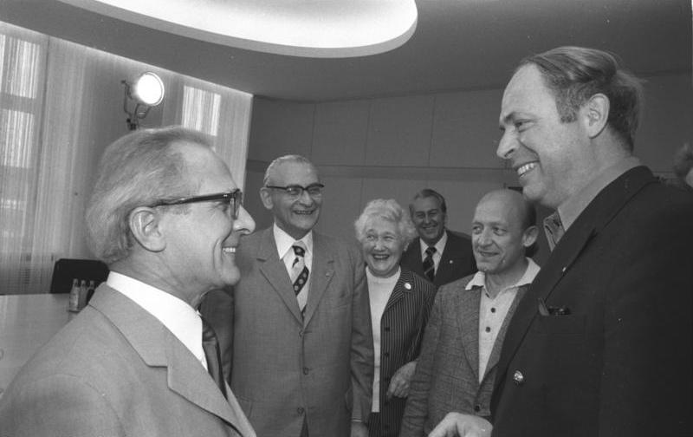
Lars Werner, chairman of the “Left Party Communists” from 1975-1993, meets Erich Honecker during a visit to East Germany in 1974.
While the Maoist opposition later disbanded, the Marxist-Leninist opposition stayed and in 1977 re-established the communist party in Sweden, under the name of the “Workers’ Party Communists”.
During this time, the name “Communist Party of Sweden” had come out of use by Marxist-Leninists and was open to use, which the Maoists did. For a period during the 1970s and 1980s, the name “Communist Party of Sweden” was used by the Maoist movement in Sweden. However, as they disintegrated during the 1980s, they stopped using the name and in 1995, after the “Workers’ Party Communists” had fought an inner-party battle against opportunism, the name “Communist Party of Sweden” was once again adopted by the revolutionary party – the “Workers’ Party Communists” became the Communist Party of Sweden of today.
Politsturm: As you said, your organisation was created as a Marxist-Leninist breakaway from the former SKP in the 1970s. After the latter renamed themselves as the “Left Party”, this name was taken by the Maoists. Why did your organisation decide to call itself SKP, even after this name was used by different deviations? Plus, as we know, there is another organisation in Sweden calling itself the “Communist Party”, which has been criticized by your organisation.
Andreas Sörensen: The name “Communist Party of Sweden” is important for several reasons, none of which are cancelled out by the usurpation of the name by the Eurocommunists or the Maoists.
It was the Communist Party of Sweden that led the creation of a revolutionary party during the 1920s, and through which eventually a revolutionary vanguard was able to be formed. It was the Communist Party of Sweden that led the workers in their most active and militant period, during the 30s. It was the Communist Party of Sweden that was at the forefront of the opposition to fascism and it took a militant stance against militarism and cooperation with the Nazis during World War II. Despite the errors and attempts to drag the name in the dirt, the name carries both a historical and contemporary meaning that can hardly be conveyed in a better way.
We are also not afraid of the past. We analyse the mistakes and successes of our predecessors, and we learn from them. By retaining the name Communist Party of Sweden, we make it clear that we aim to take responsibility for the entire history of the communist movement in Sweden.
It is correct that there exists another party calling itself simply “The Communist Party” (which emerged from Maoist “KFML” split from the first CP of Sweden and was known as “Communist Party Marxist-Leninists (Revolutionaries)” between 1977 and 2005 – PS). However, one should not read too much into a name; as we know, parties may be communist that do not officially call themselves communist, and parties that call themselves communist, may in reality be everything but communist. What they choose to call themselves is not our problem, in the end, the people will know the difference.
Politsturm: How do you assess the state of the SKP at the current time? What successes and challenges can you highlight in your organisation?
Andreas Sörensen: There is no hiding that we are a small party, quantitatively speaking. At the moment, we lack influence within the workers’ movement and we cannot decisively affect the direction of the class struggle.
However, what we have done in the last couple of years is to realign some aspects of the party activity. We place great emphasis on our studies, and we require all prospective members to attend two courses in Marxism-Leninism, one basic and one advanced. This has certainly raised the level of our members and also attracts more serious new members.
In turn, this has laid a good foundation for a more solid organisation that is increasing its discipline and work, which has bore fruit – we have re-established our youth organisation and in the last couple of elections, we have continuously increased our share of the vote, albeit we are still on a very small level.
In our particular corner of the world, we face a very solid anti-communism that is entrenched among the older generations. This is not necessarily the case among younger people, who do not hold the same prejudices about communism and socialism. In combination with a general apathy towards politics and one of the most individualized populations in the world, our work is slow and we face challenges breaking through to people.
Politsturm: How active is the labour movement in Sweden? What tactics do you use to engage with workers, support their struggle and attract potential members to your party?
Andreas Sörensen: The labour movement in Sweden is generally very passive. The Social Democrats are in complete control of it and they have not been effectively challenged in decades, for a variety of reasons, some of which are mentioned above. This has allowed them to form the conception of what a labour union is, which permeates a large portion of the working class - when the labour union is a vehicle for compromise, and thus a vehicle for capital, apathy tends to spread and the movement becomes disorganised. Many people have no experience of labour struggle and leave their problems in the hands of the hired professionals of the union.
There are some shining exceptions to this, of course, such as the train drivers in Stockholm, who went on strike for three days this spring, in spite of opposition from their union.
Our tactics are briefly outlined in our party programme, where we point out the need to set the bureaucracy to the side through struggle - it is not possible for us to struggle against the domination of the union bureaucracy and the reformist domination in the unions using their own structures and methods; we see a need to create new spaces for the organisation of the workers, which at this point in time does not mean separate unions, but rather forms of struggle committees.
We are working on coordinating the activity of party members and sympathizers within the different unions so that we can more effectively intervene in the struggle.
Our work as of yet is in an embryonic form, but we have seen some successes and we build on the previous work of the party, which could boast active workers’ committees in several industries.
Politsturm: How would you characterize the modern left movement in Sweden? Which views are dominant and which organisations express them? Which organisations are most dangerous for communists?
Andreas Sörensen: The left in Sweden is in its very essence reformist and opportunist. It comes from a long tradition of adaptation towards social democracy and capitalism, and it has not been able to break this hold. To understand this, we need to go back in time, to the 1930s.
When the 7th International Congress of the Comintern was held in 1935, the international communist movement found itself with a new strategy and tactics; it was now to seek cooperation with social democracy, where it had previously attacked it; the capital was divided into good or bad, that is fascist and democratic and the idea of stages, such as advanced democracy or anti-monopoly democracy, on the road to socialism was (re)introduced. These changes – and many more, as well as changes and developments in capitalism – in effect redirected the communist movement, and set it on a path to adapt to capitalism, and one can easily trace the central problems of the communist movement to these ideas.
Why do I bring this up? Because these ideas are still central in the world-view of the left.
All organisations on the left seek the broadest possible cooperation in almost every issue – be it opposition to NATO, solidarity with Palestine or political work against austerity. These broad alliances create problems, insofar as they necessitate compromises, which in turn requires the leftists to tone down their potentially revolutionary ideology and adapt it to a minimum programme in every instance. This is why we have chosen to not be a part of the general protest movement against NATO, instead organising our own protests.
All organisations on the left will in some form or another struggle for stages, effectively postponing the struggle for socialism. The object of their struggle may vary – for some, it is necessary to disengage from the EU to be able to talk about socialism, while for others, it is necessary to get rid of the right-wing government to be able to talk about socialism. These stages fill the same function as the struggle for advanced democracy or anti-monopoly democracy, as they all shift focus away from the struggle for socialism and they all open the door to the popular or united fronts, which in turn necessitates unity around a minimum programme.
All organisations on the left will in some form or another work to tie the working people to the big parliamentary parties. Some organisations work as fractions within the Left Party, thus giving them a very strong alibi and showing people that you indeed can count yourself as a revolutionary and still be a part of the Left Party. Other organisations are separate, but in every election, they will give active or passive support to the Left Party – either by claiming that you should “vote against the right-wing” or that you should strengthen the leftist voice within parliament.
There is no real difference between the various organisations of the left in these manners – whether they count themselves as reformist, Trotskyist or Marxist-Leninist, they will objectively espouse the same ideological tenets.
As for the most dangerous organisations, we will have to maintain that the Social Democrats, which still tie a significant portion of the working population to capitalism, and thus constitute an important factor in its social support, as well as the Left Party, which acts as a radical alibi to social democracy and keeps the left front of capitalism intact, are the most dangerous organisations.
With the help of both the Social Democrats, who were in government, and the Left Party, the right to strike was heavily curtailed a couple of years ago, and employment security was eroded. All of this was justified by them saying that it would have been even worse, had the right wing been allowed to carry out the attacks! If these parties are not a real danger to the working people, I do not know what is.
Politsturm: You talked about the Left Party and their broad structure, the Social Democrats and the theory of "stages". But what about other deviations? How strong are Trotskyists, Maoists, etc.? Do they pose a threat to your work?
Andreas Sörensen: No, they do not pose a threat to our work. Most of the Trotskyist parties are centred around their newspapers, which receive significant support from the bourgeois state, and they are members of the Left Party. The Maoist groups exist either online and engage in ideological discussions on the merits or demerits of Gonzalo, or they dress up in black and play revolution. None of these parties attempts to engage with the masses, but in a very sectarian manner isolate themselves from ordinary people.
“The Communist Party” is the biggest formation on the more radical side of the political spectrum, but they experience several problems. Up to 2018, a far-right faction was able to form within the party, which adopted a far-right position on immigration, the state and the police, to name a few examples. In 2018, they left the party (they were never excluded, but until the end, most members sought to unite the party and disregard the ideological and political differences), taking with them a significant part of the more active cadre.
This event, which I hesitate to call split, because no one actually split, was reflected in the following election, where the electoral results of the party halved. During this process of renewal, the party also adopted a new party logo, removing the hammer and sickle.
The next big problem that they face is that the state support to their party paper, which amounts to around 300 000 Euros per year, risks being cut, as new rules are to be applied.
So no, we do not regard these parties and organisations as threats, as we have radically different goals and methods; we are interested in organising a communist party for the revolutionary overthrow of capitalism, while they are not.
Politsturm: Sweden's accession to NATO is now a matter of time. What is the reaction of the Swedish people to this event? What positions do the various left-wing forces take on this issue?
Andreas Sörensen: Before the Ukrainian crisis, the majority of Swedes were against entry into NATO, but after the outbreak of the war, those favouring a Sweden outside of NATO found themselves in a minority position, not the least because of the intensive pro-NATO propaganda that was conducted. As of now, around two-thirds of the population wants to join NATO.
In one way or another, most groups to the left of the Left Party oppose membership, albeit in different ways. In the same manner, as described above, all of them focus on organising as broad a coalition as possible against a membership, which results in a very watered-down movement. This leads to an idealization of Swedish neutrality, where many people favour a return to neutrality as if Sweden has ever been neutral – there were very tight relationships with the British and American intelligence and military during the entire “neutral” period. In turn, this suggests an illusion about the possibility of neutrality under capitalism, as if it was possible for certain countries to stand apart from the imperialist contradictions that ravage the world.
In addition to this, opportunist slogans have been rampant, and a popular one has been “No to an alliance with a fascist”, referring to the Turkish president Erdogan. This gives the impression that it would have been fine to enter NATO, had Erdogan not been president of one of its member countries, which in turn completely hides the nature of capitalism, imperialism and NATO.
For these reasons, we have chosen not to take part in the movement against NATO and to organise our own protests.
Politsturm: The conflict in Palestine, which erupted in early October, continues to capture the attention of people around the world.
On the one hand, we see a denial of the existence of Palestinian civilians. “They are all militants, these are the usual excesses of war” – the IDF says. This war turned into the destruction of the civilian population of Gaza by the IDF under the pretext of fighting the Islamists. At the same time, as it now turns out, Hamas was supported by Israel itself in order to fight against the Palestinian movement for independence and split it.
At the same time, it seems that a number of communist parties, for various reasons, ignore the role of Hamas as the initiator of this incomprehensible “raid”, as an organisation that has received support for decades from Iran, reactionary Middle Eastern monarchies and from Israel itself.
Should communists differentiate between support for the Palestinian independence movement and support for Islamists? How to avoid falling into the trap of supporting a “lesser evil”, just as some leftists once supported the Taliban’s victory in Afghanistan under the pretext of their supposed progressiveness and "national-liberation struggle" in the fight against “American hegemony”?
Andreas Sörensen: In our policy on Palestine, we have not condemned Hamas, nor do we intend to. We do not wish to shift focus to individual representatives of the bourgeois classes of respective countries; we do not blame Putin or United Russia for the events in Ukraine or George Bush and the Republicans for invading Iraq, but we view it as central to point to the interests that underlie the way in which the different political factions act.
The Palestinian population is oppressed ethnically, and our primary concern is the solution to this problem. In this situation, we are not interested in discussing which bourgeois political forces are the best representatives of the Palestinian nation.
Therefore, our party has adopted the position of returning to the borders of 1967, for the reason that this is the most reasonable way to reduce nationalist tensions in both Palestine and Israel because we are convinced that these nationalist ideas are ultimately in the way of the struggle for socialism, and that nationalism and the struggle for socialism cannot be combined.
Of course, we do not support Hamas, which as an organisation of course represents a section of the Palestinian bourgeoisie. It is also ideologically distant from the communist movement. What we do support is the armed resistance against the occupation, and we support the struggle of the communists in the region to achieve a leading position in it; we support the struggle of the Palestinian people for their land and their right not to live under occupation; we support their right to their own land.
It is true that some communist parties fall into the trap of supporting Hamas, as they have incorporated the idea of the “lesser evil” but also a relativism, in regards to the ways in which people organise their resistance. To avoid this trap, it is necessary to focus on the study of ideology, to get a good and solid grasp of the ideology and politics of Marxism-Leninism, as well as its practice, as this is the only way to avoid traps such as these.
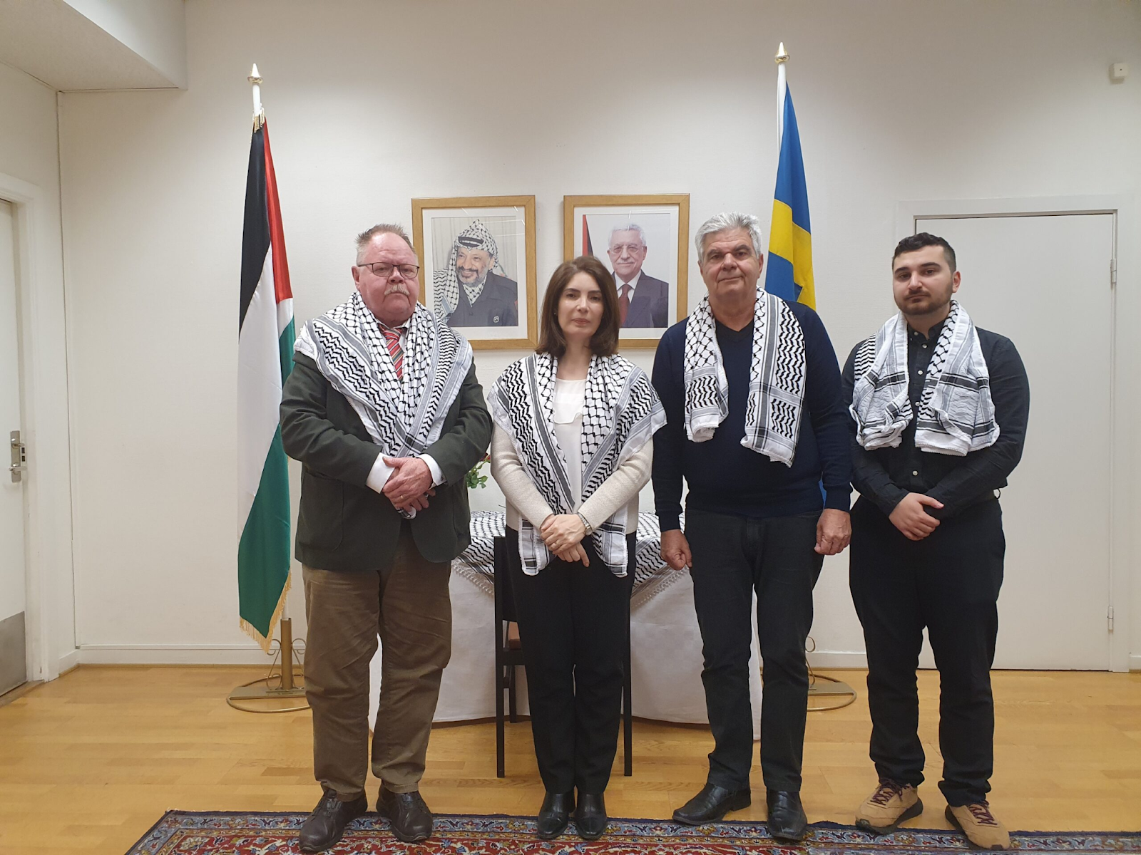
A delegation from SKP and SKU visited the Palestinian embassy in Stockholm in November to express their solidarity. From left to right: Per-Olof Jönsson, Ambassador Rula Al-Mhaissen, Panos Alepliotis and Martin Tairi. Source: Riktpunkt.
Politsturm: Speaking about focus: can you explain the reasons for not showing the responsibility of certain political forces and leaders? Historically, the communists, besides attacking capitalism as a whole, did not hesitate to directly name the culprits of the events: during WW1 the Bolsheviks condemned Nicholas II and tsarism, the German communists denounced the Kaiser, and during WW2 the Comintern called Hitler and Mussolini aggressors, without ceasing to denounce imperialism and the interests of the Anglo-French capitalists.
Andreas Sörensen: If we submit to criticism, such as this, that focuses on the politicians, we open the door to alternative politicians. If the Kaiser or the Czar made individual mistakes, then surely, they could be replaced and mistakes could be avoided in the future?
If we focus on Hamas, or the Likud party, and hold them responsible, we open the door to other alternative capitalist administrations, be it Fatah or the Yesh Atid party in Palestine and Israel, respectively.
However, by focusing on the occupation, it becomes clear that this is a problem that exists beyond this specific war, horrible as it is, and that the situation cannot be solved by a change in government on either side.
As communists, we are interested in the systemic aspect, in the underlying causes. We risk being stuck in particularities, not seeing the forest because of all the trees, if we are not careful.
When we intervene in a Swedish political context, we are always very careful not to place the blame on the current government as such. This would give fuel to the idea that another government would act in another way. Instead, we condemn the acts in themselves, but we are very careful to show that they are part of the strategy of Swedish capital and not the ideas of a given government. Is the right-wing coalition that right now rules Sweden more responsible for the attacks on the people than the previous, left-wing coalition led by the Social Democrats? For us to condemn the governments in and of themselves is meaningless, we want to show whose errands they run, and who they represent.
Politsturm: Indeed, despite the bombing of the population of Gaza by the IDF, it was Hamas that began the escalation on October 7. How do you assess their “Al-Aqsa Storm” operation and how do you feel about it?
Andreas Sörensen: It is very difficult for us to assess it. We are not aware of the goals that they had nor of their capabilities to resist. We do not know if they anticipated the Israeli reaction or not, nor do we know what their original goal was. As I mentioned earlier, the fog of war is slowly lifting and new information is coming to the surface daily, which eventually will give us a better opportunity to look objectively at the operation of Hamas.
Because of the constant barrage of propaganda pushed through bourgeois media, it is very difficult to arrive at a definite conclusion, which is why we do not attempt to do it at this time. We say that the Palestinian people have a right to armed self-defence, and we support their resistance against the occupation and colonization.
Politsturm: In the end, one can say that all the peoples are now oppressed by capitalism, and we can highlight progressive and reactionary forces in every country. Couldn't such tactics lead to support for any "anti-occupation" movement in any situation and discredit the communists? What do you think?
Andreas Sörensen: We can not only highlight progressive and reactionary forces in every country, but we also distinguish between classes in every country, be it at the top of the imperialist pyramid, or the bottom. To consider a people, as such, to be oppressed opens the door to a reconciliation between the classes within a given country, and rejects the class interests of the various classes within that country. In turn, this opens up the idea of “stagism” – that is, first we must reach this given stage, and after that, we can discuss socialism. This will, indeed, discredit the communists.
In the very specific situation in Palestine, our analysis is that the nationalism of both sides is harmful to the struggle for socialism, and needs to be done away with. In this struggle, we do not say that everyone is an ally, who opposes the occupation, but we say that the struggle against the occupation must be connected to the struggle for socialism, and it must be connected to the struggle of the Israeli workers for socialism as well. The struggle for socialism needs to be the top priority of a communist party, and all other questions must be subordinated to it, and a political struggle against reaction, opportunism and reformism will of course be necessary in Palestine and Israel as well.
Politsturm: As you know, the problem of migrants in Sweden is one of the key issues on the country's political agenda. How does your party feel about this problem? In a situation where the right-wing parties are striving for power, are you accused of supporting Hamas and Islamist terrorism?
Andreas Sörensen: We do not see migrants as a problem, but the current conservative government paints them out to be. Harsh measures have been put into place to restrict the rights of migrants in Sweden, and repression has been stepped up. This continues the trend from the previous social democratic government, although it has intensified.
We see this as a big problem, as it divides the working class in Sweden into two camps: native and migrant. When one sees the other as the enemy, it makes it more difficult to unite on a class basis. This is why we have rejected every repressive action taken by the government and we have repeatedly stated our solidarity with not only migrants but with refugees fleeing imperialist war and poverty created by capitalism.
As far as I know, we have not been accused of supporting Hamas, nor have we been accused of supporting Islamist terrorism. However, this accusation is dealt out by the right-wing parties against the Social Democrats, in an attempt to discredit them.
Politsturm: At the end of October, the “Meeting of Communist and Workers' Parties” was held in Izmir, Turkey.
Your party, as a member of Solidnet, also took part in it. From the published materials and resolutions, one gets the impression that the “Marxist-Leninist pole” is giving in to the social-chauvinists, who have been organised into their “World Anti-imperialist Platform” for a year now and are imposing compromises on the most important issues, which is manifested in the vagueness of the final statements and the “Plan of Action”.
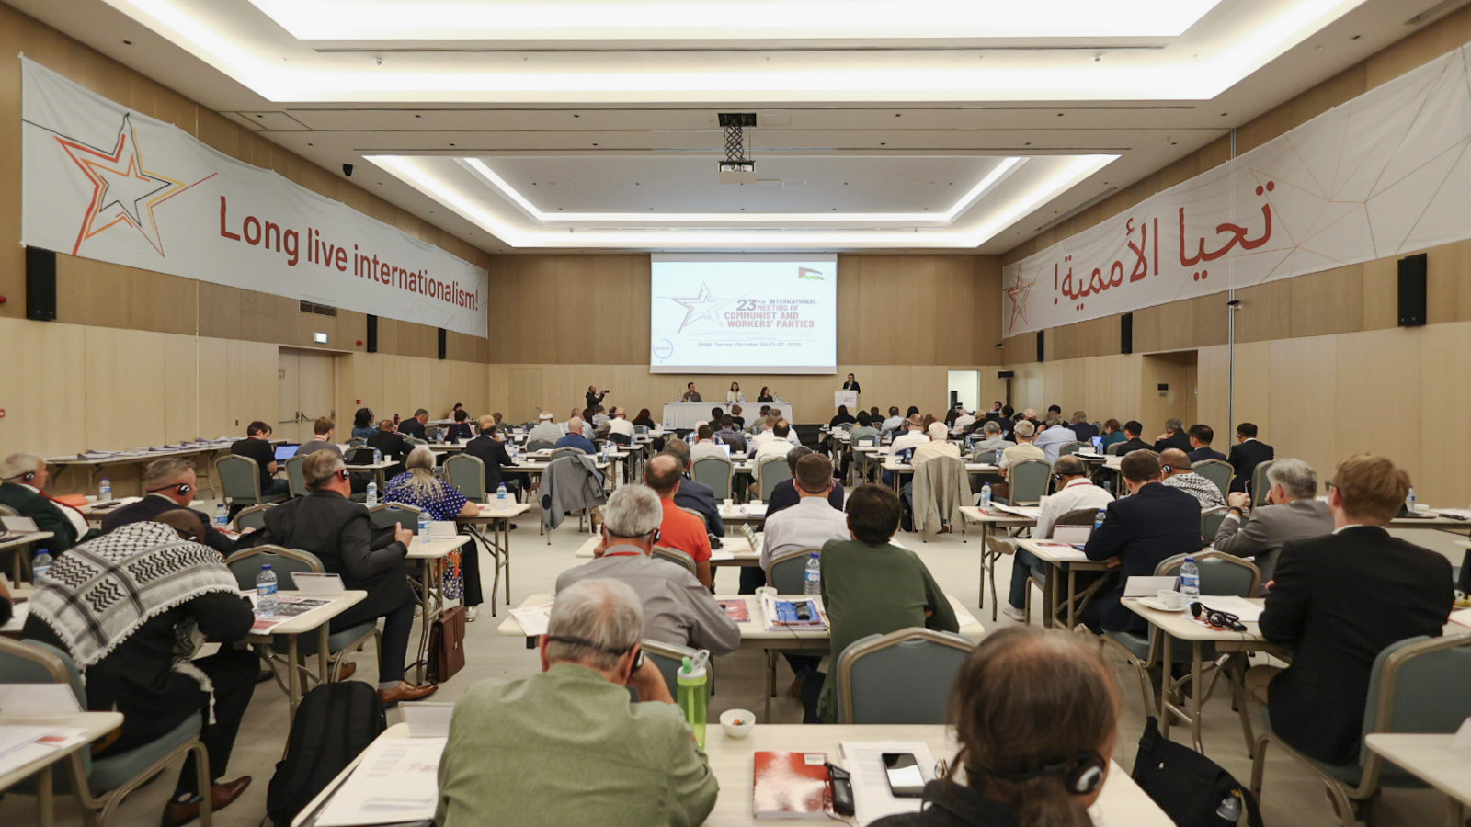
“23rd International Meeting of Communist and Workers Parties” in Izmir, Turkey
What do you think is the reason for such passivity? What measures must be taken to successfully combat opportunism and social-chauvinism, to revive and strengthen the international communist movement?
Andreas Sörensen: One has to be aware that there is a struggle within the international communist movement that has been accentuated by the events in Ukraine. This event has been the catalyst for an intensified struggle, but we must recognize that behind this, lie huge ideological differences that can be traced back for decades.
The creation of the World Anti-Imperialist Platform is a sign of the intensifying contradictions and is an attempt to gather the opportunist parties in the world, who have rallied to the support of Chinese and Russian imperialism and who espouse reactionary ideals on multipolarity and anti-imperialism, completely cut off from anti-capitalism.
On the other side, the revolutionary parties are organising themselves as well, such as in the European Communist Action, which I will discuss in the next question.
Between these two poles, are a number of parties who do not wish to choose a side, who champion unity and who want to avoid a confrontation. As with every ideological struggle, there is a centrist group, who try to mediate.
All of this is also manifested within the international communist movement, and it is highly present in events such as the meeting in Izmir. Of course, documents such as the Action Plan will reflect these tensions and are formulated in such a way as to cater to all sides – for example, the Action Plan states that all parties should “oppose imperialist wars”, leaving it up to each party to define what it considers an imperialist war. This does not constitute a surrender to opportunism.
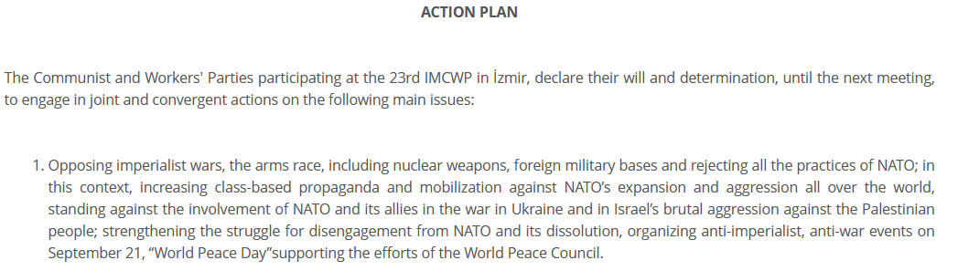
The first point of "Action Plan", adopted during the 23rd "Meeting". Source: SolidNet.
We must instead see meetings such as these as an arena of ideological struggle, which becomes evident when one looks at the speeches of for example the Communist Party of Mexico, the New Communist Party of the Netherlands, and the Communist Party of Greece and the speech held by the representative of our own party, to name a few. In these speeches, and in others, there are clear criticisms of the opportunist positions taken by some other parties, which call themselves communist.
This is also how it has to be. We do not categorically refuse to participate in elections under capitalism, as it would deprive us of an arena of struggle, and we do not categorically refuse to participate in events where opportunists are present, for the same reason. We criticize them and call them out on their opportunism, and we never concede to their positions.
Apart from absolute ideological clarity, or at least striving for this clarity, is the organisational strength of the revolutionary camp, by strengthening the bonds between the revolutionary parties and to strengthen the multilateral cooperation between them, which was done by the formation of the European Communist Action in Athens.
Politsturm: Naturally, no one denies the ongoing struggle, as well as the need to use different platforms for Marxist-Leninist campaigning. However, general words are not enough to win. When, in your opinion, should the moment of decisive disengagement with the opportunists and social-chauvinists come? When should the communists start naming things and organisations as they are?
Andreas Sörensen: It is very difficult to foresee the developments that the international communist movement will find itself in, and therefore, I cannot say when the moment has arrived.
If we look at the history of the European Communist Initiative and the founding of the European Communist Action, we can clearly see that the struggle between the revolutionary parties and opportunism could not be developed within the framework of the former, but had to be continued in the latter. The inner-party struggle in most of the opportunist parties was over and had been won by opportunism, and nothing was to be gained by cooperating with them. A decisive disengagement was necessary.
Looking at the international movement, we see that in several parties, such as the Brazilian Communist Party, there is still an inner-party struggle and the outcome is not yet decided. This is why international meetings, such as the one in Izmir, still have to be viewed as an arena for a struggle against opportunism. In this struggle, the communist parties have certainly named things as they are, as evidenced by the speeches made by the parties I referred to above.
It is not enough to criticize harshly, it is also necessary to support the positive forces in a given party and country, and our estimation is that at this given moment, this can be done through interventions in these international meetings.
Politsturm: On November 18, in Athens, at the initiative of the KKE, the founding conference of the “European Communist Action” was held, designed to replace the “European Communist Initiative”, created 10 years ago and dissolved in September of this year. Your organisation also participated in the EСI and is now declared among the participants of the new association.
In your opinion, what are the reasons for the failure of the ECI? Are there any guarantees that the ECA will not repeat the fate of the ECI?
Andreas Sörensen: First, I want to make clear that I do not regard the European Communist Initiative as a failure; it has provided very important lessons, it has allowed for a further consolidation of the revolutionary parties and it has allowed for a further development of many of the participating parties in a positive direction. Of course, there have been fewer positive developments as well, but on the whole, we must regard the experience of the ECI as positive, and on the lessons that we have derived from it, we can further strengthen our cooperation. However, nothing is ever guaranteed, and it would be dishonest for me to say that the European Communist Action is completely guaranteed to succeed in every way.
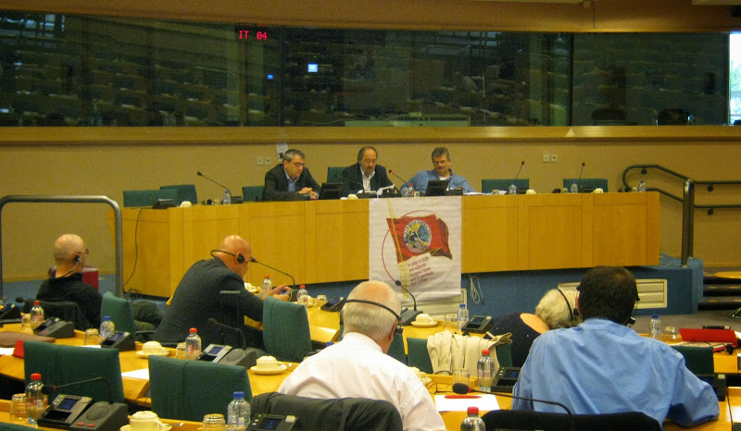
The founding meeting of the ECI, October 2013. Source: “INITIATIVE”.
We have to be aware that bourgeois society will push its ideology onto the communists and their parties at all times, both directly and indirectly. It is difficult to live in a society and not be affected by it. This is why we put such emphasis on ideological studies, and this is why there is a constant risk that a given party will be affected by bourgeois ideology in various ways, because of this, we have to give bourgeois ideas and ideology constant battle, which is one of the main objectives of the ECA.
I think it is more fair to talk about the experiences of the ECI in terms of the parties that did not succeed in establishing and consolidating a revolutionary line, than to talk about the parties that failed, so to speak. In these parties, the problems of opportunism were never dealt with, and the level of discussion and analysis often remained shallow. These parties never practised criticism and self-criticism. This allowed bourgeois ideas to flourish and gain a strong foothold, and once established, many parties completely succumbed to them. I talk now about ideas such as “multipolarity”, the ideas of stages on the road to socialism or false ideas about market socialism.
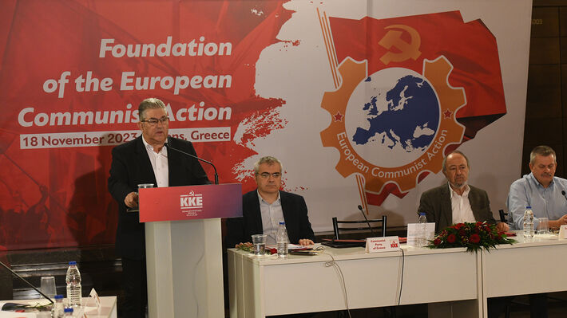
KKE’s General Secretary at the founding meeting of the ECA, November 2023. Source: KKE.
These parties, many of whom have now joined the World Anti-Imperialist Platform, are not part of the new ECA. If anything, the demarcation line against opportunism has been made more clear by the founding of the ECA and the parties that constitute the new organisation all stand on a solid revolutionary foundation, which is something that speaks for the ECA – but I cannot say that it guarantees anything.
Politsturm: Thank you for your responses. They helped clarify the position of the SKP on many issues. In conclusion, what would you like to wish our readers in Russia and other countries?
Andreas Sörensen: It is very important for us to keep in close contact with parties and organisations that are close to us, so I would also like to thank you for the interview.
We know that the situation in Ukraine and Russia is very dire for the revolutionaries and that the pressure on the communists weighs heavily. We have great respect for the comrades who refuse to adapt their positions, and who continue to hold the banner of socialism-communism high, and we are inspired by their character and perseverance.
In the rest of the world, a development in the same direction is taking place, and as the imperialist contradictions sharpen, the principled stance and struggle of the communists will become more and more important; we hope that through ideological and practical struggle, we will be even more ready to face the sharpening class struggle, and we hope that the readers of these articles will be strengthened in their conviction that the only solution lies in socialism and that they will act accordingly.

Original article

