International Workers' Day 2020
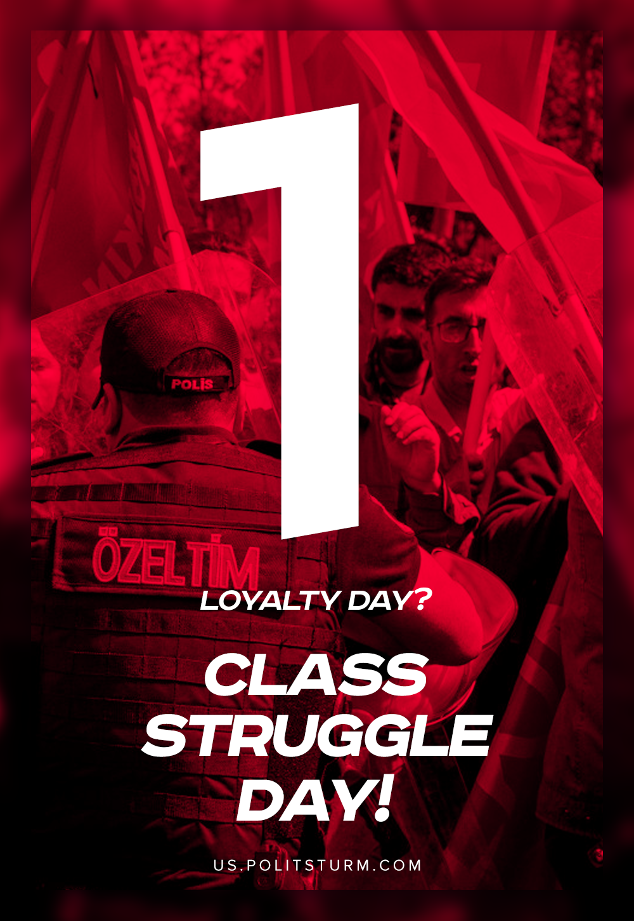

Original article
2020-05-01
1 min read

Comrade workers! May Day is coming, the day when the workers of all lands celebrate their awakening to a class-conscious life, their solidarity in the struggle against all coercion and oppression of man by man, the struggle to free the toiling millions from hunger, poverty, and humiliation. Two worlds stand facing each other in this great struggle: the world of capital and the world of labour, the world of exploitation and slavery and the world of brotherhood and freedom.
On one side stand the handful of rich blood-suckers. They have seized the factories and mills, the tools and machinery, have turned millions of acres of land and mountains of money into their private property. They have made the government and the army their servants, faithful watchdogs of the wealth they have amassed.
On the other side stand the millions of the disinherited. They are forced to beg the moneybags for permission to work for them. By their labour they create all wealth; yet all their lives long they have to struggle for a crust of bread, beg for work as for charity, sap their strength and health by back-breaking toil, and starve in hovels in the villages or in the cellars and garrets of the big cities.
But now these disinherited toilers have declared war on the moneybags and exploiters. The workers of all lands are fighting to free labour from wage slavery, from poverty and want. They are fighting for a system of society where the wealth created by the common labour will go to benefit, not a handful of rich men, but all those who work. They want to make the land and the factories, mills, and machines the common property of all toilers. They want to do away with the division into rich and poor, want the fruits of labour to go to the labourers themselves, and all the achievements of the human mind, all improvements in ways of working, to improve the lot of the man who works, and not serve as a means of oppressing him.
Vladimir Lenin, “May Day”

Original article

