Industrial Production Suffers Largest Decline in History
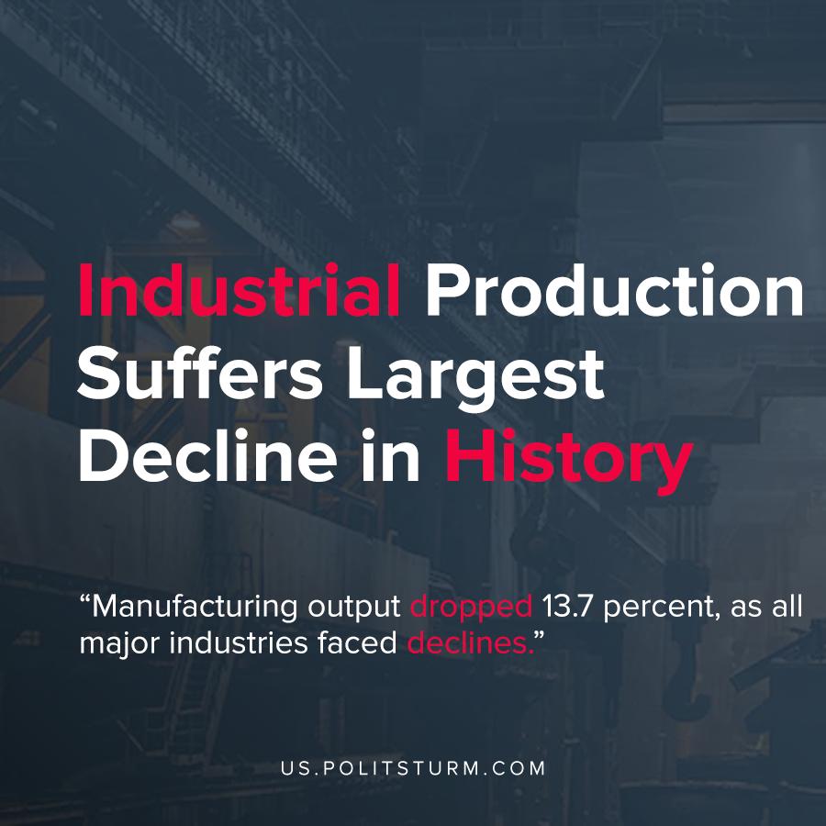

Original article
2020-06-02
1 min read

The U.S Industrial Production index experienced its largest monthly decline in it’s 101 year history, according to data released by the Federal Reserve. Industrial output dropped 13.7 percent, as all major industries faced declines.
Automobile and automobile part production fell 70%, whereas general manufacturing output fell 10.3%. Manufacturing capacity utilization stood at 64.9%, lower than the previous all-time low set in 2009.
The statistics demonstrate that the decline in production was generalized across all sectors of the U.S. economy. Capitalist production, in contrast to socialist production, is subject to generalized overproduction of commodities that paralyzes production roughly every 10 years.
In addition to the coronavirus pandemic and protests over racial injustice, the U.S economy is reeling from a decennial crisis of overproduction. The working class is subject to the negative repercussions of the capitalist crisis, including record unemployment.
In the struggle of competition, capitalist firms produce commodities and sell them on the market in order to maximize profit. There is no societal plan that regulates production according to social needs, and thus both the possibility and inevitability of a generalized crisis of overproduction arises. However, the wave of bankruptcies, the lowering of wages for workers and the destruction of commodities are all countervailing factors through which recovery can begin and the irrational cycle begins anew. The working class, guided by a proper understanding of Marxist-Leninist theory and principles can put an end to cyclical crises of overproduction and the social problems that accompany them.

Sources: 1 , 2

Original article

