Both India and Pakistan Declare Victory as Ceasefire Begins
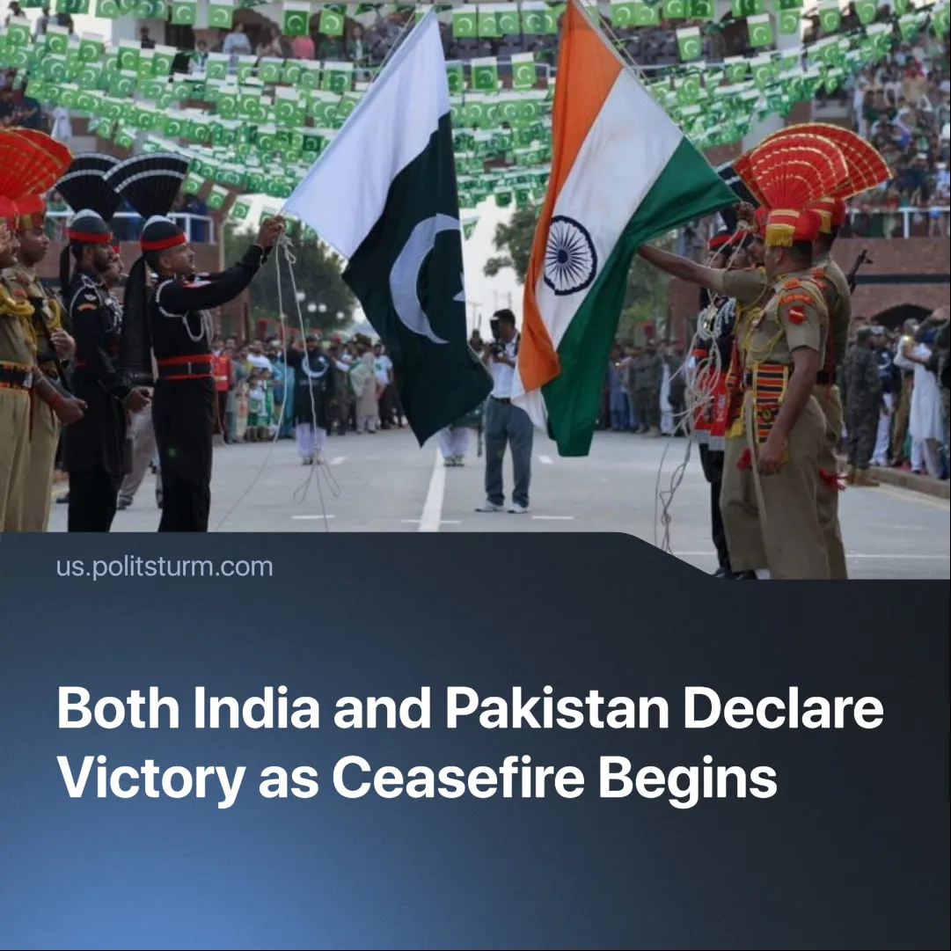

Original article
2025-05-12
2 min read

Following the start of a ceasefire between India and Pakistan this weekend, both sides have declared "victory" in the conflict.
Details. After a terrorist attack in Pahalgam killed 26 civilians, India launched “Operation Sindoor,” striking alleged "terrorist infrastructure" in Pakistan-administered Kashmir and Pakistan itself. These struck deeper into Pakistan than any in decades and reportedly hit civilian areas.
► Pakistan responded with missile and drone attacks on Indian cities, including Amritsar, while India struck Pakistani air defences in Lahore and damaged sites near strategic command centres. Both sides suffered military losses.
► A ceasefire was brokered on May 10, with both countries claiming victory and crediting separate mediators; India emphasised direct military communication, while Pakistan acknowledged prominent U.S. involvement, as well as “three dozen countries.”
► Despite the ceasefire, both sides reported violations within hours and blamed each other.
Context. The Kashmir conflict has shaped India–Pakistan relations since the partition of British India in 1947. The last major conflict, the Kargil War in 1999, saw both nations engage in direct military confrontation over the disputed territory.
► Both countries possess nuclear weapons, raising global concerns whenever tensions escalate. India tested a nuclear weapon in 1974; Pakistan followed in 1998.
Important to Know. India, though a BRICS member, is increasingly aligned with the U.S. and EU. In 2023, it was set to be a key transit hub in the India–Middle East–Europe Corridor — an alternative to China’s Belt and Road. The project was suspended after Hamas’s “Al-Aqsa Storm” and regional war.
► India’s historic reliance on Russian military hardware has come under strain due to Russia’s prioritisation of arms production for the Ukraine conflict. This has opened the door for the U.S. and its allies to expand their share of India’s lucrative defence market.
► Pakistan is increasingly aligned with China. The China–Pakistan Economic Corridor (CPEC) links it to Beijing’s regional aims. China is also consolidating its influence in Afghanistan to stabilise its frontier and secure economic routes.
► The U.S., EU, Russia, and China were caught off guard. Washington brokered the ceasefire. The EU urged “direct dialogue.” China called for restraint while backing Pakistan. Russia, traditionally close to India, stayed neutral.
► This escalation is part of a general crisis of capitalism. The intensifying inter-imperialist contradictions resulting from the crisis are being addressed by imperialist blocs through armed conflicts (Ukraine, Karabakh, Gaza, etc.).
► For communists, this escalation is yet another urgent warning: the temporary “peace” of the post-Cold War world is collapsing. Communists need to distance themselves from various deviations as quickly as possible and unite on the basis of Marxist-Leninist theory.

Original article

