India’s “Communist Parties” Side With Government on Kashmir Conflict
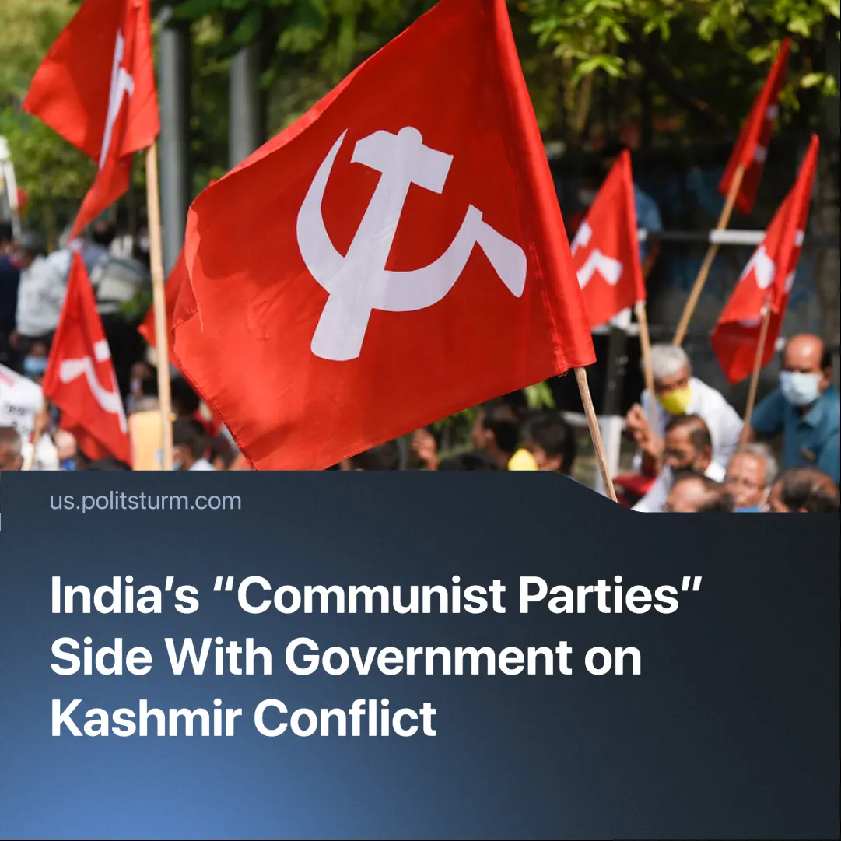

Original article
2025-05-14
2 min read

Both major “communist parties” of India, representing the country in the "IMCWP," sided with the Indian state during the Kashmir escalation.
After the launch of India’s military operation “Sindoor,” the Communist Party of India (CPI) and Communist Party of India (Marxist) (CPI(M)) issued statements echoing the BJP-led government's narrative and calling for national unity.
Details. The statement by the "Communist Party of India" claimed the government had “no choice,” urged national solidarity and supported the military response while offering pacifist calls for peace.
Quote. "CPI believes that India had little choice but to respond firmly against the sources of such terrorism... The targeted nature of the strikes... demonstrates a calibrated and non-escalatory approach, prioritizing accountability without inviting full-scale conflict. CPI urges the Government of India to immediately call for an all-Party meeting to strengthen national consensus and collective resolve in the fight against terrorism... Let this be a moment of unity, strength, and unwavering commitment to justice and secular values of the people of India."
► At the May 8 all-party meeting, CPI reaffirmed support: "We are firmly with the nation’s fight against terrorism and we believe responses at such critical junctures must reflect unity, responsibility, and democratic inclusivity... our nation’s greatest assets are our unity, secularism, and our democratic spirit... We assert that our real enemies are terrorism and religious fundamentalism. They must be confronted collectively, across borders and political divides"
► The CPI(M) also published a statement on "Operation Sindoor". Its content largely mirrored the CPI, calling for national unity.
Quote. "Operation Sindoor was carried out by the Indian armed forces with the objective of destroying terrorist camps and infrastructure in PoK and Pakistan. According to the armed forces, these strikes were focused, measured and non-escalatory and carried out successfully at nine places. In the All Party Meeting convened by the Union Government, all the political parties had extended support to the measures taken by the Union Government aimed against the terrorists and their handlers... The Indian government should ensure that the unity of the people and integrity of the country are protected."
► The Communist Party of Pakistan (CPP) stance was more straightforward, condemning both states’ actions and warning that nationalism veils the deepening crisis.
Quote. "The Communist Party of Pakistan firmly condemns the military aggression initiated by the Indian bourgeois state and the counter-aggression launched by the Pakistani ruling class... We assert that the working masses of India and Pakistan have no stake in the nationalist sabre-rattling of their respective ruling classes... Such military posturing is a diversion, a smokescreen to veil the deepening crisis of capitalist exploitation, inflation, unemployment, and social unrest. It is a tactic long used by bourgeois regimes to stoke reactionary nationalism and crush the rising tide of class consciousness... the path to lasting peace lies not in diplomatic band-aids between warring states, but in the revolutionary transformation of society through the overthrow of capitalism."
► This statement aligns much more closely with proletarian internationalism. The CPP highlighted that this war benefits capitalists, rejecting both nationalism and "diplomatic band-aids".
Context. CPI, CPI(M), and CPP are members of the “International Meeting of Communist and Workers' Parties”, also known as "Solidnet", after its informational portal.
► Initiated by the Communist Party of Greece in 1998, this structure claims to formally unite communist parties adhering to Marxist-Leninist principles.
► In reality, its ranks include numerous deviations. Among Solidnet's members are social-chauvinists from the CPRF and RCWP, Chinese capitalists represented by the CPC, Juche revisionists from the WPK, and other opportunists.

Original article

