India Overtakes UK as the World’s Fifth Largest Economy
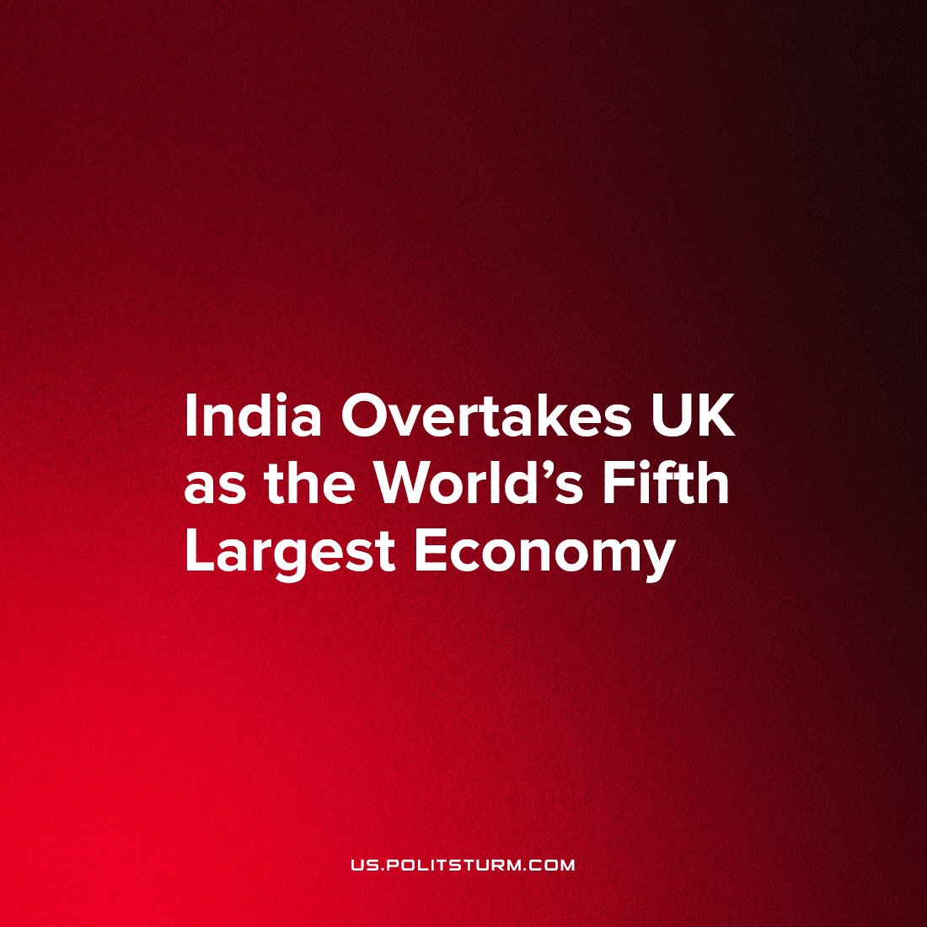

Original article
2022-09-06
2 min read

On the 2nd of September 2022, Bloomberg reported that the United Kingdom was overtaken by India as the fifth largest economy in the world. This has caused a shock in the UK as it highlights the malaise that Britain finds herself in and the scale of the crisis that is affecting the country and her bourgeoisie.
The news comes as a ‘further blow to the government in London as it grapples with a brutal cost-of-living shock’ according to Bloomberg with the Indian economy leaping past the UK in the final three months of 2021 to become the fifth-biggest economy in US dollars, further adding that it has ‘extended its lead in the first quarter,’ of this year ‘according to GDP figures from the International Monetary Fund.’ It is speculated that the UK is ‘likely to have fallen further’ since the end of 2021 with the UK’s GDP growing at just ‘1% in cash terms in the second quarter and, after adjusting for inflation, shrank 0.1%.’
This is contrasted with the general economic downturn that Britain has been experiencing. Higher cost of living has brought an upswing in the workers’ movement with a variety of trade unions and sectors having gone on strike over the summer and threatening further strikes in the autumn and winter should the newly-minted Prime Minister, Liz Truss, follow through on her threat against workers’ rights.
The population grows increasingly uneasy as winter approaches, squeezed by the growing cost of food, the British proletariat is in dire straits with absurdly high heating bills as gas companies seek to accumulate further record profits in the current market at the expense of British workers. In order to make ends meet, the working-class in the country are borrowing money in spite of increasing interest rates that have been raised to cope with this crisis. What faces the most destitute of the United Kingdom is the choice between freezing or starving to death in their homes.
It is clear that the sun has set on British imperialism. The British economy has been increasingly unproductive for years and the COVID pandemic simply tore open the wound of gross corruption and cronyism within British politics as the government’s feeble response wrought havoc on the workers. The bourgeoisie is beginning to find it more and more difficult to govern, as working Britons will find further attacks against them intolerable. These are the elements of a developing revolutionary situation.
But with no serious Communist Party in the UK, even in such an openly chaotic and transformative situation for the British people, it remains unlikely that the masses will be able to smash the state-machinery and win power for itself. It is, therefore, of paramount importance that dedicated communists work tirelessly to imbue the working-class of the country with socialist ideas; not to strike while the iron is hot would be a grave error and one that risks the loss of all the small gains that the workers have won for themselves.

Original article

