India Joins Hands with EU to Counter the China’s Belt and Road Initiative
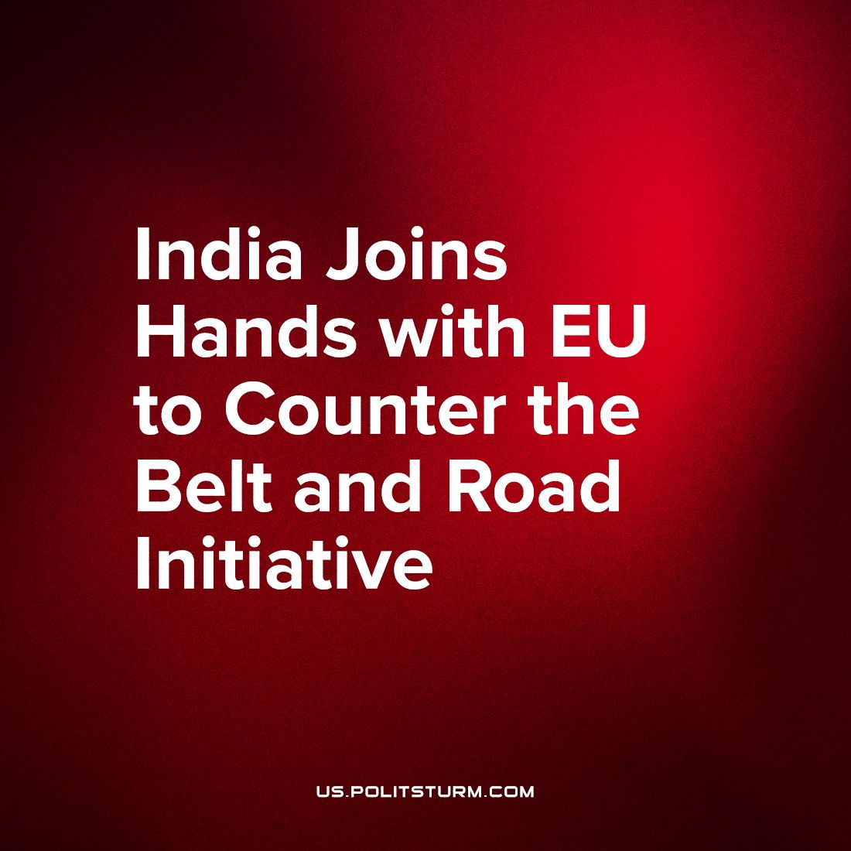

Original article
2023-10-03
2 min read

On 10th September 2023, during the G20 summit India agreed with the United Arab Emirates, Saudi Arabia, Israel, Jordan and with the European Union to build ports in Europe and India and construct railways through the Arabian desert and Israel. The planned use of this infrastructure is to get a more direct and a faster route to the Indian market for the European imperialist powers.
This summit shows a shift in the imperialist order of the world where European Union is now taking an active role in competition with the China. The latter previously started their own infrastructure project, Belt and Road Initiative, which aims to develop infrastructure in Africa and Asia and a way for Chinese capital to gain influence over nations through debt trapping. This project also reflects the “armistice” between the State of Israel and Arabian nations like UAE, Qatar, and Saudi Arabia who are now giving a blind eye to the Israeli actions in Palestine.
With the current proposal of the project the railway line would go directly through occupied Palestine regions to reach the Mediterranean Sea. Another big player in this region, Turkey, who criticized this project as a way to bypass its territory, is already working with China and Azerbaijan to develop rail lines and gas pipelines from Azerbaijan to Turkey via the Armenian territories, which Azerbaijan was recently fighting over.
This project and many like this exposes inter-imperialist competition and ambitions of international and national capitalist class who is willing to work together for profits, while keeping an eye closed on ‘unhandy’ things: calls for genocide of Palestinians for Europe’s ambitions or war, or genocide of Armenians for Chinese and Turkish ambitions in the quest for more profit.
Wars are always used as one of the means to solve the contradictions between different groups of capitalists. It's only a matter of time before the competition for markets and profits turn into a direct military conflict between the imperialist powers of the world.
Only Socialism promises development of every nation without plunging the entire world into a war, without exploitation of weaker nations by the imperialist powers and without genocides. Only working class has the power exercised through the communist party to end this system built on wars and exploitation of man by man.
Sources:
https://www.financialexpress.com/business/defence-world-leaders-launch-india-middle-east-europe-economic-corridor-seen-as-counter-to-chinas-bri-3238862/
https://www.middleeasteye.net/news/turkey-erdogan-opposes-india-middle-east-corridor
https://www.awazthevoice.in/opinion-news/saudi-israel-participation-in-imeec-may-help-breakthrough-on-palestine-24105.html

Original article

