Independence Day
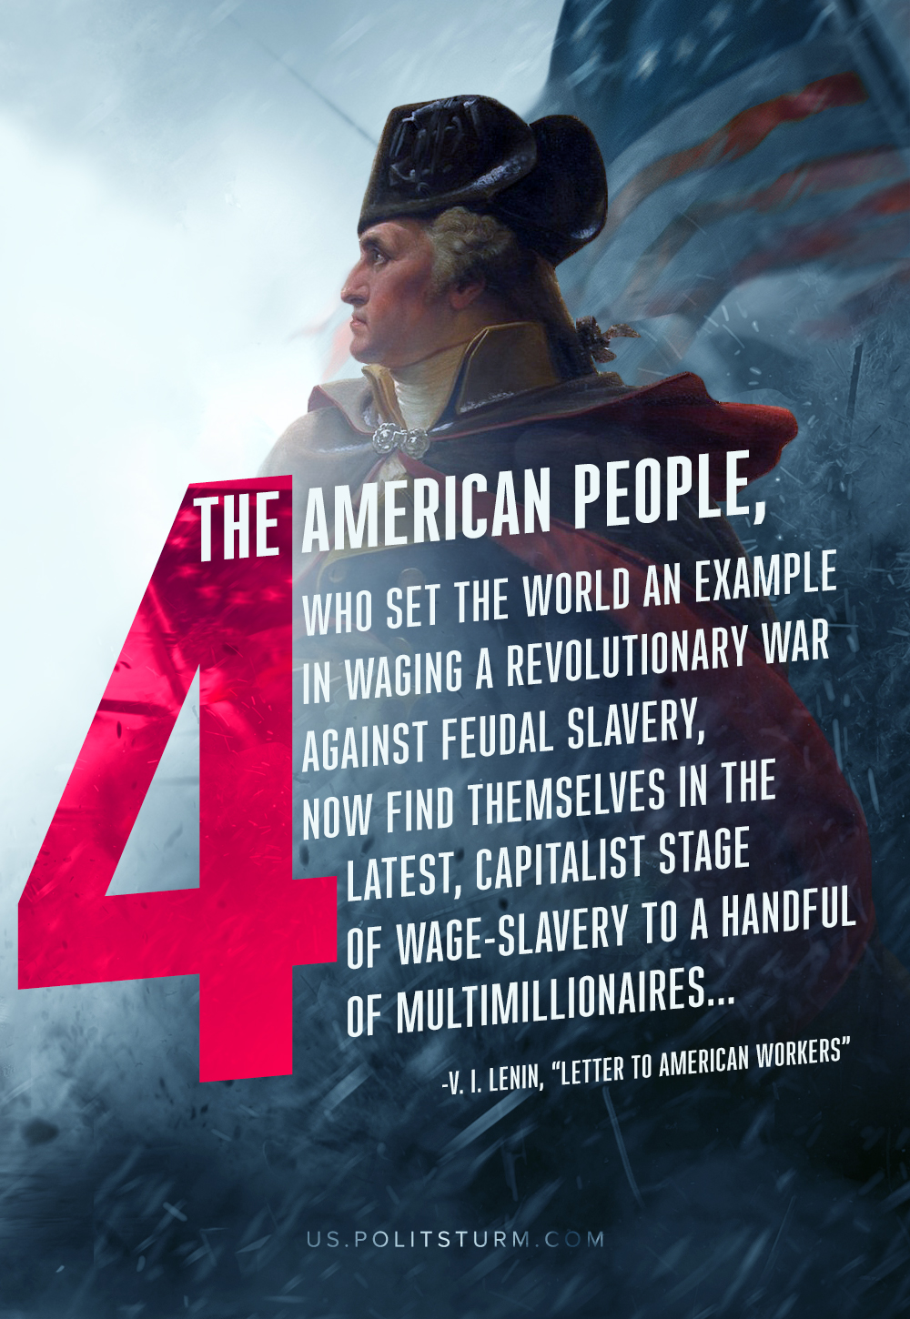

Original article
2019-07-04
2 min read

Today is a great day! Almost 250 years have passed since the start of the American Revolutionary War through which the United States gained independence from British colonialists. It was one of the first revolutions against monarchy and its medieval shackles that prevented mankind from going forward.
The War of Independence was also a war of classes. Tens of thousands of colonial loyalists fought in the English army. The merchants and the plantation owners, who led the struggle for independence, opposed the implementation of the democratic demands of the soldiers, farmers, and workers. The victory of the revolution was possible only thanks to the participation of the broad masses of people in it.
The War of Independence influenced the struggle of Europeans against absolutist regimes. About 7,000 European volunteers fought in the ranks of the American army. During the Great French Revolution, the insurgent people took advantage of the organizational experience and revolutionary military tactics of the Americans. The American victory in the War of Independence contributed to the development of the liberation movement of the peoples of Latin America against Spanish domination.
However, not all the tasks that objectively confronted the American revolution were solved. In the south of the country slavery was not destroyed. All states maintained a high property qualification for voters. Loyalist estates and land in the west were sold in large lots and fell into the hands of speculators.
250 years after the Revolutionary War the American people find themselves in slavery again. The capitalists have thrown their progressive history overboard. They have given America to the power of money. They exchanged the power of the people for the power of capital. The American billionaires have converted all, even the richest, countries into their tributaries. They have grabbed hundreds of billions of dollars which are sullied with unpaid labor of the American workers and the workers of the whole planet. They have become the new colonialists.
The United States intervenes with lush words about freedom, but in reality monopolies carry colonialism to the occupied countries – the very colonialism that George Washington and all the Founding Fathers fought against. Capitalists exploit nationalist sentiment for the purpose of manipulating the American public to support its imperialist actions. While the oligarchs utilize and interpret American history for the purposes of glorifying what they want to be glorified, it is necessary that the American working class remember its glorious traditions of fighting against colonialism and slavery for freedom and better life.
Celebrate, but remember! It is necessary to apply the same revolutionary legacy forward against the oppressive and reactionary bourgeoisie – against modern colonialists. Sooner or later the Revolutionary War will happen again. And it will bring the true freedom for all the oppressed people.
https://www.marxists.org/archive/lenin/works/1918/aug/20.htm
https://us.politsturm.com/nationalism-and-its-class-meaning/

Original article

