In Russia, The Risk Of Poverty Is 2.5 Times Higher For Families With Children
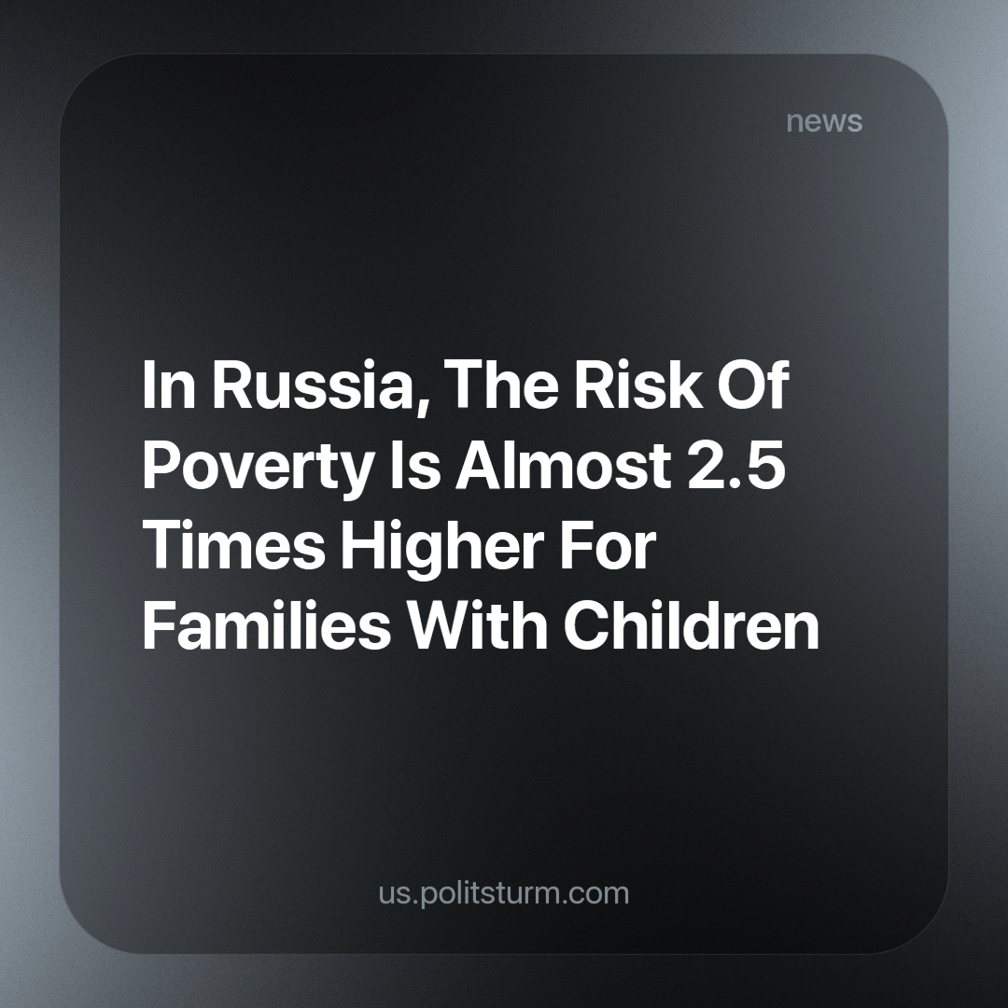

Original article
2023-11-13
2 min read

The Financial Research Institute of the Ministry of Finance of the Russian Federation and RANEPA published an article in the scientific journal of the Federal Research Sociological Center of the Russian Academy of Sciences, which is devoted to the analysis of targeted payments for children by the state. Research has shown that the poverty risk of households with 3 to 17 aged children is more than 1.5 times higher than the poverty risk among all households as a whole and more than 2.3 times higher compared to households without children.
The birth of even a first child doubles the likelihood of a family falling into poverty. This issue is especially acute in villages. The article also talks about the numerous difficulties that families face in applying for public welfare payments. The poverty level of large and rural families with children remained high even taking into account provided benefits, since the income deficit of such families is often greater than the amount of social assistance provided to them.
Recall that since January 1st, 2023, there has been one unified benefit assigned to families with children with incomes below one subsistence level per person in the region.
Social guarantees and state support can largely eliminate most of the problems not only for young families, but also for society as a whole. Unfortunately, in a state with a market economy as its basis, such assistance is pretty much a formality. A government supporting the big business elite will never think about the problems of the rest of the population. The capitalist system is not capable of solving the problems of society as a whole. The very essence of such a system creates inequality. While the minority enjoys luxury and takes everything from life, the rest inevitably fall to the bottom.
Only socialism is capable of solving problems of this kind. This is confirmed by the historical example of the USSR, where no one encroached on the human right to work, to receive high-quality free education and medicine, and where parents were confident in the future of their children.
Source: “Nakanune” - “The risk of poverty of families with children is almost 2.5 times higher than without children” dated September 27, 2023.

Original article

