In Germany, the Number of Families Receiving Child Benefits Has Increased Significantly
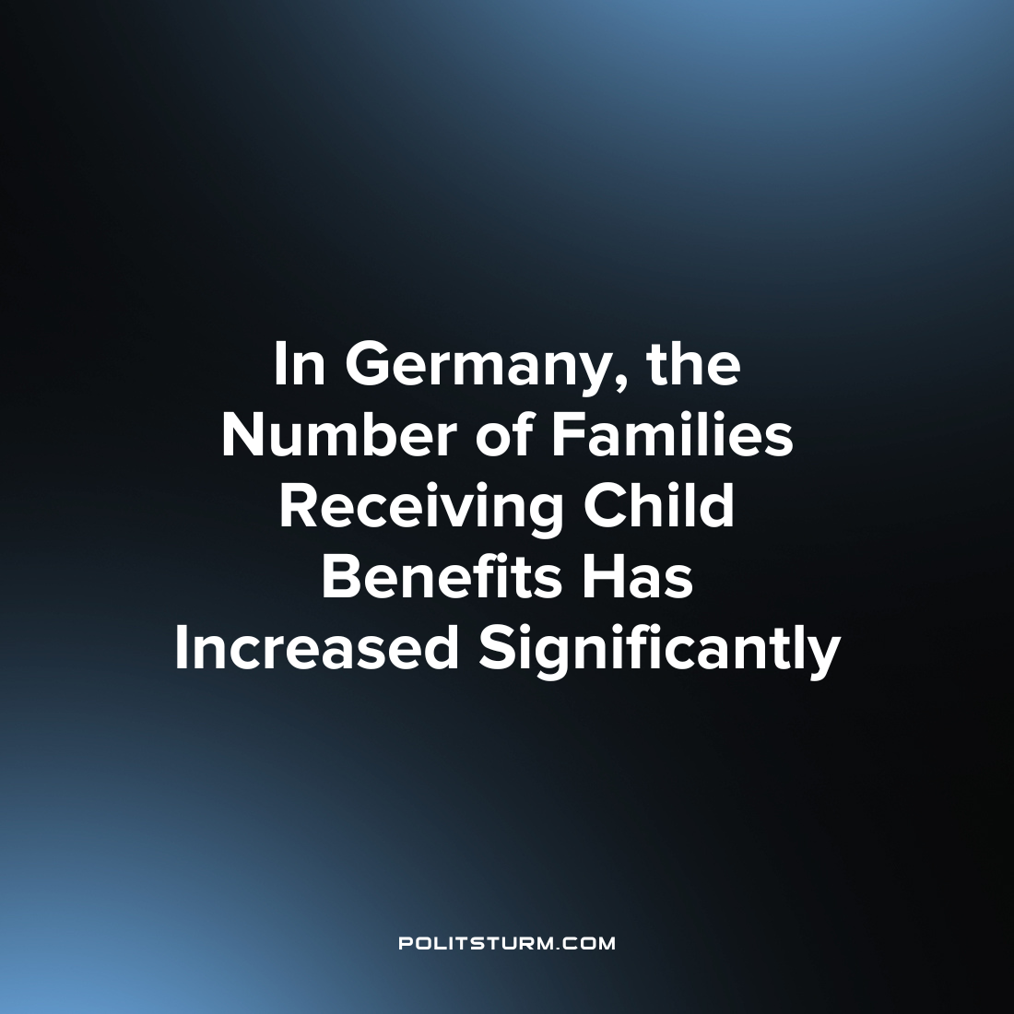

Original article
2023-09-03
1 min read

Since the beginning of the year, the number of low-income families receiving state child benefits has increased by 200,000, and in July the figure reached almost 1 million recipients. According to the Federal Employment Agency, in April of this year 1,966 million young people under the age of 18 were in difficult conditions and receiving benefits from the state. In December 2021, this figure was 1.764 million.
About 65% of people eligible for this benefit did not use it either because they did not know that they were entitled to it, or because of bureaucratic difficulties in proving income. As a result, according to February estimates, about 1.5 million children remained in hidden poverty, which in total with the registered cases reaches almost a quarter of the total population under 18 in Germany. [1]
"Child poverty in Germany remains at a consistently high level,"politician Heidi Reichinneck said. She also said that the financial resources currently being discussed in the federal government for planned child support are "not enough even to provide a basic level." In addition, the government continues to "pursue a course of austerity in kindergartens, schools and universities." [2]
Under capitalism, the income level of the vast majority of the population is declining and their children, pensioners, and the disabled, suffer in addition to the working population. Alleged “left-wing” representatives of the authorities exclaim to the government with a request to help those in need, but such requests can be easily ignored or addressed ineffectually. Having received political points, the left-liberal politicians in the government can be self-satisfied with 28% child-poverty compared to 30%.
Sources:
1, 2

Original article

