Iran's Hidden Workforce: Afghan Refugee Children in Municipal Labor
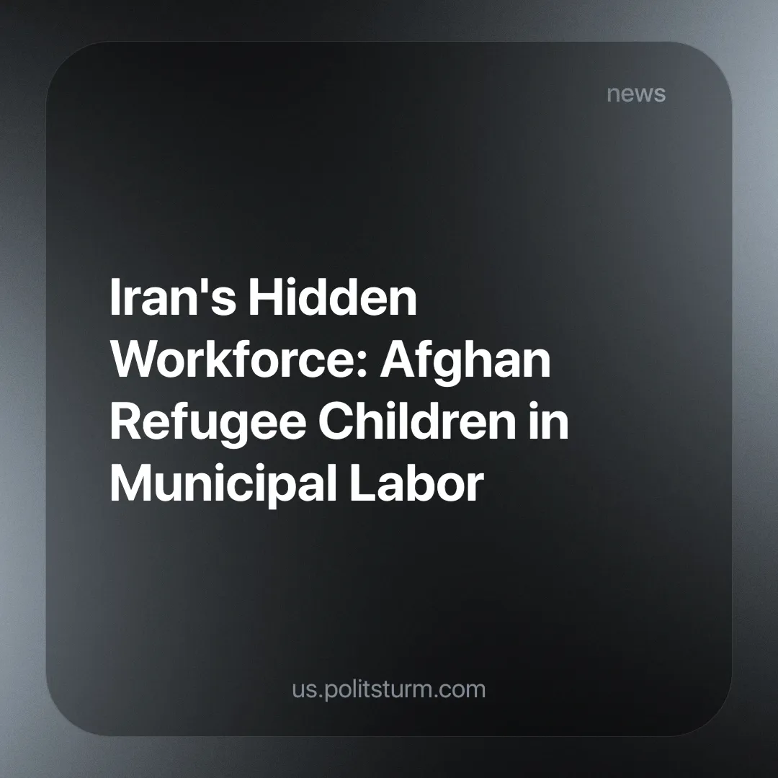

Original article
2024-09-12
2 min read

In line with our previous report on the 3 million child laborers in Iran, a member of the Tehran City Council has revealed the demographics of these children in the Iranian capital.
Most of the workers employed by the private contractors who provide municipal services are Afghan refugee children. In fact, the hiring of these children is widely practiced in all kinds of industries and services, from small shops to companies [1].
According to Naser Amani, an IRGC brigadier general turned city councilor, immigrant children are exploited "because they do not possess any identity cards" [2]. This, of course, raises the question of why at least 3.4 million Afghans [3] who have been part of Iranian society for decades, many of them born here, should be denied this bare minimum by the Islamic Republic.
He goes further by saying:
"After being employed, their salaries are not paid on time, and there are many problems for these children, and we have warned the municipality about this many times, and of course, the Iranian worker also doesn't like working with the municipal contractor for some reasons".
As a result of being denied membership in bourgeois civil society, a refugee in the service of Tehran's city contractors cannot protest the irregular payment of an already meager wage.
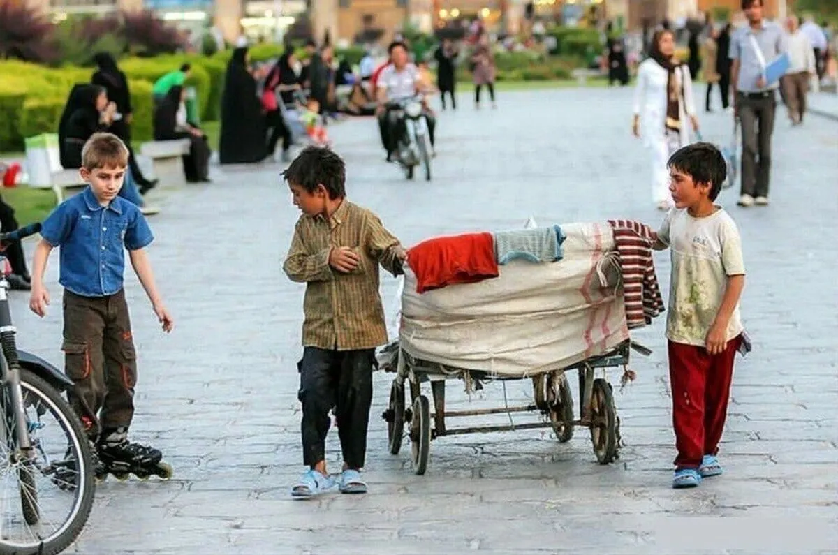
Although the employment of foreigners by municipalities and the employment of children under the age of 15 is illegal under Iranian labor law, the authorities prefer to save on municipal expenses. As evidenced by what the aforementioned Tehran City Councilor has revealed, "In the neighborhoods I visit, I see that unfortunately the contractors have committed violations and employ young citizens such as 13- and 14-year-old children," [2] we can conclude they know that such violations of labor law regarding children are taking place.
This highlights an inherent contradiction in bourgeois statehood, that Iranian municipalities, much like Iranian corporations, have outsourced the management of workers to private contractors who effectively undermine their vaunted "humanitarian" bourgeois laws (see our article on the Labor Protests Spread Across Iran). Such laws (limiting working hours, criminalizing child labor, etc.), which date back to the 19th century and the reports of the British Factory Commission (often cited by Karl Marx in Das Kapital), were designed to ensure the physical reproduction of the working class and thus the further accumulation of capital.
While this problem is especially acute in Iran, one in ten children worldwide work for food. It is not something exclusive to the most poor and backward countries, as this phenomenon is present in the US as well. The failure of global capitalism to uphold these practices is indicative of its dire situation and intensifying contradictions. American sanctions on Tehran coupled with the inherent contradictions tendencies of capital have not only led to the willful violation of their own labor laws, but have forced them to desperately submit to the Chinese Imperialists.
This hypocritical way of running the municipalities, which in this case divides the citizen workers and exploits the non-citizen workers, could only be overcome by the vanguard party of the entire working class, whether migrant or local.
Join us, at Politsturm to help work towards constituting such a party!
Sources:
[1] Middle East Eye — “Nothing is Certain: The Precarious Lives of Afghans in Iran” — 18 September, 2021.
[2] KhabarOnline —" Employing the children of foreign nationals by municipal contractors/ some municipal service workers and especially children are paid 4 to 6 million tomans" — August 28, 2024.
[3] UNHCR— “UNHCR Iran Factsheet” — 19 May, 2024.

Original article

