IBM Fired Up To 100,000 Workers in Recent Years
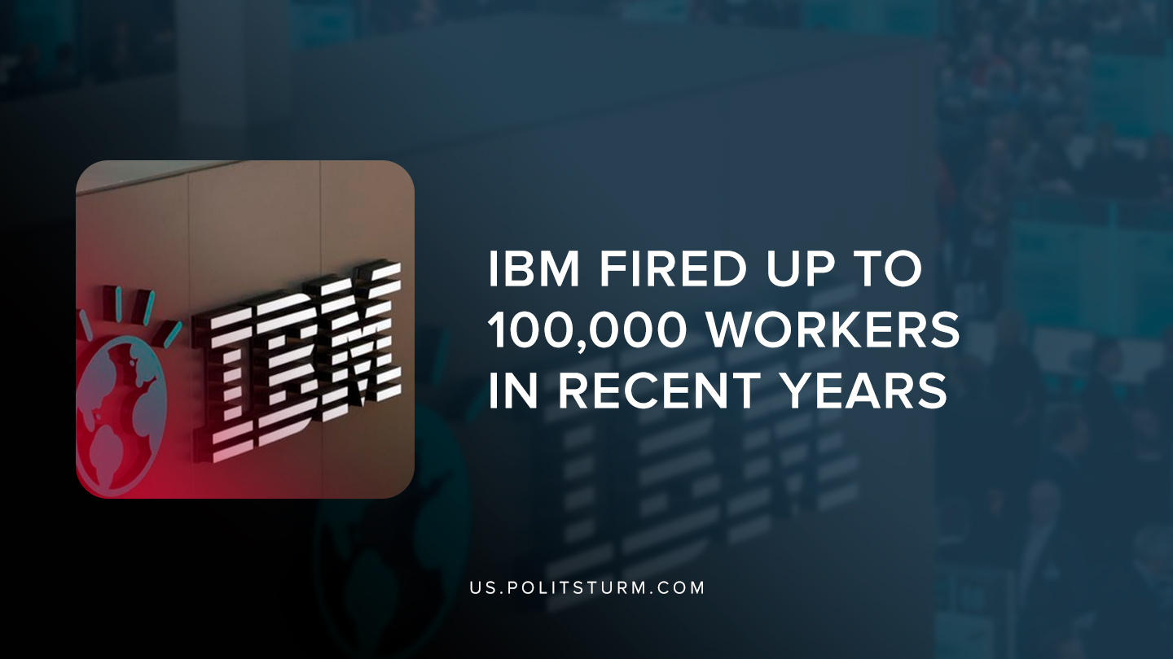

Original article
2019-08-02
1 min read

International Business Machines (IBM) has fired between 50,000 to 100,000 workers in the last several years, according to former vice president of Human Resources Alan Wild. The company has faced several class-action lawsuits which accuse them of firing older workers.
The court documents show that the company justified the layoffs as an attempt to improve IBM’s public image. The company has struggled with declining revenue in recent years and used the layoffs as a strategy to appear as a “as [a] cool, trendy organization”, like Google or Amazon.
After adopting this new strategy, the company began firing older workers in order to replace them with younger workers. The move was justified saying that younger workers are more receptive to technology and innovative than older workers.
IBM’s recent lawsuits are just another example of how under capitalism, employers will discard workers once they are no longer useful, or even if they do not promote the image the company is looking for. Tens of thousands of workers have been laid off over the last several years, disrupting the livelihood of the workers.
All of the changes were made at the behest of executives for the purpose of boosting revenue and profits. Only under a socialist economic formation, in which the rights and needs of the working class are paramount will this absurd situation cease to occur.
Souces: 1,2

Original article

