The Red Magyars: Hungarians in the Russian Civil War


Original article
2024-12-07
29 min read

Preface by Politsturm:
We are publishing a translation of the article by Grigory Tsidenkov, Russian historian, sociologist, and faculty member at Russian Samara State Socio-Pedagogical University. It is part of a series exploring various historical topics and myths. Although not a communist, Grigory Tsidenkov approaches historical events with a commitment to objectivity.
In this article, he sheds light on an often misrepresented aspect of the Russian Civil War (1917–1922) — the involvement of Hungarian soldiers in the Red Army, also known as the Red Magyars, who fought under Bolshevik leadership against counterrevolutionary forces. Over the decades, myths rooted in anti-Soviet propaganda have emerged regarding their role, including claims that the Soviet government concealed the large-scale involvement of foreigners and accusations of their cruelty and mercenary behavior.
The article provides valuable insights into the October Revolution and the Russian Civil War, uncovering the true reasons behind the Hungarians’ decision to fight on the side of Soviet Russia. It also offers great examples of internationalism within the labor movement. People who had recently fought against Tsarist Russia in World War I were ready to stand alongside Russian workers and peasants in their struggle against class oppression. Their participation was an example of a profound sense of class solidarity and shared revolutionary ideals.

“We are ready, even at the cost of our lives, to defend the Russian Revolution, which brings peace and brotherhood to the whole world. The Russian Revolution, as a revolution for the liberation of the working peoples, is at the same time our revolution, the revolution of the Hungarian workers,” was the oath Hungarian prisoners in Omsk swore in February 1918 as they joined the Red Army. Who were these red Magyars, who have long since become one of the legends of the Russian Civil War, and where did they originate? How many of them were there, and ultimately, where did they go?
In recent decades, particularly since the late 1980s, several incredible yet firmly entrenched myths have emerged in the public consciousness regarding Hungarian and other foreign fighters in the Red Army. It is claimed that the Soviet authorities concealed the mass participation of foreigners on the side of the Reds during the Civil War and that the Red Army won battles thanks to divisions formed from mobilized Hungarians and Chinese. “The Reds mobilized 80,000 Magyars, who spilt blood across all of Russia,” the author of this material, for example, personally heard such a statement from a respected and well-known historian in professional circles. It is also asserted that Hungarians and Chinese, about whom there will be a separate discussion (other materials of this author about the Civil War – PS), were brutal mercenaries and punitive forces. That those among them who did not wish to serve the Reds were starved. That they fought either for money or under the threat of execution.
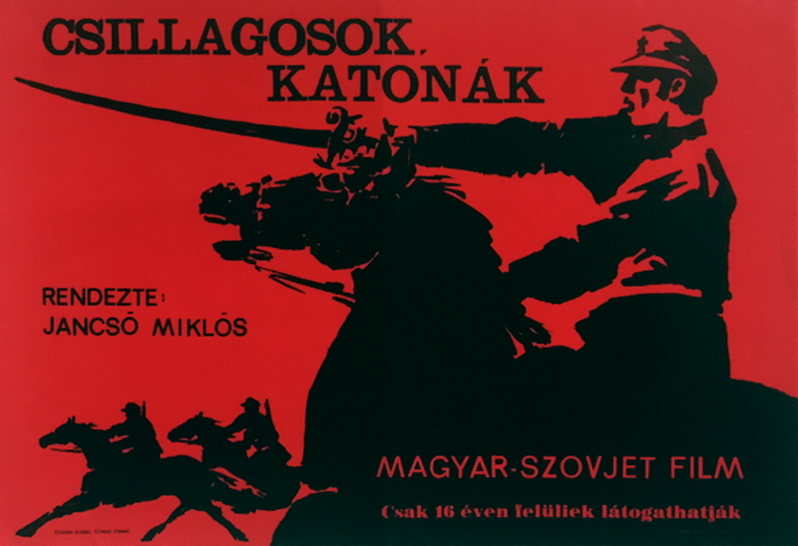
Hungarian movie poster for 'Stars and Soldiers' (Csillagosok, Katonák)
Assertions that "everything was hidden from us" stem from a simple lack of knowledge: if one hasn't heard anything, it implies it didn't exist. Meanwhile, during the Soviet era, a significant amount of both popular and scientific literature was published regarding the involvement of foreign internationalists in the Civil War. To confirm this, simply enter a search query in the bibliographic database of any major library. The mass publication of books and articles peaked during the anniversaries of 1957–1959 and 1967–1969. Subsequently, summarizing monographs were also released. Regional studies and collections of local documents were published separately, covering areas from the western regions of Ukraine to Vladivostok and Chukotka. The list of literature provided at the end of the article is merely the tip of the iceberg.
Internationalist warriors were widely depicted in both Soviet and foreign cinema. Some feature films were entirely dedicated to them, such as the Soviet film about Oleko Dundich (also known as Aleksa Dundić – PS). The most vivid and closest to reality is the 1967 Soviet-Hungarian film directed by Miklós Jancsó, "Stars and Soldiers." It is based on events that occurred at different times and in various locations, yet was brilliantly woven into a cohesive narrative by the screenwriter and director.

Where and How Many?
The myth of hordes of foreigners as the primary striking force of the Red Army necessitates a more detailed analysis, particularly regarding several aspects: where the Hungarian soldiers originated in Russia, how many Hungarians participated in the Civil War on the side of the Reds, and how many of them fought concurrently on the fronts? Let us attempt to answer these questions.
The vast majority of Hungarian fighters in the Red Army were Austro-Hungarian prisoners of war captured during World War I. By the end of 1917, according to approximate yet the most reliable data from the International Red Cross, there were 54,146 officers and 2,050,000 soldiers of the Austro-Hungarian army in Russian captivity. Of this number, roughly a quarter were Hungarians. All prisoners of war were held in over 400 camps throughout the country. The camps were distributed among military districts as follows:
- Moscow — 128,
- Kazan — 106,
- Turkestan — 41,
- Kharkiv — 37,
- Irkutsk — 30,
- Omsk — 25,
- Odessa — 18,
- Petrograd — 15.
How many Hungarian prisoners of war participated in the Civil War on the side of the Reds, and what motivated them?
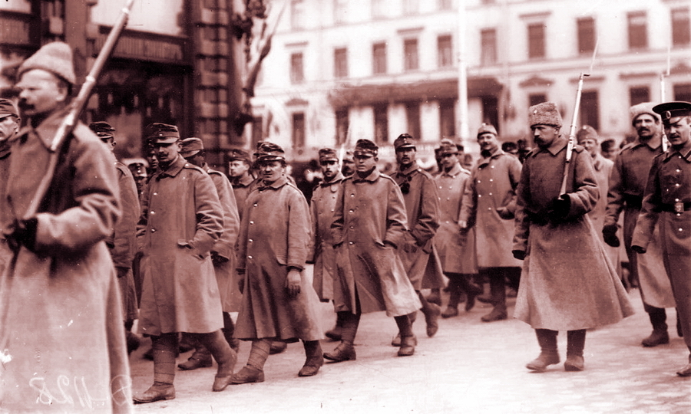
Austrian prisoners of war under escort walk along Nevsky Prospect in Petrograd, May 1916.
Unfortunately, we do not have an exact figure. Firstly, such a count is impossible due to the often spontaneous emergence of the first Red Guards and partisan units, where records were kept carelessly or were entirely absent. Secondly, the figures reported in Soviet and White Guard press, as well as in the press of the Entente countries at that time, greatly complicate matters: all sides inflated the number of internationalists among the Reds for various reasons.
The Soviet agitation aimed to involve as many prisoners of war as possible in the cause of the world revolution. The propaganda of the opponents of Soviet power, in order to justify intervention, propagated the myth that the Germans and Austrians were about to seize all Russian railway lines, destroy the Czechoslovak Corps, and launch an offensive through Turkestan into India. Additionally, the threat of "Hungarian-German hordes" was intended to awaken a sense of patriotism among the Russian population and attract greater attention from the Entente countries.
Subsequently, through a detailed examination of the situation in the USSR and the Hungarian People's Republic, historians were able to establish a lower threshold for the number of Hungarian internationalists in the Red Army, as well as in the Red Guard and partisan units — 60,000 individuals during the period from January 1918 to January 1921. This figure corresponds to the number of record cards for Hungarian internationalists stored in the file of the Central State Archive of the Soviet Army (now RGVA (Russian State Military Archive – PS)), which was transferred to the Military Historical Museum of the HPR (Hungarian People's Republic). This file does not include Hungarians from the initial Red Guard units that participated in the suppression of General Kornilov's rebellion, and it lacks a complete dataset for the Turkestan Front, with only fragmentary data available for Siberian partisan units.
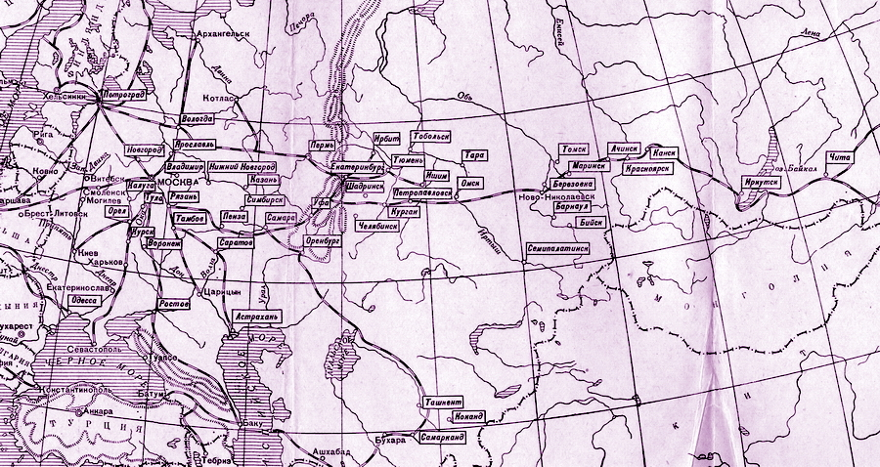
Map of the locations of war camps prisoners for the year 1917. They are mainly distributed along the railroads.
Historians from the Hungarian People's Republic ultimately estimated the total number of Hungarian internationalists to be between 80,000 and 100,000, reasoning that higher figures were due to connections with Siberian partisan units as well as a desire to emphasize their compatriots' traditional contribution to the establishment of Soviet power. Soviet historians, however, operated with more conservative figures, estimating the number to be between 70,000 and 80,000.
Of course, these tens of thousands of fighters never faced numerous enemies simultaneously on the same front. It suffices to understand that Hungarian prisoners of war were dispersed over a vast area, and by the conditional onset of the Civil War in November 1917, they were in entirely different circumstances. The map illustrates from which camps and when Hungarian prisoners of war participated in the conflict in various ways.
Naturally, these figures challenge the widespread generalization that "all Hungarians and Germans were for the Reds": we see that the overwhelming majority of Hungarian prisoners of war, up to 88-89%, did not participate in the war at all.
It should also be understood that not all Hungarians falling under the then-concept of "internationalists" — that is, individuals who shared the ideas of the Third International or fought for world revolution — were combatants. At the Moscow meeting on January 18, 1918, the leaders of the committees of internationalist prisoners of war proposed three main tasks: a) communist propaganda in the German and Austro-Hungarian armies aimed at ending the imperialist war; b) participation in the defense of Soviet Russia; c) assistance in restoring the national economy.
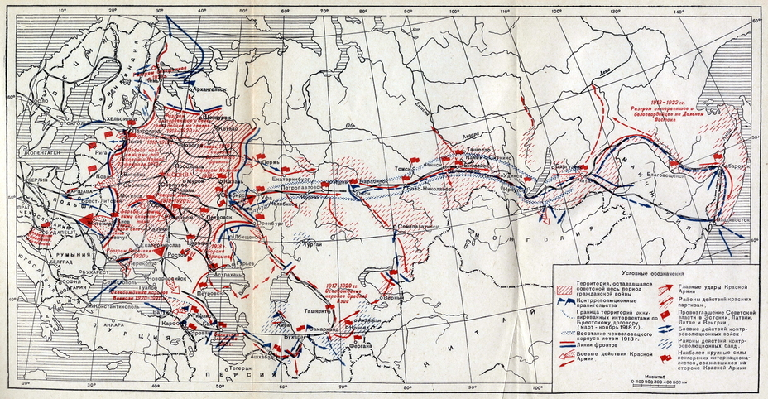
The participation of internationalists in the events of the October Revolution and the Civil War, 1917–1922.
Of course, prior to the signing of the Treaty of Brest-Litovsk, emphasis was placed on propaganda — both in prisoner-of-war camps and in their home countries of the captives. This activity was conducted with considerable success, and its instigators, such as Béla Kun and Tibor Samueli, later had a significant impact during the days of the Hungarian Soviet Republic. In most cases, the internationalists returning home went back to the front, where they politically undermined the combat units, significantly contributing to the onset of the German and Austro-Hungarian revolutions.
General Erich Ludendorff, reflecting on the reasons for Germany's defeat, identified the decline of morale as one of the causes: "The significant deterioration of the troops' psyche was caused by reinforcements made up of soldiers returning from Russian captivity." In Austria-Hungary, out of 660,000 repatriated prisoners of war before the collapse of the empire, 10,000 were classified as "dangerous agitators" and sent to concentration camps — mostly to the infamous Kenyérmező and Wieselburg.
The Hungarian section activists of the RCP(b) and representatives of the prisoners-of-war committees at various congresses and conferences should also be considered among the agitators. Additionally, the instructors of the Hungarian command and political courses, established in Moscow and several major cities (282 people), did not participate directly in the fighting.

Three Hungarian Waves
Among those who fought with weapons in hand, only a few engaged continuously throughout the Civil War. Generally, three periods of participation by Hungarians and other internationalist prisoners of war in combat actions are distinguished.
The first period spanned from May to September 1918. It is characterized by the mass enlistment of prisoners of war into the Red Army and Red partisan detachments, followed by their fierce struggle against the Czechoslovak Legion, the troops of Ataman Dutov, and the Komuch Army. According to researcher V.R. Kopylov, just before the start and during the initial phase of the Czechoslovak uprising, 75–85 international units of the Reds, totaling approximately 12,000 to 15,000 people, operated in a fragmented manner across various fronts. About half of them were Hungarians.
The second period occurred in the spring and summer of 1919 when Hungarian internationalists were leaving en masse to defend Soviet Hungary. Despite the dire situation on the eastern front during the spring offensive of Kolchak's army, the Soviet government issued several orders and directives instructing Red Army commanders to immediately release Hungarians who expressed a desire to fight in their homeland.
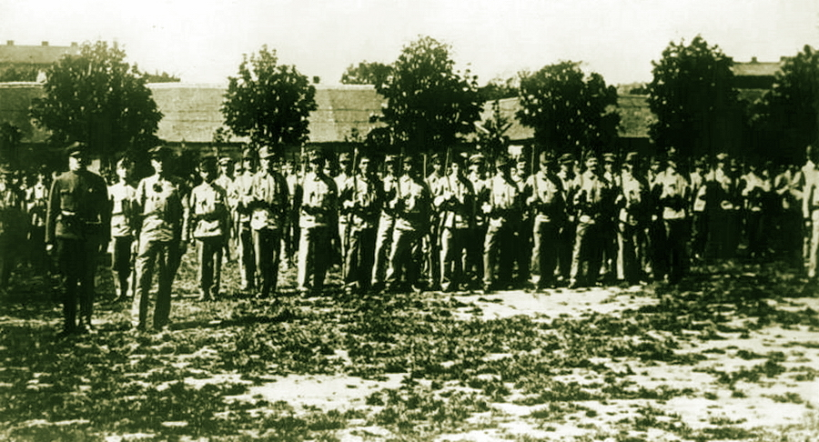
The formation of one of the units of Hungarian internationalists
The third period lasted from the end of 1919 through all of 1920. Here, one can observe the mass enlistment of Hungarian prisoners of war into the ranks of the Red Army and Red partisans from camps that were previously under the control of the Whites and interventionists, and later liberated by the Reds. The map provided above clearly shows that most Hungarian prisoners of war remained in camps on territory controlled by anti-Bolshevik forces during the first half of the Civil War. At this stage, large and fully formed international military units, including brigades, appeared in the Red Army. Throughout the years of the Civil War, only one international division was formed, in Ukraine.
The Turkestan Front was notable, where the proportion of internationalists on the side of the Reds remained consistently high throughout its existence — around 7,000 to 7,500 fighters, mostly from the Tashkent prisoner-of-war camp.
It is necessary to clarify a few more points. Internationalists rarely fought in isolation; they were most often organized into units within existing Red Army, Red Guard, or partisan formations. In separate international units at the level of battalions, squadrons, regiments, and brigades, alongside foreigners, there were Russian and "Muslim" fighters — meaning that the term "international regiment" was not synonymous with "regiment of foreigners." Operationally, internationalists also very rarely acted independently — usually only alongside other Red Army units. Exceptions could be found on the Turkestan Front.

The Situation of Hungarians in Russian Captivity
The Russian government categorized Hungarian prisoners of war, along with Germans, Austrians, and Turks, as “unreliable” throughout World War I. They were frequently sent to remote parts of the empire: to the Urals, Siberia, and Turkestan. The journey to the camps was long and difficult.
Initially, most prisoners were taken to the Darnytsia sorting camp near Kyiv, where soldiers were separated from officers and sorted by nationality. Later, from late 1915, prisoners were also divided by civilian professions: warring Russia needed skilled workers. Almost all prisoners perceived the Darnytsia camp as "hell on earth," where unsanitary conditions, epidemics, hunger, and agonizing waiting were prevalent.
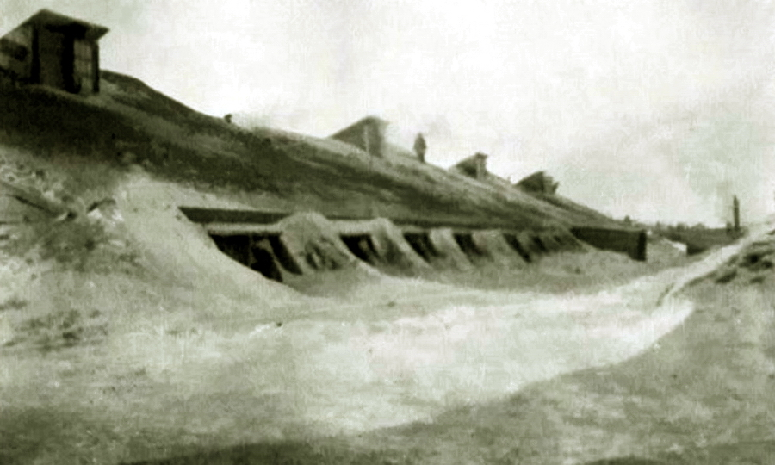
Dugouts and barracks for Austro-Hungarian prisoners of war in the camp in Novonikolaevsk (now Novosibirsk)
After sorting and transport assignment, the prisoners endured a prolonged, semi-starved journey to their destination. Due to most locomotives being occupied with supplying the front and the limited capacity of the railroads, trains carrying prisoners were dispatched at long intervals and experienced significant delays en route to allow for the passage of trains headed for the front lines.
The journey from the Darnytsia camp to the Siberian or Turkestan camps typically took between 3 to 4 months. For example, Armand Müller, who would later become the commander of one of the Hungarian partisan units, was sent from Darnytsia to the Irkutsk camp in early February 1915, but he only arrived in May. Not everyone survived such a trip; many succumbed to epidemics of typhus and intestinal diseases. In winter, the cold added to the infections: in January 1915, Turkish prisoners from the Caucasian front were sent to the Totsky camps near Buzuluk in unheated cars, resulting in a train arriving at the Samara station with frozen corpses.
“Unreliable” prisoners of war who were enlisted soldiers — unlike officers who retained their privileges and received regular payments — were kept in significantly worse conditions than the captured Slavs, Italians, and Romanians, among whom there was active agitation to join national units to fight on the side of the Entente.
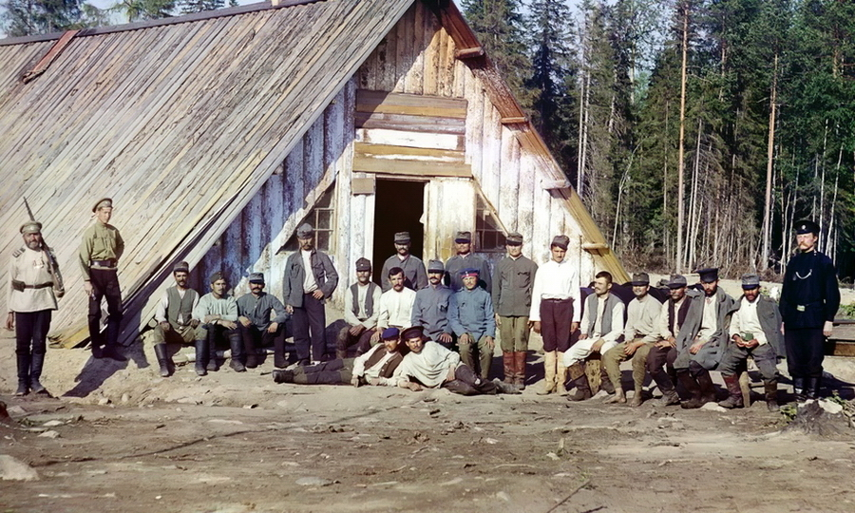
Austro-Hungarian prisoners of war working on the construction of the Murmansk railway. Photo by S.M. Prokudin-Gorsky.
The Red Cross had to repeatedly appeal to the Russian authorities regarding violations of international agreements concerning the conditions of prisoners of war and the use of their labor. The most egregious case involved the sending of several thousand Germans and Austrians to construct the Murmansk railway, where most perished from scurvy. It was only after the active intervention of the Red Cross that the prisoners of war were replaced by hired Chinese workers. Nevertheless, the severe economic situation and mass mobilizations compelled the Russian government to increasingly involve prisoners of war in various types of labor. By the end of 1916, 545,000 prisoners of war were employed in agricultural work, 160,000 in timber harvesting, 294,000 in mining, 168,000 worked on the construction of railways and canals, 60,000 in sugar factories, and another 103,000 prisoners were employed in various construction projects.
According to the Red Cross, between 1914 and 1917, 471,398 former soldiers of the Austro-Hungarian army died in Russian captivity due to hard labor, illness, cold, and hunger. In comparison, the Austro-Hungarian army lost 312,581 soldiers killed on the Eastern Front during the same period. The prisoners of war, of course, were unaware of the statistics, but they witnessed the deaths of their comrades almost daily, which understandably led to feelings of resentment towards the conditions in Russia.

What Did the Red Magyars Fight For?
The primary motives for Hungarian prisoners of war joining international units and participating in propaganda and party groups can be categorized into two sections.
In terms of class composition, 60% of Hungarian prisoners of war were peasants and laborers, 10% were representatives of the working professions, and the remaining 30% belonged to other categories. The author lacks data on the political affiliations of the prisoners of war, but most, particularly soldiers, held predominantly leftist views and beliefs. Before the war, the Hungarian Socialist Democratic Party boasted over 200,000 registered members. Additionally, the peasant party "Independence" and the "Radical Party," which represented the urban intelligentsia, were also significant movements.
From October to December 1917, during the establishment of Soviet power at the local level, representatives of these parties found it considerably easier to engage with local councils. In nearly all prisoner-of-war camps, soldiers' committees were established to maintain order amid the revolutionary chaos and organize the equitable distribution of food. Previously, officers received monetary allowances similar to those at home, were sent food parcels, and dined incomparably better than the soldiers. Consequently, soldiers' committees enforced equal distribution of food within the camps. Local authorities supplied soldiers' committees with weapons— mainly for self-defense and the protection of camp and construction property, as well as for countering officers' committees, which armed soldiers could challenge.
Armed soldiers' committees formed their own detachments of the Red Guard, which local authorities frequently called upon for patrolling the streets and dealing with local gangs. Soldiers' committees also dispatched delegates to the "All-Russian Congress of Prisoners of War," held in Moscow in April 1918.
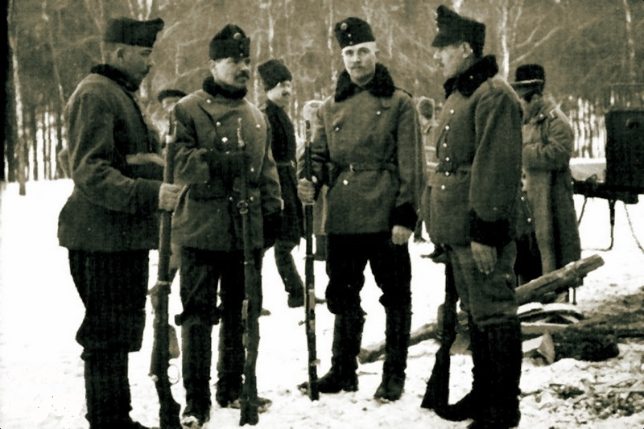
"Group of voluntarily surrendered Hungarian hussars, 1915–1916."
From among these deputies and ideological organizers of the international Red Guard detachments emerged the most prominent Hungarian communists of later years: Béla Kun, Tibor Szamuely, Máté Zalka, Károly Ligeti, Ferenc Münnich, and others. These "ideological" internationalists became the first wave of Hungarian participants in the Civil War in Russia, forming the backbone of international units, later participating in the defense of the Hungarian Soviet Republic, and generally tying their lives to the international communist movement.
The primary mass of Hungarian internationalists was made up of individuals from humble peasant backgrounds. Their "ideological" motives were aptly described by Károly Ligeti, commander of the Omsk international partisan detachment: "The Hungarian peasant, who has fought for land for centuries, driven to the point of a bayonet, now, clenching his fists, with bloodshot eyes, gazes at the men dividing the land and reflects, reflects on his homeland." These fighters of the "first wave" departed in the spring-summer of 1919 to defend the Hungarian Soviet Republic, closer to their native fields.
The second, significantly larger wave of Hungarians joining the ranks of the Red Army began after the signing of the Brest Peace and continued until the very end of the Civil War.
After the peace treaty was concluded, Soviet Russia and the Central Powers initiated the mutual repatriation of prisoners of war. This process was lengthy and arduous, particularly due to the devastation of the railways and the scarcity of food supplies. In May and June 1918, vast territories, especially in the Urals, Siberia, and the Volga region, fell under the control of the White forces and foreign interventionists. They did not acknowledge the terms of the Brest Peace and forcibly returned prisoners of war to camps, often under significantly worse conditions, as parcels from their homeland now reached the camps with great difficulty, and as there was a lack of a centralized food supply.
Furthermore, prisoners of war suspected of holding any leftist views faced repression. There were also instances of violence based on nationality — for example, in Samara, occupied by Czechoslovak Legionnaires on June 8, 1918, staff from the Swedish Red Cross noted several cases of summary executions of Hungarian prisoners of war who had not participated in the city's defense. Many prisoners of war fled from the camps under such conditions and joined partisan groups.
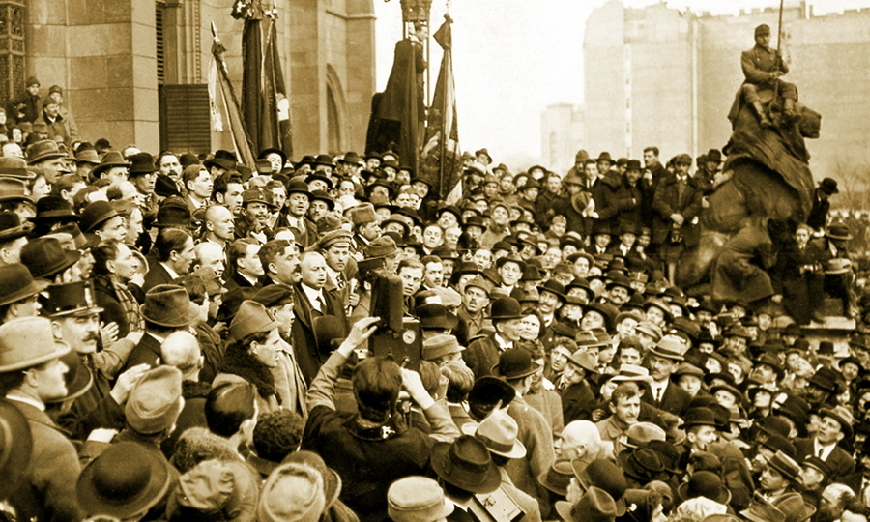
In the center of the crowd stands Béla Kun, a prominent leader of the Hungarian Revolution of 1919.
However, the largest wave of recruits joining the Reds began in late summer and early autumn of 1919, when the Red Army liberated vast territories in the Urals and Siberia. The internationalist prisoners of war were motivated by both a sense of revenge and necessity: joining the Red Army offered uniforms and regular food rations, which were the ultimate dream for most of those confined in Siberian camps. Another benefit of joining the international units of the Red Army was that command and communication could be conducted in national languages, which was crucial for Hungarians, Czechs, Slovaks, Croats, Serbs, Bosnians, Poles, Romanians, and Italians who had served in the Austro-Hungarian army, where communication was often limited to the German language.
Nevertheless, it is important to reiterate that far from everyone joined the Red Army — most prisoners of war from the liberated camps chose simply to wait for repatriation.
No forced mobilizations were carried out in the camps liberated by the Red Army, which was impossible for several obvious reasons: during the mutual exchange of prisoners of war with the Central Powers, observers from the Swedish and Danish Red Cross were present in the camps, and even the most desperate and shortsighted Red commanders wished to avoid complicating international relations.
Stories that the Bolsheviks allegedly starved prisoners of war to coerce them to join the Red Army do not hold up to scrutiny at all — primarily because the vast majority of prisoners of war returned to their homeland. Increased mortality in the camps during the Civil War was noted by Red Cross observers specifically in those regions controlled by the Whites and foreign interventionists. In May-June 1919, the regimental councils of Hungarian international brigades and the Hungarian section of the RCP(b) attempted to mobilize Hungarians in Kyiv and Nizhny Novgorod to "save the Hungarian Soviet Republic," but this effort ultimately failed: nearly all prisoners of war and interned civilians from these areas had already been repatriated in 1918. Those who remained were either already serving in the Red Army or simply disregarded the call.
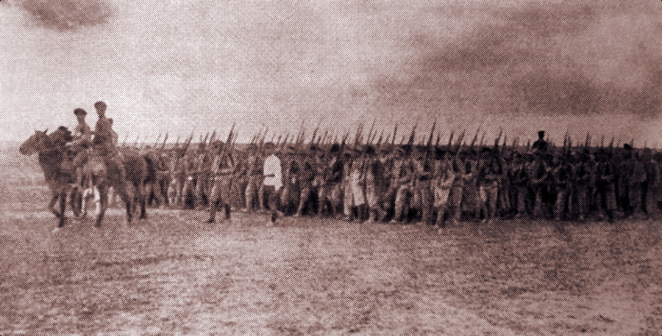
The 2nd International Regiment moving to the front lines. Eastern Front, 1919.
The myth that Hungarians were mercenaries also has no basis: all Red Army soldiers received the same pay, which varied depending on local conditions and inflation. There were no additional payments for internationalists. Yes, in the first Red Guard units at the end of 1917 and the beginning of 1918, the amount of pay could be determined by the commanders independently, but it was again tied to the available treasury. There are no known millionaires or individuals who simply became wealthy among the returning Hungarians and those who remained in the USSR as internationalists.

Hungarian Cruelty: Truth or Fiction?
In any war, similar narratives emerge regarding the particular cruelty of the enemy, especially among its "unconventional" units. Most of these accounts lack credibility and do not have documented evidence to substantiate them.
Stories about the Hungarians often emphasize their role in punitive operations aimed at suppressing uprisings behind the lines of the Red Army. It is important to note that any military unit follows orders: wherever they are deployed, that is where they will go. Participation in the suppression of uprisings was not a voluntary decision made by international units.
The Hungarians and other internationalists were impervious to enemy propaganda. It was nearly impossible to negotiate with them, while mobilized, inexperienced Red Army units could become demoralized and even switch sides under the influence of agitation — the Red command had a clear rationale for employing internationalists in such operations. The Hungarians participated in executions ordered by revolutionary tribunals as soldiers, not as Hungarians.
It should be acknowledged that the Hungarians often harbored animosity towards the enemy, but there were reasons for this. Counter-revolutionary anti-Bolshevik uprisings typically erupted suddenly and were accompanied by the capture of Red Army soldiers, and the reprisals of the insurgents against outsiders, for the reasons mentioned above, invariably exhibited particular cruelty.
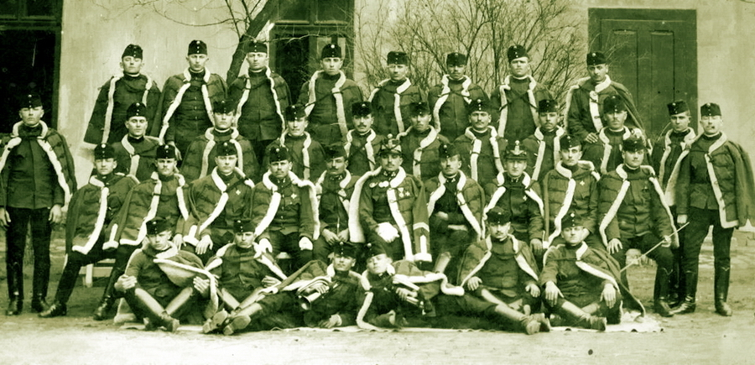
The hussars maintained a distinctly recognizable uniform throughout the war. Photo from 1917.
Not all Hungarians who participated in the Civil War in Russia fought for the Reds. Some Hungarian officers voluntarily served in the detachments of atamans Dutov and Semyonov and acted as advisors in Kolchak's army. They took part in punitive operations against Red partisans and rebellious peasants behind the White armies.
In general, when characterizing the involvement of Hungarians in the battles of the Civil War, Soviet military specialists in research from the 1920s and 1930s noted the resilience of internationalists in combat and their high morale. The Red Hungarians practically never surrendered, knowing what awaited them if they were captured. It was also pointed out that the international units were cohesive, with fighters and commanders often referring to each other as brothers. Finally, Hungarians were distinguished by their good training, especially compared to the first voluntary Red Guard units, and their high technical proficiency. For this reason, Hungarians were often assigned as machine gunners, which led to myths about the "masses of Hungarian machine gunners in Red shock troops."
Characteristically, there were cavalry detachments made up of former Hungarian hussar prisoners of war, operating on the fronts in the Volga region, Turkestan, and Ukraine. These were some of the few cavalry units of the Reds that could match the professional White Cossack cavalry. Unlike most prisoners of war, the hussars preserved their bright uniforms and refused to fight in Red Army gymnasts and greatcoats, making them easily recognizable to both their own and the enemy.

“Menjünk haza!” — “Let’s go home!”
What became of the Hungarian internationalists? Many, as previously mentioned, returned to their homeland in 1919 and took part in the struggles for Soviet Hungary. Following the defeat of the Hungarian Revolution, most faced repression. Those who survived lived as ordinary workers and peasants, keeping in touch with the Communist Party of Hungary, which during World War II was referred to as the "Peace Party."
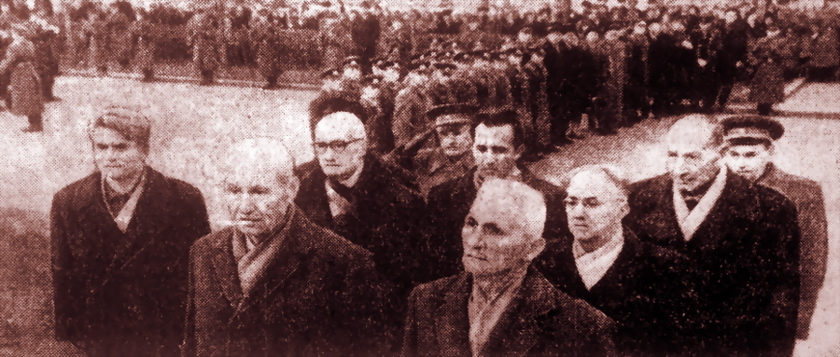
Hungarian veterans of the Civil War in Russia, who fought in the "Samara Communard" unit, during a visit to Kuibyshev (formerly and currently Samara), 1965 (photo from a local newspaper)
The same applies to the internationalists who arrived in Hungary after 1919. Following the end of the Civil War in Russia, they were demobilized en masse and largely returned to their homeland. The Soviet authorities often attempted to conceal them among the other returning prisoners of war. Those who passed through filtration camps faced a challenging working life. Those who did not pass faced concentration camps, imprisonment, or execution.
All these individuals never forgot their internationalist past; they were members of the Communist Party or sympathized with it. In 1944-1945, during the battles on Hungarian territory, numerous instances were recorded of former internationalists participating in partisan anti-fascist groups and assisting the Red Army as guides, scouts, and translators.
Those who remained in the USSR primarily served in the Red Army and intelligence, as well as working in the Comintern. Hungarians actively participated in defending the republican government in Spain, and during the Great Patriotic War, they collaborated with Hungarian prisoners of war and commanded anti-fascist Hungarian partisan units. Subsequently, these personnel were utilized in the formation of the Hungarian People's Army. Those who "earned their place" entered Soviet educational institutions and contributed to the national economy — thus becoming ordinary Soviet citizens.
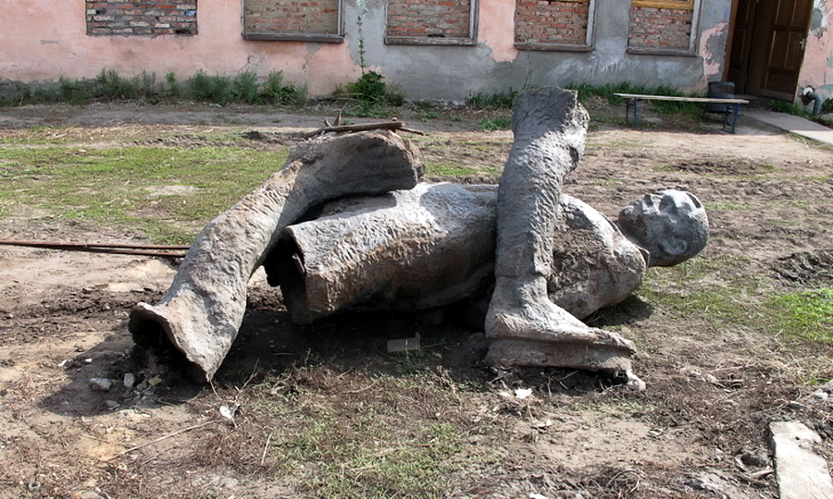
Times are changing. While the authorities in Omsk have been deliberating for several years on whether to erect a monument to Admiral Kolchak, the monument to Károly Ligeti, who was executed here, has been decaying in a dilapidated state for nearly 20 years in the back of the local communal services yard.
In the post-war years, meetings and congresses of former internationalists took place in the USSR and the Hungarian People's Republic. Collections of memoirs were published, and delegations visited the sites of past battles. Gradually, this process diminished for objective reasons, and by the early 1990s, it had nearly come to an end. Now, memories of the "red Magyars" are becoming increasingly scarce.

Sources:
- J. Kende, L. Gecsényi, A. Steinbach. — Hungarian Revolutions of 1918 and 1919 — Moscow, "Politizdat," 1969
- Hungarian Internationalists in the October Revolution and the Civil War in the USSR. Collection of documents in two volumes — Moscow: "Politizdat," 1968
- Gai G.D. — In the Battles for Simbirsk — Ulyanovsk, Typolithography No. 1 of the Municipal Trust, 1928
- Guseva Y.N. — Turkish Prisoners of War of World War I in Samara Province / New Historical Herald — 2016 — No. 2
- Hungarian Internationalists in the Great October Socialist Revolution. Collection of documents from the Military-Historical Institute of the Hungarian People's Army — Moscow: "Voenizdat," 1959
- Hungarian Internationalists in Siberia and the Far East, 1917–1922 — Moscow: "Nauka," 1980
- A. Jozsa, G. Milei. — Hungarian Internationalists in the Struggle for the Victory of October. In two volumes — Moscow: "Progress," 1977
- History of Hungary. In three volumes — Moscow: "Nauka," 1972
- R. Garashin.— Red Hussars — Moscow: "Voenizdat," 1970
- E. Ludendorff. — My Memories of the War 1914–1918 — Moscow: "Gosizdat," 1924
- Kopylov V.R. Central Bodies for the Formation of International Units of the Red Army (1918–1920) / October Revolution and Proletarian Internationalism — Moscow: "Nauka," 1970
- P.A. Olsson — Prisoners and Angels of War: Swedish Aid Workers during the First World War — Stockholm: Historiska Media, 2018 P.A. Olsson.

Original article

