'Anarcho-Capitalist' President Elected in Argentina: How Did This Happen?
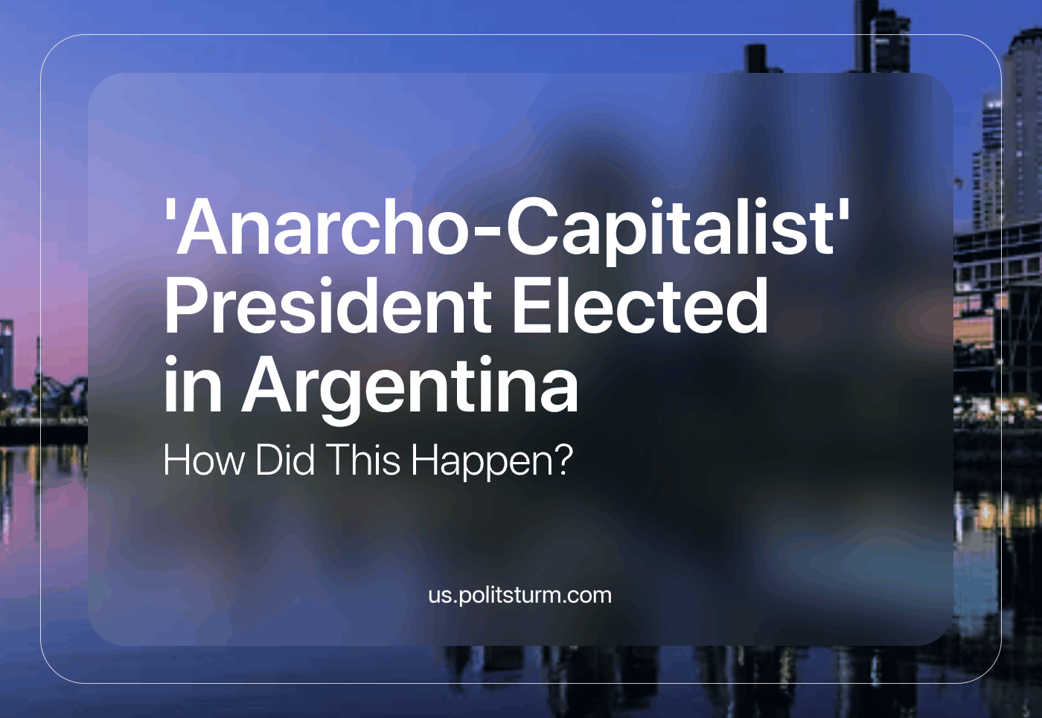

Original article
2023-12-23
18 min read

Recently, the elected president of Argentina, Javier Milei, took possession of his seat in office after winning the last of three electoral rounds against the Economic Minister of the former government [1]. It’s not surprising that even someone with evidently poor mental health [2] and aggressive rhetoric could win an election against the traditional political forces in the context of a deep economic crisis with signals of hyperinflation [1].
However, this restricts the analysis to conform within a superficial explanation without truly understanding the situation and drawing conclusions from it. Marxism is characterized by exposing the relationships between historical events and their social background. Thus, it finds the causes of them in the unavoidable conflict between social classes.
The first actor we need to understand for this analysis is Peronism, the ideological framework of the former government and the biggest political force in Argentina since the latter half of the 20th century. Juan Domingo Perón, the founder of the movement, was an army officer who adhered to the military coup of José Félix Uriburu against Hipólito Yrigoyen [3]. Yrigoyen was a liberal reformist that nationalized oil and incorporated, to some degree, the urban petty bourgeoisie and the provinces in the management of the state while promoting some wealth redistribution policies [4]. Uriburu carried out most of his government (1922-1930) under state-of-siege in alliance with the most reactionary proponents of nationalism, including admirers of fascism [3] [4]. After the death of Uriburu, the government chief office was assumed by Agustín Justo (1932–1938), a retired military engineer who continued the persecution of Yrigoyenists, socialists, communists, and anarchists under limited republican formalities in alliance with moderate and traditional sectors [3] [4].
Perón participated in both military governments and then in a new coup in 1943, occupied a higher position; the Minister of Labor. In this new military regime, headed by Edelmiro Farrell, the biggest independent trade union federation—the CGT #2, influenced by socialists and communists—was dissolved. At the same time, the subordination of the other trade union confederation—CGT #1, influenced by right-wing socialists — was established. Perón implemented some reforms with the aim of using CGT #1 as the basis of creating a single military-controlled union movement imitating the Francoist regime of Spain. At the end of the Farrell government, Perón was detained, but his popularity forced Farrell to release him and resume the republican order, Perón got elected president after that.
These quotes are illustrative of Perón's intentions [5].
“Harmony between capital and labor, inseparable extremes of the production process, is an essential condition for the economic development of the country, for the development of its productive forces, and for the strengthening of social peace. [...] We seek to overcome the class struggle, replacing it with a fair agreement between workers and bosses, under the protection of the justice that emanates from the State.”
Juan Domingo Perón, Speech, November 1, 1943. Translated from [5].
“It has been said, gentlemen, that I am an enemy of capital, and if you observe what I have just told you, you will not find any defender, we would say, more determined than me, because I know that the defense of the interests of businessmen, industrialists, merchants is the defense of the State itself. Do not be afraid of my unionism; capitalism will never be better than now, since I am also one [of you] because I have a farm and workers there. [...] What I want is to organize the workers at a state level so that the State directs them and sets their course; in this way, the ideological and revolutionary currents that could endanger our post-war capitalist society will be neutralized within them. That is why I believe that if I were the owner of a factory, it would not be difficult for me to win the affection of my workers with social work carried out intelligently. Many times it is achieved with the doctor who goes to the house of a worker who has a sick child; with a small gift on a particular day; or with the boss who passes by and pats his men kindly and speaks to them from time to time, just as we do with our soldiers.” – Juan Domingo Perón, Stock Exchange Speech, August 25, 1944. Translated from [5].
"I would never have forgiven myself when I grew old for having been in Italy and not having met a man as great as Mussolini. He gave me the impression of a colossus when he received me at the Venice Palace. It cannot be said that I was a newbie and felt shy in front of great men. I had already met many. Furthermore, my Italian was as perfect as my Spanish. I entered directly into his office, where he was writing; he looked up at me attentively and came to greet me. I told him that, knowing his gigantic work, I would not have gone happy to my country without having shaken his hand. (...) Until Mussolini's ascension to power, the nation went on one side and the worker on the other. (...) I already knew the doctrine of National Socialism. I had read many books about Hitler. I had read it not only in Spanish, but also in Italian Mein Kampf." – Torcuato Luca de Tena, Juan Domingo Perón, Luis Calvo and Estebán Peicovich, I, Juan Domingo Perón: autobiographical story, 1976. Translated from [5].
Naturally, Perón had fascism as one of his main ideological influences, but given the international context after the Second World War, he maneuvered skillfully. He expressed ambiguous sympathy for all of the political positions that advocated for class conciliation, from fascism and the social doctrine of the Catholic Church to social democracy. During all of his governments, he followed erratic policies, trying to combine the proposals of the aforementioned political schools and adapt them to the Argentinian reality.
His first term as elected president (1946–1952) started with five-year “plans” (dependent on the cooperation of the capitalists) along with the purchase of the railway network from European capitals and some pro-labor reforms. This was enabled by favorable prices of the agrarian commodities exported by Argentina. Then, in 1949, the prices of Argentinian exports fell, so Perón’s government was forced to reduce state spending, give incentives to foreign capital, subsidize large estate agrarian production, and let salaries sink against rising inflation. His second term (1952–1955) was therefore the continuation of those conservative policies for the sake of stability. Similar outcomes arose from the third presidential term of Perón (1973–1974), but we must remember that similar crises occurred at the same time in other commodity-exporting countries. This reveals that Perón only followed the ebbs and flows of the world market and the policies pushed by international finance capital through the IMF and the World Bank [5].
In the political sphere, Perón grouped around himself diverse political trends that agreed only in their nationalism and economic interventionism [5]. While he was in government, the right-wing factions were very present in the cabinet, especially in repressive matters and had the state’s full support against the left-wing Peronists [6]. Two eloquent signals of this are firstly the creation of the Special Section—a police division in charge of the torture and forced disappearance of left-wing activists—in 1946. And secondly the foundation of the Argentine Anti-Communist Alliance—an alliance between the armed forces and terrorist organizations of the Peronist right-wing—by José López Rega, one of the Perón ministers in his third term [7]. During his terms, the exterior policy of Argentina closely followed the directives from the USA; this in no way contradicted Argentina’s participation in the “Non-Aligned” movement or its protection of Nazi war criminals. When Perón was deposed by the army in 1955, he fled to countries under reactionary regimes including Paraguay and Spain. Only in this situation, he gave some support to the left-wing factions of his supporters to press for his return and the legalization of the Peronist movement [5].
During his exile, the movement grew, and within it, a silent conflict between the original right-wing sectors (military and CGT) and the left-wing (Peronist Youth) developed, with each one claiming to be the original Peronism and accusing the other of being infiltrators. When Perón returned to Argentina in 1973, the right-wing armed groups massacred the masses waiting for their leader at the Ezeiza Airport, receiving a weak armed response from the left-wing Peronist urban guerrillas. Perón himself called for peace between the trends but implicitly supported the right-wing nationalists, and in the following years, he called for “cleaning” the movement of “Marxist infiltrators”.
This internal purge used both legal (intervention of local governments and base structures) and illegal (terror and assassinations) measures against anyone suspected of being “Marxist”. Accusations were frequently used by local leaders to get rid of rivals. Obviously, this persecution was in line with the Cold War state terror around the rest of the world, so it occurred in parallel with the persecution of non-Peronist left-wing organizations [7].
After the death of Perón and the end of the military junta that followed, unsurprisingly, the Peronist movement navigated within its ideological ambiguity. In 1989, Carlos Menem became president under Peronist flags, but his policies were not very different from the liberal consensus of those years. His policies were things like ending the “Welfare State” with drastic privatizations, removals of labor rights, and subsidized services while international trade and diplomacy were submitted to US interests. Menem got elected again in 1995 under Peronist flags, despite the apparent conflict between Menen’s and Perón’s policies. Then, in 2003, the face we know as Peronism reached the executive chief office again. Néstor Kirchner became president that year and started a period of pro-labor reforms that focused on informal workers but kept intact the commodity-exporting (and capitalist) character of Argentina. This resulted in the creation of a loyal mass of voters who depend on subsidies to live [9] [10].
Now, analyzing the counterpart (anti-Peronism), we can say that it’s just as ambiguous and internally divided as Peronism [11]. Since 1946, anti-Peronist candidates have only won presidential elections against Peronist candidates in 1983, 1999 [11], 2015, and 2023. The ideology of the mainstream anti-Peronist bloc tends to orbit around republican formalism, free-trade liberalism, and anti-worker elitism [11]. All of these elements could seem to be the antithesis of the foundations of the counterpart, but that applies solely in the rhetorical sphere.
We already mentioned that Perón took part in a military coup against Yrigoyen and his attempt to nationalize the oil sector, that his second term was characterized by a return to the conservative policies of the traditional elite, and that through all of his political career, he used and advocated for counter-revolutionary terror. In this last topic, we should mention that anti-Peronism is also not innocent. Some months before the 1955 coup, the armed forces bombed a Peronist civilian demonstration in the main square of Buenos Aires (May Square) [12]. Apart from that, state terror was deeply rooted in the armed forces, at least in the last century, and was applied equally by both nationalist and liberal military officers.
From a class perspective, we can say that before Perón, Argentina was governed by conservative agrarian large-estate owners and liberal urban emergent commercial and manufacturing bourgeoisie. With Yrigoyen, the latter sector became nationalist, aiming to establish a semi-independent industrial capitalism. Then, Perón initially acted in the interests of the conservative and liberal elites but migrated to nationalism inspired by fascism and maneuvered for his own benefit in line with the growing political consensus in the direction of economic intervention. Under his first two terms, the traditional elites formed a bloc and gained support among the military to defeat Perón, but were unable to connect with the working classes.
The workers were pushed towards Peronism by the anti-reformist attitude of the elites and the constant persecution of independent class representatives. The anti-Peronist elites were forced to allow their bourgeois rival in elections again in 1973 because of that lack of popular support and to avoid the left-wing radicalization of his supporters. Perón was unable to accomplish that, but after his death, the right-wing of his movement allied with their bourgeois rivals to eliminate any expression of reformist and revolutionary organizations with open terror while following liberal policies. Finally, since the 1990s, Peronism and anti-Peronism have become almost indistinguishable, despite the fact that the Peronists still have some political feuds in the union movement and impoverished masses dependent on state subsidies.
As an outsider actor in this dichotomy, the “anarcho-capitalist” movement arrived and gained relevancy by denouncing the corruption of both parties and calling them “socialists” and members of the “caste” [13]. It’s very obvious for any politically or economically literate person that socialism isn’t merely state intervention in the market, taxation, or even nationalizations and state-owned companies, but a fundamentally different mode of production. Socialism means that the whole economy is socially owned and centrally planned by a state that responds to the interests of the working masses with the goal of the complete elimination of the market—as the economic basis for the bourgeoisie—in favor of a consciously and scientifically planned flow of resources and production. Though the world has experienced the growth of this free-market fundamentalism in recent years, the recurrent inflation crises in Argentina gave them mass support and the chance to enter the government.
About inflation, liberal economists tend to point at money emission as the primary cause of inflation crises and they propose as a solution the reduction of government expenditures, the restriction of money printing to some level (for example, to the least necessary to buy the same quantity of dollars in order to keep the exchange rate constant), the liberalization of the economy through privatizations, and the reduction of state regulations [14]. Other liberal economists, without distancing themselves from placing the primary cause as excessive expenditure in relation to tax revenue, analyzed the problem more deeply and found that the exchange rate of the dollar was sometimes a cause instead of an effect of inflation and that the interest rate variations also played a role in the abrupt deficits of the Argentinian state.
They affirm this because the exchange rate increased the state debt already acquired and the rapid increases of the interest rate forced the state to create money to cover them [15]. Furthermore, the latter group of economists says that liberal policies such as deregulating the exchange rate and interest, opening the economy to foreign debt, deregulating the banking sector, financing the deficit with privatizations, or compensating for the falling of the local currency with the purchase of dollars were also causes of future economic crises [15]. Above all, we can observe how one real central factor was not identified in those bourgeois studies, namely: the dependence of the country on the international market and the finance sector.
On the other side, the growing popularity of ultra-liberal thought in Latin America and the rest of the world didn’t take place because of the superiority of these theories or the benefits those proposals could reap for the wide masses. As with any other capitalist political movement, it has its main support in that same ruling class. Concretely, the main organization behind the phenomenon is the Atlas Economic Research Foundation (a.k.a. the Atlas Network), a “think tank” inspired by the ideas of Ludwig von Mises, Friedrich Hayek, and Ayn Rand, with the notable sponsorship of the billionaire Koch brothers and the US government-funded National Endowment for Democracy [16]. This network is behind political events such as the coups against Dilma Roussef in Brazil and Manuel Zelaya in Honduras. This “research foundation” also has close ties with Donald Trump (some of their cadres were part of his administration) and supports several reactionary political figures in Latin America [16]. It’s worth mentioning the fact that the Atlas Network branch in Argentina was integrated into the political party of Mauricio Macri [16] and is now the core of Milei’s political movement [17]. Ironically, Milei accused Macri of being a socialist in the first part of his campaign.
Now, after Milei’s first days in the office, Argentinian workers are suffering heavy price increases—meat prices rose by 40% and fuel prices by 37%, for example—while the Security Ministry announced the armed forces would not tolerate any road blockages from protesters and would not limit the violence they would use for dissolving them [18]. However, the financial markets reacted well to these measures; in other words, these changes had been received favorably by the owners of the financial-industrial monopolies that control the Argentinian economy. At the same time the unions, Peronists and independents in parallel, and other popular organizations are calling for mass demonstrations and a general strike [18].
The cabinet of this new government includes some Macri ministers, defenders of previous state officials involved in money laundering and drug dealing, open admirers of Nazism, other “anarcho-capitalists” who advocate for the legalization of the sale of human organs and children [19] (as Milei did). Also, the vice president is a denialist of the crimes of the last military regime. From this, we can clearly see that the only freedom this new government defends is the freedom from work that the capital owners enjoy because we are forced to do that for them.
Out of all of this, we must draw some conclusions. First, we as Communists should insist on the necessity of organizational and political independence for our party and our mass organizations, along with our ideological independence by remaining critical towards national myths. Conditioning our activity to the reformist will of the bourgeoisie will only make us fail in the long term when those reforms are no longer needed by the class enemy and the masses are too weak to demand them. Second, this independence should not be left to the spontaneity of the mass movement since it would only give the bourgeois and reactionary trends a free hand to grow amongst the working masses. Third, in order to counteract the ideological influence of all the bourgeois trends, we need to have our own theoretical platform and teaching organs, which should work coherently with the rest of the organisms needed for the coordination and execution of the political activity of our class. This last point is nothing else but the necessity of an organization of professional revolutionaries in charge of training the cadres of the working class and being the expression of their consciousness to the full extent. And finally, it’s not strictly necessary for the capitalists in the current context to carry out their violent repression of the masses and the “anti-democratic” adjustments of their state through classic fascist movements; they only needed state intervention, mass open repression and significant reforms when a workers’ state was already showing the world that industrial production can feed an entire country and develop without private owners. Now they have no effective class opposition, so they can rely more so on their propagandistic dogma of individual merit and freedom, while their violence and “dirty work” is carried out by the state under formal democracy and eventually by fanatic individuals they have no easily demonstrable relation with [20] [21].
Sources:
[1] https://www.reuters.com/world/americas/sergio-massa-argentina-economy-chief-charms-voters-with-tax-cuts-payouts-2023-11-16
[2] https://www.forbes.com/sites/afontevecchia/2023/09/29/javier-milei-telepathic-conversations-with-dogs-and-god-a-troubled-youth-and-the-issue-of-mental-health/
[3] https://www.laprensa.com.ar/Peron-y-el-golpe-del-6-de-septiembre-de-1930-506264.note.aspx
[4] http://lanic.utexas.edu/project/etext/llilas/ilassa/2008/plans.pdf
[5] https://bitacoramarxistaleninista.blogspot.com/2021/01/peron-el-fascismo-la-argentina-equipo.html
[6] https://www.laizquierdadiario.com/Peron-y-la-Policia-Federal-un-largo-romance-criminal
[7] https://acontracorriente.chass.ncsu.edu/index.php/acontracorriente/article/download/10/124/544
[8] https://clas.berkeley.edu/sites/default/files/publications/brlas_spring_2007_05-24-07a_6.pdf
[9] https://latinoamerica21.com/en/menems-imprint-on-argentine-democracy/
[10] https://theglobalamericans.org/2023/06/kirchnerism-is-in-crisis-but-peronism-will-survive/
[11] https://www.lavoz.com.ar/supletemas/los-atributos-del-antiperonismo/
[12] https://www.cipdh.gob.ar/memorias-situadas/en/lugar-de-memoria/del-cielo-los-vieron-llegar-monumento-a-las-victimas-de-los-bombardeos-a-plaza-de-mayo-de-1955/
[13] https://english.elpais.com/international/2023-11-01/javier-mileis-u-turn-on-macri-how-argentinas-former-president-went-from-foe-to-friend.html
[14] https://www.reed.edu/economics/parker/f10/201/cases/Argentina.html
[15] https://manifold.bfi.uchicago.edu/read/case-of-argentina/section/9905ef24-8c94-42ad-adf7-068efb4d9afb
[16] https://theintercept.com/2017/08/09/atlas-network-alejandro-chafuen-libertarian-think-tank-latin-america-brazil/
[17] https://foreignpolicy.com/2023/11/16/argentina-election-milei-venezuela-machado-libertarianism-economics-us-influence/
[18] https://buenosairesherald.com/politics/what-we-know-about-javier-mileis-cabinet-so-far
[19] https://english.elpais.com/international/2023-12-18/javier-mileis-first-week-in-power-skyrocketing-prices-threats-of-repression-and-calm-in-the-financial-markets.html
[20] https://newsbeezer.com/mexicoeng/the-argentine-government-has-been-hacked-by-the-hentai-mafia-kudasai/
[21] https://www.enelsubte.com/noticias/cayeron-los-autores-de-las-amenazas-de-bomba-eran-militantes-de-milei/

Original article

