How Ukrainian Capitalists Drive the Country into Debt Void
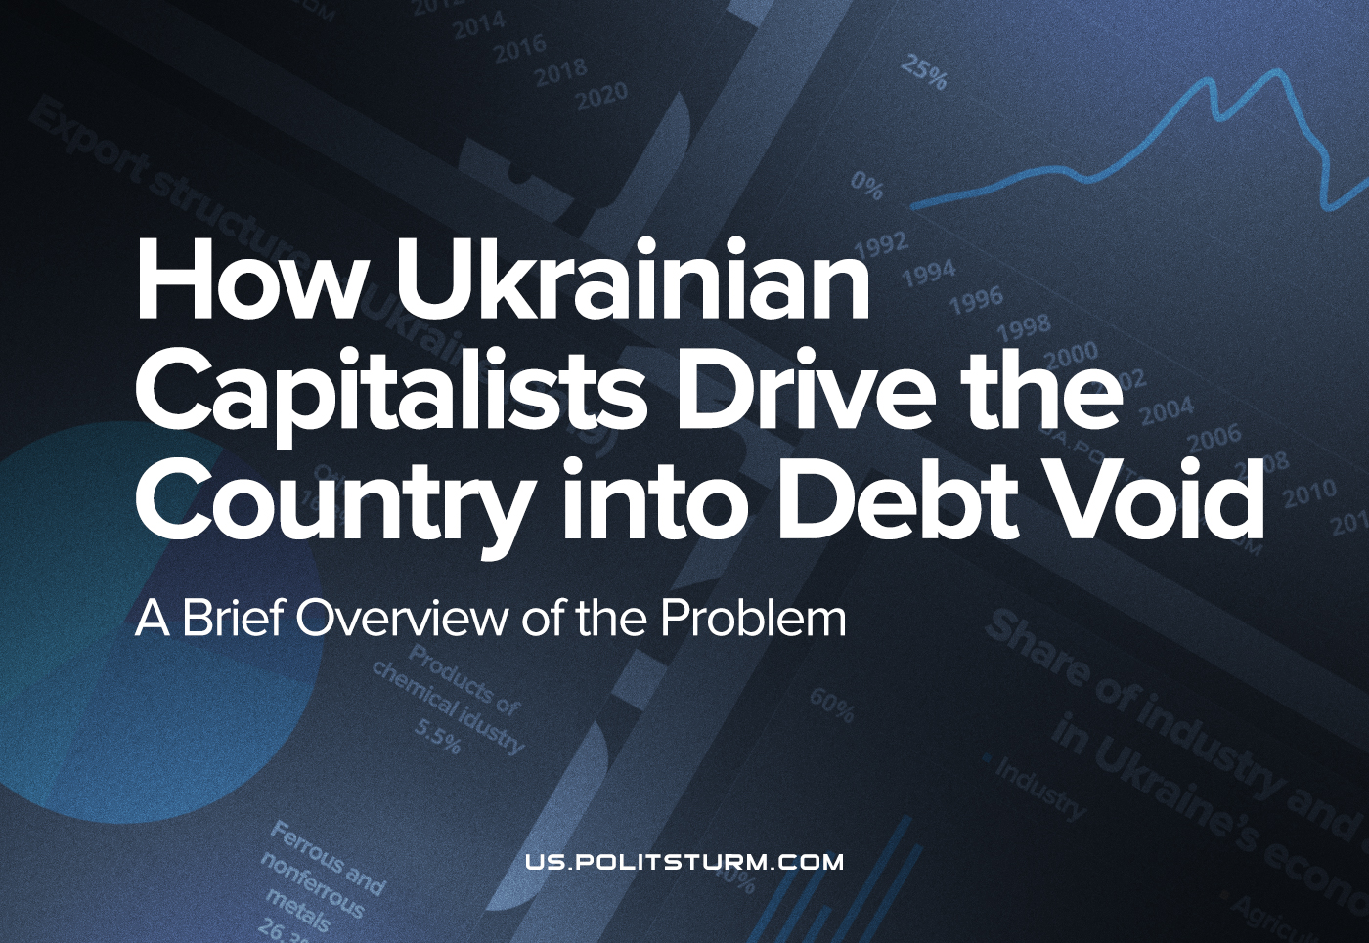

Original article
2022-09-05
21 min read

The hostilities that began at the end of February 2022 in Ukraine have resulted in massive destruction. It was a great opportunity for the Ukrainian government to demand from the world community the cancellation of its debts, which were accumulated over many years to various foreign creditors. First and foremost, these are debts to the IMF, which has already issued such cancellations for about 25 countries due to the outbreak of COVID.
In our material, we want to describe in greater detail the current state of Ukraine’s economy and what the cancellation of Ukraine’s external debt promises to the capitalists, who are the true beneficiaries of this, and most importantly, how languid these demands are.

General Information About the External Debt of Ukraine
By the end of 2021, Ukraine’s external debt amounted to $125 billion, more than 40% of this is due to state obligations. Moreover, the cost of repaying a debt this high requires annual spending of almost half of the state budget.
Due to this, the flailing economy of Ukraine has an increased sensitivity to world economic crises. This was clearly demonstrated after the beginning of the pandemic in 2020 when the budget deficit reached a record level since the beginning of the conflict in Donbas in 2014 and amounted to $11 billion.
To eliminate this deficit, the capitalist government was once again forced to turn to foreign loans. At the same time, the repayment of the continuously growing external obligations became practically impossible without new tranches of money from the IMF with the absence of any other cash infusions into the economy. The IMF itself was already strongly dissatisfied with Ukraine’s failure to meet pre-agreed requirements.
It should be noted that the IMF, when issuing loans, obliges the government of the debtor state to carry out a number of reforms aimed at reducing the role of the state in the economy, reducing social spending and much more.
An example of this is the end of the Standby Agreement announced by the IMF in 2020. It approved the issuing of four loans with a total sum of about 5 billion dollars, of which 2.1 billion dollars were to be given immediately. But since the conditions of the agreement (i.e. the IMF sanctioned reforms) have not been met by Ukraine, the second tranche was reduced to $700 million and allocated as late as November 2021.
Stand-by credit – is a special form of IMF credit in which the fund reserves a specified amount set by the due date, the client uses it in part or in full, depending on the need for a loan.
In this case, the country is assured that it can automatically borrow in foreign currency within the amounts at any time during the life of the loan’s securities and under the restriction of its conditions. Such a loan is usually granted for a period of up to two years.
Error loading image
Thus, despite the periodic debt restructuring, Ukraine’s financial dependence on the advanced capitalist countries is growing from year to year, tightening the debt noose around the neck of the Ukrainian working class and depriving the country of the possibility of growth. It is notable that according to the Ministry of Finance, the total Ukrainian state and state-guaranteed debt in 2021 reached 48.9% of GDP.
The safe level of debt – is the level at which the government can:
- Fulfil its debt obligations in a timely manner and in full without the help of international financial organisations (or other entities), without being forced to restructure or reform at the request of these organisations or defaulting.
- Carry out public borrowing in the capital markets at acceptable interest rates.
According to various domestic and foreign studies, this level, for Ukraine, is about 35% of GDP. This conclusion was based on the statistics of countries that have defaulted on their debt in emerging markets, and on Ukraine’s own experience. Ukraine was unable to fulfil its debt obligations twice before, both times with a lower level of debt than the current level.
Ukraine’s prior defaults happened first in the late 1990s (which led to a restructuring of public debt) and then in the late 2000s, when Ukraine turned to international financial organisations for assistance, where the total amount of the relief loans Ukraine received was the second largest in the world (after the IMF assistance for Hungary).

Economic Development Tax
In 2015, another debt restructuring happened which was designed to save the country which was depleted by the war in the East, from defaulting again, the threat of which was obvious to both Ukrainian and Western capitalists. Due to this, in 2019, the government had to pay about $15 billion in debt repayment and servicing, and there was simply nowhere for them to get these funds.
After 2019, as part of the restructuring of the debt (which had grown to $18 billion), 20% was written off, and the repayment of the remaining amount was delayed for 4 years, with an increase of the percentage service charge from 7.2% to 7.75%. However, the situation would be much more simple if the written-off debts were not compensated with the issuance of GDP warrants as compensation, which is due in 2040.
A warrant – is a derivative, i.e. an exchange contract widely used in the stock market. This instrument gives the owner the right to buy the company’s shares at a predetermined price in the future.
In the field of public debt, warrants are guarantees that require repayment depending on certain indicators of the national economy.
Despite the fact that the total nominal value of these specific derivatives is $3.24 billion, in the end, the initial amount might be a multiple of the total annual income, since it is directly linked to Ukraine’s GDP and calculated as a percentage of its growth.
The situation is as follows:
- If the country’s GDP growth rate in the reporting year is less than 3%, then the number of payments will be equal to 0 (which is why there will be no payments on warrants in 2022, because in 2020 Ukraine’s GDP fell by 4%).
- If the GDP growth rate is from 3% to 4%, then the number of payments rises to 15% of the level of growth over 3% of GDP. For example, if GDP grew by 3.5%, then the number of payments is calculated from 0.5% of GDP – i.e.,15% of 3.5 minus 3, which will be 0.075% of total GDP for the reporting year.
- If the GDP growth rate exceeds 4%, then the number of payments will be 40% of the level of growth over 4, plus payments for GDP growth from 3% to 4%.
Therefore, if GDP growth is 3.5% by 2040, then the total payments on warrants would reach $5.7 billion, and if the growth is 4.3%, then the payment would be as much as $27 billion. If, before 2040, Ukraine’s economy demonstrates the growth of an average of 5.7% per year, warrant payments would amount to approximately $82 billion which was more than half of Ukraine’s total GDP for 2021.
Error loading image
It should additionally be considered that according to the terms of the 2019 agreement, debt payments have to be made in foreign currency, and this will inevitably have a negative impact on the Hryvnia exchange rate and the position of the state budget. The ruling class of Ukraine agreed to these conditions, destroying all prospects for the development of the domestic economy, in order to write off $3.6 billion of their debt.
However, Ukraine has not known GDP growth rates above 4% for more than ten years. While maintaining the current trajectory, it is theoretically possible that the economic growth rate until 2040 will not exceed the mark of 3%, which will completely eliminate the need for Ukraine to fulfil the debt obligations under the GDP warrants. But it is obvious that these machinations will be beneficial only for the capitalist class, but not for the working majority, especially because such a scenario requires the absence of any quick recovery and development of the country after the end of current hostilities.

Causes of the Debt
Ukraine is entirely dependent on foreign capital and serves as a raw material base, a source of cheap labour and a commodity market. In terms of real GDP per capita in 2021, it hasn’t yet surpassed Soviet levels, lagging behind 1990 by 13%.
This was greatly facilitated by the deindustrialisation carried out throughout the thirty years of “independence”. This included the destruction of science-intensive production, which led to the very existence of domestic science being called into question, as well as other industries that were unprofitable for the ruling class, which previously served as pillars of Ukrainian economic strength and self-sufficiency.
Error loading image
Subsequently, the share of industry in the country’s GDP has fallen from 50% to 20%, and the rate of production growth fell from 20% to 9%. During the years of “independence”, the share of constant capital expenditure (e.g. the purchase of machine tools, equipment, construction of buildings and real estate) decreased from 30–35% in the 1990s to 10–15% in the 2010s.
Error loading image
High-tech production requires a significant investment of funds but provides profit only in the long term. At the same time, the export of material resources, the sale of Soviet-era industry and equipment, and the reorientation of the economy to the raw materials industries give the capitalists the needed short-term profit at a minimal cost.
Error loading image
That is why Ukraine’s exports are dominated by commodities, agricultural products, ores and coal, while Ukraine’s main imports are machinery, medicines, electronics and refined petroleum products.
Since the global financial crisis in 2008, commodity prices have generally declined, and the intensity of exploitation of Ukraine by foreign monopolies has increased as the terms of trade deals have worsened, as evidenced by the fall in the following index, which is calculated as the ratio of export prices to import prices.
Error loading image
The above factors force the ruling class of Ukraine to continuously increase the value of loans, thereby prolonging the life of the market economy in Ukraine. Of course, none of them care for the consequences, because they are placed squarely on the shoulders of the working class, left to the mercy of fate.
But the fate of the Ukrainian proletariat is not limited to poverty, unemployment and lack of rights. Along with the destruction of industry and the degradation of science that followed the liquidation of the Soviet Union, the working class of Ukraine (as well as other former Soviet Republics) received another “privilege”, one afforded especially to those who live in dependent capitalist countries – the prospect of dying during the next armed confrontation for the redivision of spheres of influence in the interests of imperialist states.

Is it Possible to Solve the Problem?
In the field of information, several common demands are put forward in which some people see a miracle cure for the existing problem in the country. Among them we highlight the following:
- nationalisation of the property of oligarchs (local and/or foreign) for post-war reconstruction;
- gratuitous write-off of external debt.
Politicians and other public figures of the left wing, not limited to those who put forward such demands, consider the capitalist state not as an instrument of the class domination of the minority over the majority, but as some kind of independent body in the system of social relations, which plays only the role of a regulator in an abstract social democratic society of consent and unity between the capitalist and the worker.
In reality, however, the state is not divorced from society, but is, in fact, most intimately connected with it. Moreover, society itself is not homogeneous, but it is divided into social groups – classes – defined by their various conditions of life, productive relations and social and material inequality. As a consequence, these groups have different objective interests, which gives rise to contradictions and antagonisms between them.
The social class that owns all the means of production in the country (land, resources, enterprises, etc.) has the ability to impose its will on other classes, force them to work for them and derive material benefits from their labour, therefore making them a class of exploiters. For the effective implementation of this task, the state machine is subordinate to this class and serves it with all its power, financial and information levers of coercion.
In turn, the class that is deprived of the means of production, i.e. those who own nothing except their ability to work, and therefore are forced to sell themselves, to work for their exploiters, is a class that is, in turn, exploited, oppressed and robbed. And most importantly, it has the objective class interest in changing this unfair state of affairs in society for good, by freeing their labour from its current status as a commodity.
It would seem that nationalisation, i.e. the socialisation of the means of production is a logical solution, but it is precisely the specific conditions within which it is carried out, that are important.
Firstly, if political power, and hence the state, remains in the hands of the exploiting class, i.e. the capitalist class, and if its representatives sit on the boards of the nationalised branches of the economy and control them, and the nationalised branches continue to operate on the basis of the exploitation of the labour of the working class in the interests of capital, then nationalisation in no way improves the fate of the workers.
Just as before, they will be forced to work, but now for state-owned enterprises, and the fruits of their labour will again, end up appropriated by the capitalists as profit since the state itself is only an apparatus of violence, oppression and robbery in the capitalists’ hands.
Consequently, the demand for nationalisation by itself, viewed as isolated from the class nature of the social system and the state, is idle chatter that has nothing to do with the interests of the workers, since to really socialise the means of production is only possible if the working class takes full political power from the ruling capitalist class.
Secondly, writing off external debt alone will not save Ukraine from the system that caused the debt to reach such high levels in the first place. This problem is the very capitalist mode of production in the country.
Ukraine declared its “independence” 30 years ago with the goal of being able to get rich by forming a separate national market (labour, goods and capital), the newly formed capitalist class in Ukraine (as well as in other post-Soviet countries) immediately set about privatisation, i.e. the appropriation and division of the means of production created by the labour of millions of Soviet workers. In an effort to ensure maximum profit, capital reared it’s ugly head to retain only those industries that allowed it to enrich itself to the greatest degree in the shortest possible time (as is determined by the law of value).
In other words, after the destruction of the USSR, Ukraine’s integration into the world capitalist system took place at the cost of losing its own economic potential, i.e. the loss of that very economic independence, without which any sovereignty, which the Ukrainian ruling class boasts about so freely, is simply impossible.
Now the question is raised about restoring the country after the hostilities that have caused enormous damage to infrastructure (according to various estimates, this is about $40-60 billion), agriculture (the projected harvest of grain and oilseeds may decrease by 51% compared to last year) and industry (the general director of Metinvest, Rinata Akhmetova, announced the loss of 30-40% of the capacity of the country’s metallurgical industry).
Moreover, according to the Ministry of Finance, $10 billion is spent per month on the armed conflict, and Prime Minister Denys Shmyhal said that the economic losses to date have amounted to approximately 35% of the GDP. Obviously, the current conditions make the payment of external debt impossible in the coming years.
Thus, in this regard, we must draw attention to two example scenarios concerning the development of events:
a) Either, the government defaults, after which a long process of economic recovery begins, carried out by increasing the exploitation of the working class, taking new loans and creating new debts.
b) The government seeks to write off the external debt, and after that a long process of economic recovery begins, carried out by increasing the exploitation of the working class, taking new loans and creating new debts.
In this case, the Ukrainian people are offered to change their old noose for a new one. Under capitalism, there are no other real alternatives for the workers. And no reforms, no actions of “international solidarity”, no appeals to international institutions and, more importantly, no appeals to imperialist states, will change anything significant. The consequences of the steady impoverishment of the population of Ukraine, which has been aggravated by the armed confrontation unleashed by the capitalists, will fall on the shoulders of the working class.

Conclusion
The only way out of the current catastrophic situation into which the capitalists have brought the people of Ukraine is the “socialisation” of the state, i.e. the taking of political power by the working class of the country into its own hands. And only after that it is really possible to nationalise (socialise) the means of production, i.e. bring them to the public ownership of the entire working class of the country, establish their interaction and joint work within the framework of a unified system of economic planning, which takes into account the needs and interests of all members of society, and as a result – the end of exploitation of man by man.
Such a “socialised” state is socialist. In it, all the fullness of political power and economic dominance belongs to the multi-million working class, and not to a handful of oligarchs and other parasitic capitalists, guided solely by considerations of personal gain and profiting from the robbery of millions of ordinary people.
It was not the millions of ordinary Ukrainian workers who took on foreign loans and credits, and even more so they did not manage them afterwards. This is what the ruling capitalist class of Ukraine has been doing and is doing, together with its servants; the Ukrainian government.
P.S.
At the beginning of the Russia’s “military operation”, a special procedure for the purchase of foreign currency was introduced for cross-border transfers in order to pay for “critical imports” by the NBU (National Bank of Ukraine) in decree №18.
A list of these imports was defined on the 24th of February by the cabinet №153 and expanded regularly. Initially, this list consisted of mainly fuel and foodstuffs, however, now the list has become significantly larger and includes even the following items:
◾️Internet-based subscription services and software access
◾️Advertisement services
◾️Repair services for cars’ interiors
___________
It is important to mention that the exchange currency rate for buying “critical imports” was equal to the official exchange rate fixed by NBU – 29.25 UAH/1 USD (01.03.22 – 21.07.22), however, the average exchange rate in Ukrainian banks was around 36-37 UAH/1 USD.
___________
Under the pretext of covering the budget deficit, the NBU had turned on the money printers, to give the Finance Ministry more funds (to support different programs, purchases etc.) and to refinance the banks at the same time, so they can continue to issue loans.
In June alone, the NBU printed 105 billion Hryvnia, of a total of 180 billion this year. It must be noted that they plan to print 200 billion more by the end of the year.
And now, ladies and gentlemen, your attention, please! Watch how the magic of capitalism makes all this disappear…
A Ukrainian capitalist can open a credit account in a bank and receive money in the form of a loan from the Finance Ministry due to the “critical imports” acquisition program. As a result of the program, all this new printed money will flow towards the foreign exchange market, where the NBU provides the capitalist with an exchange at the official rate (29.25 UAH/1 USD) from its international reserves (this is real money now).
Next, the capitalist can choose an item of “critical import” to buy abroad, overstating the price of the commodity, if they choose to, to the NBU. When the Ukrainian capitalist buys the commodity at its real price they have the opportunity to send the excess foreign currency they received from the NBU to offshore accounts, or to smuggle it back into Ukraine where it can be exchanged back into Hryvnia at a higher rate (36-37 UAH/1 USD). As a result, each excess dollar gives the capitalist a profit of around 8 UAH solely from currency exchange, let alone the fact that the Ukrainian capitalist can still freely sell the acquired goods in the domestic market at a higher price than what they bought it for.
And this can be repeated again and again, as long as the NBU’s international reserves allow it.
This policy of the ruling class has already led to a theft of $7 billion from the NBU’s gold and foreign exchange reserves, of which $22.8 billion currently remain. It must be mentioned that the gross external debt of Ukraine is currently $127.46 billion.
In view of this, S&P, Moody’s and Fitch have all simultaneously downgraded Ukraine’s credit rating to a near default level. Consequently, very few international investors will take the risk to allocate the funds to the Ukrainian government, even to cover older debts.
As a result, we see that the government serves the capitalists by handing them these credits and squandering the country’s international reserves. However, these debts will have to eventually be paid off… with the wealth created by the Ukrainian workers.

Original article

