How Socialism Stops Crises
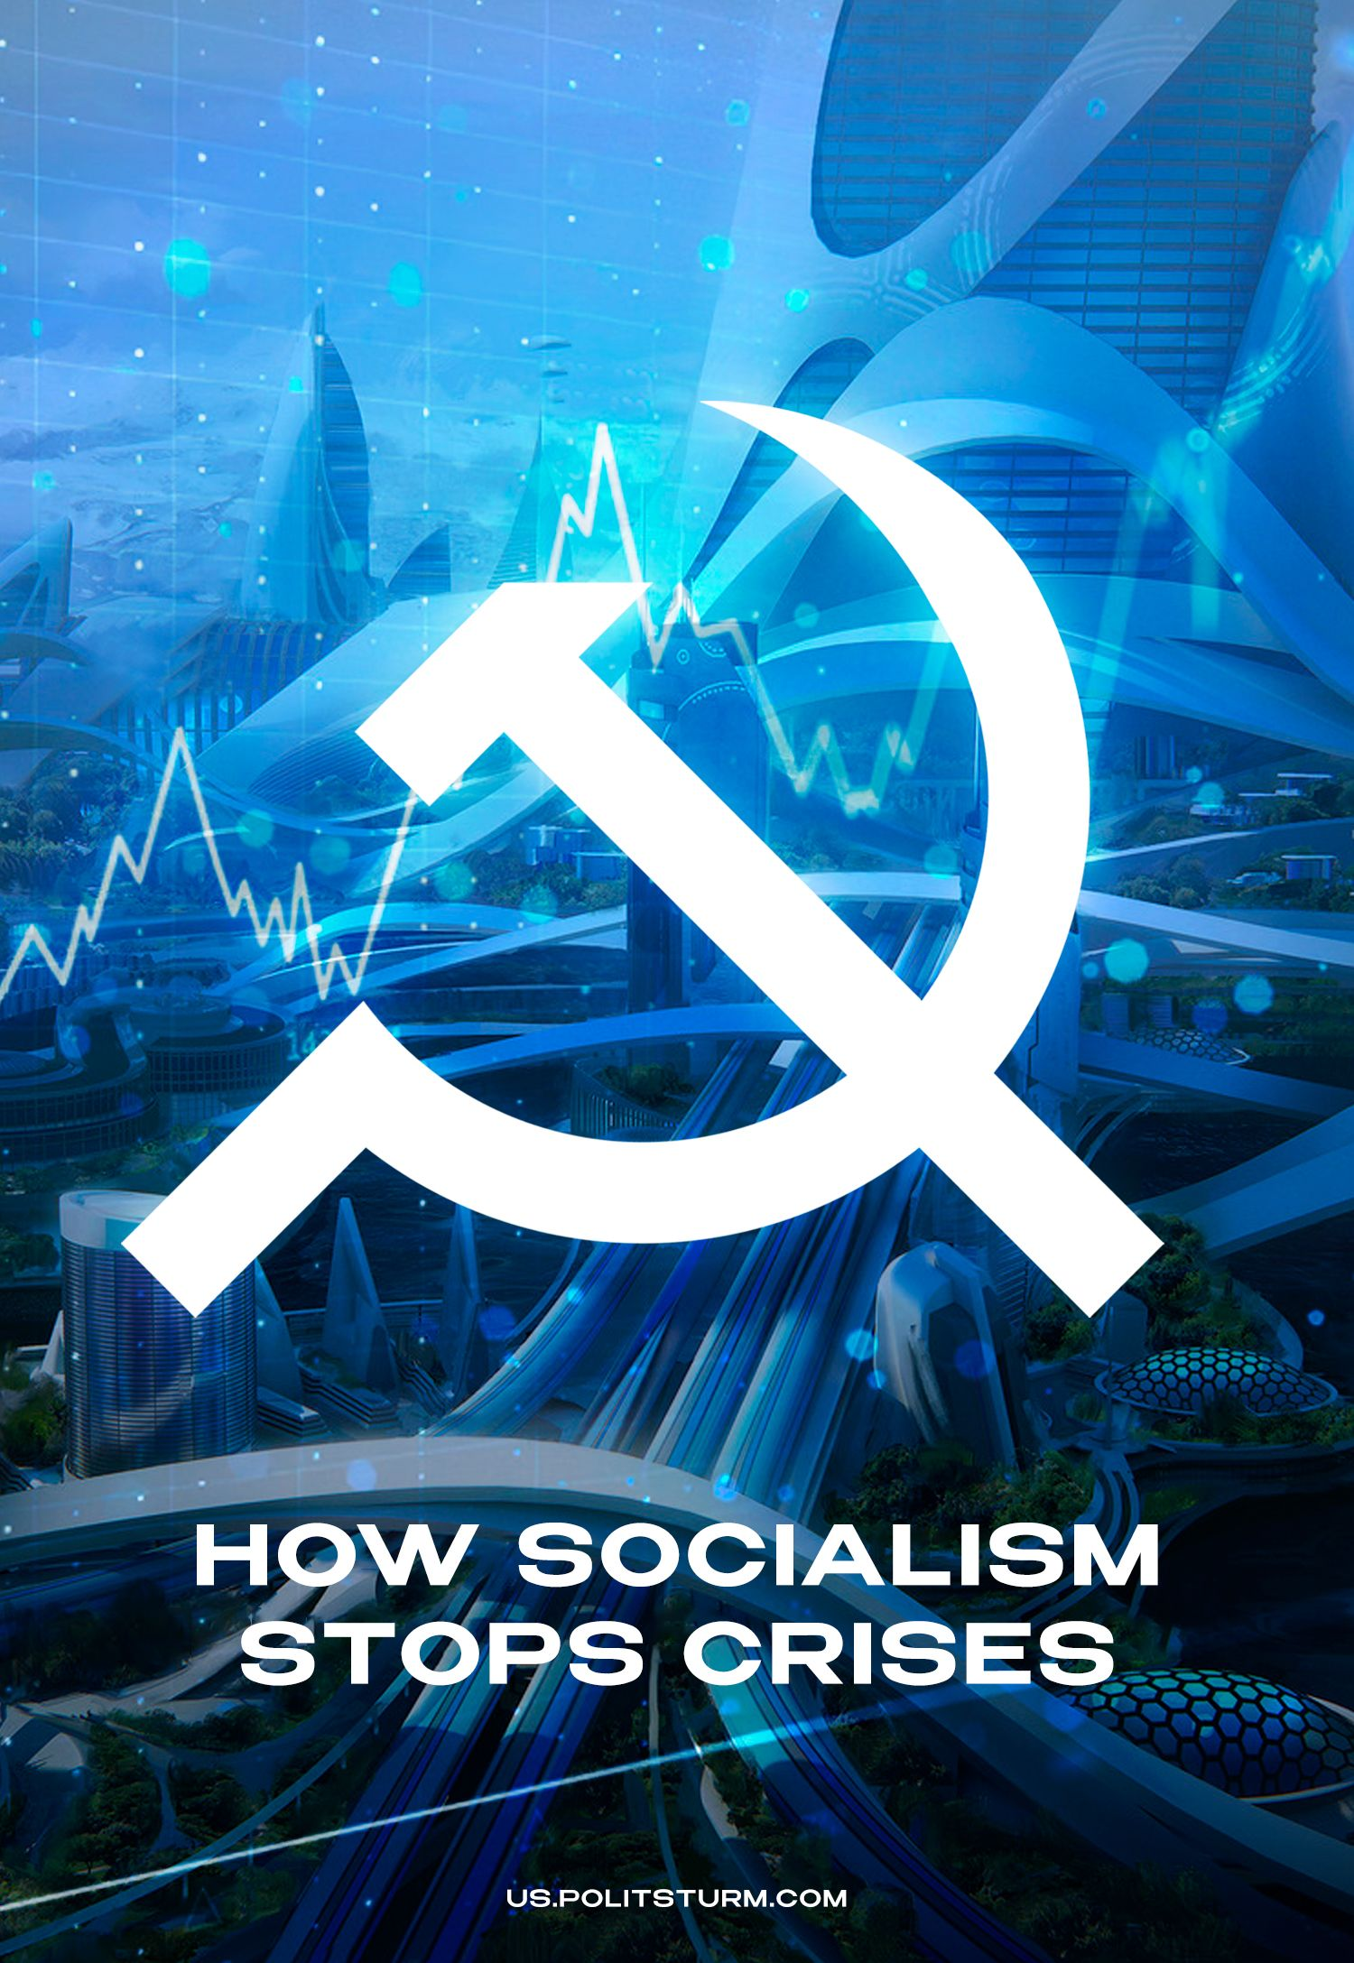

Original article
2023-10-16
26 min read

Crisis is a common phenomenon in today's economy, and every reader has felt the effects of crises in the past, as well as experiencing crises in the present. Politicians and economists find excuses for crises in the greed or ambition of individual states or politicians, but each of them turns a blind eye to the systemic nature of what is happening.
Marx described the nature of crises back in the nineteenth century, and since then we have had the scientific justification that the "failures" that occur in the system of capitalism are its normal workings and inherent nature, not an accident or error. Therefore, economic crises will never disappear from our lives as long as capitalism exists.

1. What is Crisis?
The economic crisis under capitalism is primarily characterized by overproduction and is an extreme aggravation of the contradictions of the capitalist mode of production in which the goods produced are not marketable, since there are far more produced than the population is able to buy.
It is important to note that overproduction of goods is not absolute but relative. Overproduction of goods exists in relation to effective demand, not to the real needs of the population.
The crisis of overproduction is characteristic of capitalist expanded reproduction, and its basis is the contradiction between the social character of labour and the private appropriation of its products.
Expanded reproduction is the repetition of the process of capital reproduction with the investment of part of the received surplus value in the expansion of production [1]. The driving force behind expanded reproduction is entrepreneurs' pursuit of an increase in surplus value and, ultimately, profit. The same motive of expanded capitalist reproduction is competition between entrepreneurs. It follows that expanded reproduction leads to an increase in the exploitation of workers.
The cause of the crisis is not expanded reproduction itself, but the anarchy of production inherent in capitalism.
Anarchy of production is a unplanned, chaotic management of the economy, when economic laws act not according to the idea of the managers, but spontaneously, "as it happens. Anarchy of production does not mean that the capitalist economy is not planned at all, at an individual enterprise everything can and does go according to the plan drawn up by management. But globally, in terms of macroeconomic processes, countless private enterprises act on the basis of market conditions, i.e. spontaneously, which leads to crises.
What is more, due to expanded reproduction, the exploitation of labour increases, capitalist relations encompass more and more people. Because of the desire to increase surplus value and due to competition, the entrepreneur gradually reduces the wages of the worker (this is expressed not only in a reduction of wages, but also in an increase in working hours, inflation, etc.), thus reducing the solvent demand of the population, which brings the crisis of overproduction closer.
Thus, during these processes there is, first, an absolute impoverishment of workers, i.e., a direct decline in living standards (because of inflation, increased exploitation, etc.), and also a relative impoverishment of workers, i.e., an increase in the share to entrepreneurs in the aggregate national income.
As a result, the constant increase in the number of manufactured goods, combined with the systematic impoverishment of the population and the decline in purchasing power, leads to a collapse, followed by even greater impoverishment of workers, the ruin of industries and the renewal of the more successful part of industry.

At the labour exchange.
It is also worth noting that the crisis of overproduction does not affect one or a few countries, but the whole capitalist system.
As we shall see from the first overproduction crisis in history, that of 1825, the economies of countries existed together since the very first stages of the development of capitalism. There is a global division of labour, i.e., naturally some regions are able to produce some goods more efficiently. Thus there is a dependence of some countries on others.
In addition to the global division of labour, there is also a division of roles among countries in the global market. In the past, there was a colonial system that led to non-equivalent exchanges between colonies and metropolises, making workers in colonial countries most vulnerable to crises. In today's environment, there are countries whose economies are focused mainly on the export of raw materials. If production collapses in one part of the world, stopping production there, a collapse in the countries who are exporters of raw materials inevitably follows.
These properties, when a crisis of overproduction occurs, contribute to the transfer of its consequences by the domino effect: from one region to another. At the same time, problems during the crisis have a cumulative and opposite effect, which increases its impact on people’s lives.
Crises of overproduction are cyclical in nature. All crises have a common structure: crisis, depression, revival, expansion.
Crisis. This is the phase when the contradictions of capitalism are exacerbated to the limit. It is during the crisis that the most painful events for the workers occur: the collapse of the stock-exchange, the decline in the profitability of enterprises, the ruin of the masses, bankruptcies and closures of industries, increased unemployment, rapid inflation, the destruction of necessary goods.
Depression. This is the phase of stagnation, when prices of goods are falling, but trade is sluggish. Capitalists strive to find a way out of the depression by lowering the cost of production. During this phase, the prerequisites for a subsequent recovery are created.
Revival. Production and trade levels gradually return to normal, enterprises move to expand production, and corporate profits rise.
Expension. This is characterized by a peak in consumption, expansion of production, and credit. Prices rise and traders tend to stockpile goods in anticipation of even greater growth, forcing industrialists to expand production further, for which banks provide credit. This allows production to expand beyond solvent demand, thereby setting the stage for a new crisis. Overproduction already exists, but in a hidden form [1].
It is worth noting that this is only a general scheme describing the mechanism of crises. Each situation requires specific study, differs in intensity and has different ways out of the crisis. In this case, one of the simplest ways out of the crisis is wars.
In order for the system of capitalism to function successfully, it needs to be "bloodletting" to kick-start production and to entice workers with chauvinistic rhetoric and distract them from examining the true causes of what is happening. Examples here are the Great Depression, followed by World War II, and the current 'SMO', which occurred during a global crisis amidst a pandemic.
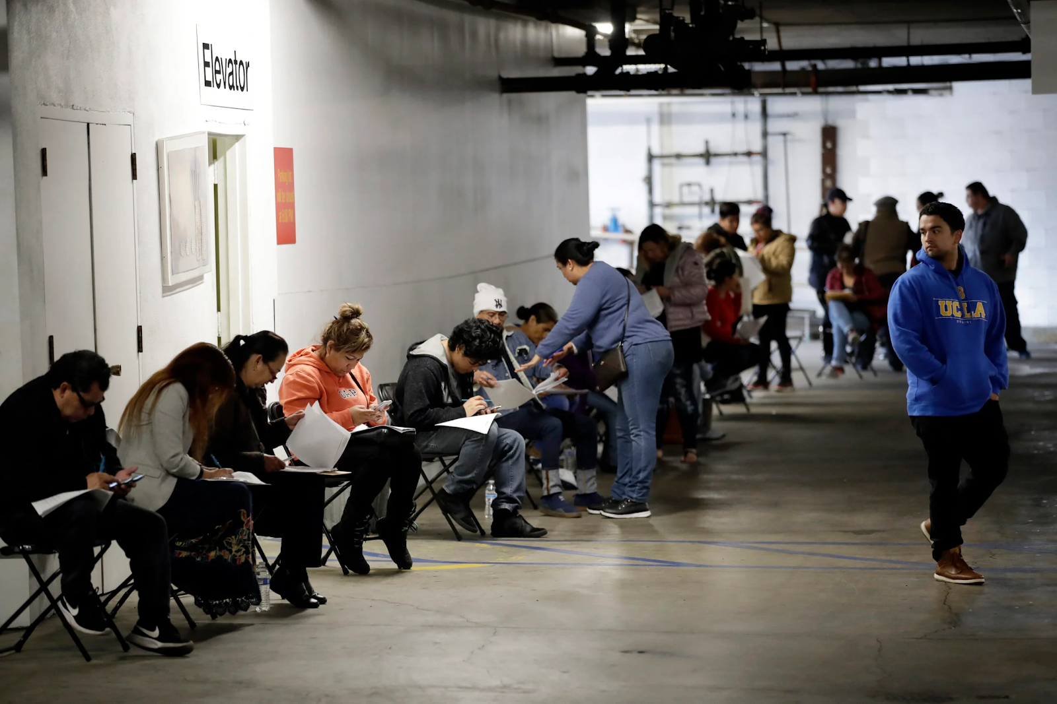
Queue to apply for unemployment benefits. Los Angeles, 2020
Note that although the 2020 crisis coincided with the COVID-19 pandemic, it had been expected [2] by economic experts a year before. The pandemic only multiplied it.
Further below we will look at several specific examples of overproduction crises.

2. History of Crises
Crises of overproduction, as a new socio-economic phenomenon, emerged in the era of industrial capitalism.
As the capitalist mode of production developed, the crises, while retaining their basic essence, changed some characteristic features. First of all: they became more and more destructive, causing not only an acute economic and socio-political crisis, but also armed conflicts, up to and including world wars.

2.1 Crises in the Age of Industrial Capitalism
The first crisis of overproduction is considered the crisis of 1825 in England. By this time capitalist relations in England were sufficiently developed to demonstrate in all their glory the contradictions that existed in them.
The years 1821-1825 were characterized by a high rate of industrial development, mainly in cotton and iron and steel. Cotton and iron consumption during this period increased by 47.4% and 57.9%, respectively. A distinctive feature of this period is the growth of foreign trade. Since the year 1820 imports had increased by 35.6% and exports by 15.1%.
In addition to the domestic economic development of the country, a major role in the economic rise of England in the early nineteenth century was played by the availability of large amounts of money capital. It was difficult to employ it in England itself because of low profitability, so British capitalists began to export capital and goods to the newly liberated former colonies of Spain in Latin America.
The export of capital and goods to Latin America spurred the development of the cotton, iron and steel, and railroad industries. In addition, credit developed: of the 40 million pounds sterling foreign loans made in London's money market, about half came from Latin America.
All this became the basis for the growth of joint-stock companies and speculation. The demand for stocks was enormous, and the masses, warmed by advertising, eagerly bought up securities in anticipation of good profits.
This is how contemporaries described the situation:
"All the propensities of human nature for excitement," wrote the Annual Register, "were translated into action, and crowds of all kinds, the gullible, the suspicious, the cunning and the daring, the inexperienced and the tempted by experience, the intellectuals and the ignorant, the princes, the aristocrats, the politicians, patriots, officials, lawyers, doctors, clergy, philosophers, poets, women of all classes and fortunes, weavers, married women, and widows, all sought to take part in enterprises of which they hardly knew anything but the name."
On the one hand, speculation delayed the inevitable, as it served to expand production, but on the other, it prefigured the severity of the coming crisis.
In the spring of 1825 it became clear that the hopes for an inexhaustible market in Latin America were unfounded, and the truth was much more bitter - the solvent demand of the countries of the region did not cover the export of goods.
Exports began to fall, the speculative "boom" was in full swing, prices in England were rising, and imports reached a peak of 42 million pounds sterling. The market was overflowing with capital and goods. When this became evident, there was a severe recession. The prices of some goods in 1826 compared with those in 1825 decreased many times over: cotton - by 62%, pepper - by 32%, iron - 25%, etc.
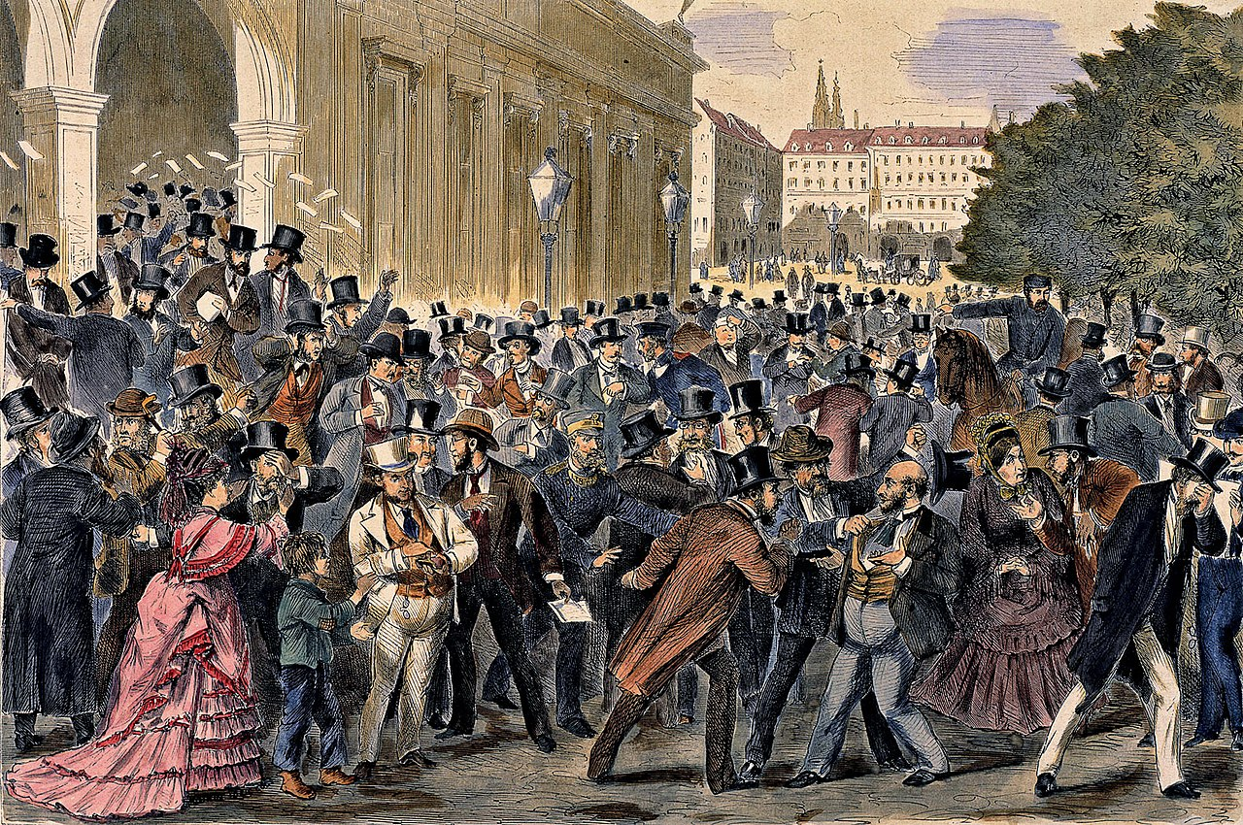
Black Friday May 9, 1873 on the Vienna Stock Exchange
In July 1825, there was a drop in the exchange rate. Illusions about the success of enterprises collapsed, people began to sell securities, resulting in a drop in exchange rates of 40% to 70%. At the same time, bank reserves were depleted, the English bank resisted increasing demands and stopped extending credit.
As a result of all these coinciding factors, a wave of bankruptcies swept across England, particularly affecting the cotton industry. For example, in 1824 there were 999 bankruptcies, in 1825 there were 1,141, and in 1826 there were 2,590.
Before December 25th, over 60 provincial and London banks stopped making payments, and provincial bank bills were no longer accepted at all, requiring only metal money. The Bank of England had to use its metal reserves to save the financial system from bankruptcy; at the peak of the crisis the bank had only 3.9% of the total money in circulation in metal reserves.
The crisis of 1825 led to the ruin of small and medium-sized proprietors, who invested their capital in the stock exchange in anticipation of profits. In this way, the crisis of overproduction eliminated most of the small and medium-sized capitalists, strengthening the centralization of capital in the hands of big industrialists and financiers. This crisis also affected the United States, Latin America and European countries [3].

2.2 Crises in the Age of Imperialism
Crises of overproduction in the imperialist era unfold on the basis of the general crisis of capitalism, and because of the high degree of monopolization of production have a devastating, catastrophic nature.
Despite the claims of the bourgeois economists of the time that monopolies resolve the contradictions of capitalism, in fact they exacerbate them many times over. Such was the crisis of 1929, legitimately dubbed the "Great Depression.
After the world war, the capitalist countries overcame the crisis of 1920-1921 rather quickly. By 1927 the economy surpassed its pre-war level and cartelization was rapid. According to the estimates of the League of Nations, the total turnover of the world trade increased by 86.2% compared with 1913. This was mainly due to industrial growth in the USA.
The rapid growth of the economy naturally spurred and expanded consumption. In the most developed Western countries (with the exception of France) the so-called "prosperity" era began.
A characteristic feature of the industrial boom was that the growth and expansion of production was due to improvements in technology and the introduction of new methods of labour organization. For example, the conveyor belt appeared in Henry Ford's engineering plants.
Usually an increase in production is accompanied by a relative decrease in unemployment, but this time the army of unemployed far exceeded the level of pre-war unemployment. That is, even during the economic boom, the worker did not receive the benefits he was usually promised.
The cycle of 1923-1929 was characterized by great growth in the financial sector. This was especially true in the United States, a country where the economy was experiencing a particular economic boom. The development of finance was predetermined by the growth of production. The period of imperialism was generally characterized by the growth of securities due to the concentration of production.
As usual, there was already a hidden overproduction during the boom. From May-July 1929 a decline in production began, which was still too slow and therefore unnoticeable. The rapid decline in production began only in October. Production encountered a shortage of effective demand, while the intensity of speculation predetermined a catastrophic stock market collapse.
The scale of speculation can be judged by the fact that it involved not only professional stockbrokers, but also banks, industrial enterprises, foreign capital and the middle and petty bourgeoisie, and, finally, ordinary people lured to the stock exchange by advertising.
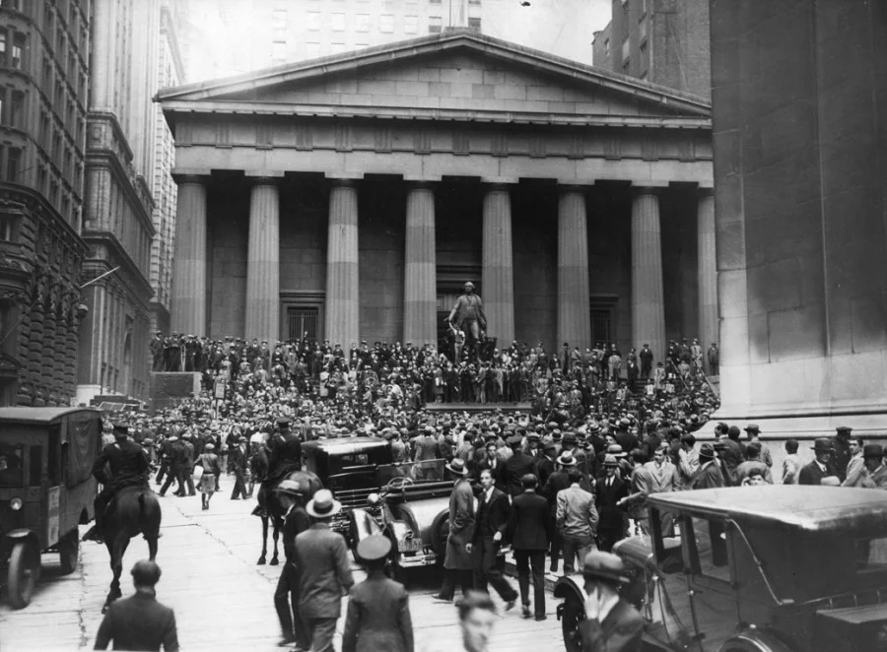
Black Thursday October 24, 1929 on Wall Street.
All this led to a stock market crash. The market fell 40% or $30 billion, more than U.S. military spending during World War I. At the same time, industrial rates fell by 87.4%. The stock market crash soon spread to capitalist European countries, causing a particularly monstrous economic crisis in England, France and Germany.
The economic crisis quickly spread to the rest of the capitalist world. Under the blows of the crisis the "stable" capitalist world was crumbling. A streak of state bankruptcies and a decline in world trade began. Bankruptcies among the petty and middle bourgeoisie numbered in the tens of thousands over several years.
The bankruptcy of firms and the consequent reduction of production did not bypass any country included in the world system of capitalism, especially the countries that exported raw materials. Thus, the currency of Uruguay depreciated by 56.9%, Argentina by 39.3% and Brazil by 48.2%.
The exceptional depth of the crisis of 1929 was expressed in the unprecedented fall in securities rates, the reduction of commercial and bank credit, the reduction in the number of private and state banks, the crisis of means of payment, the collapse of currencies, the disorganization of the international payment system.
Behind the percentages of production falling by a few tens of percent (England 23.8%, USA 46.2%, Germany 40.6%), the statistics of bankruptcies, the closure of banks, etc., behind the rising unemployment figures (in England, unemployment rose to 22.1%, in Germany to 43.8%) and the extraordinary duration of the crisis, lay poverty, destitution, hunger and violence against millions of working class representatives by the ruling class.
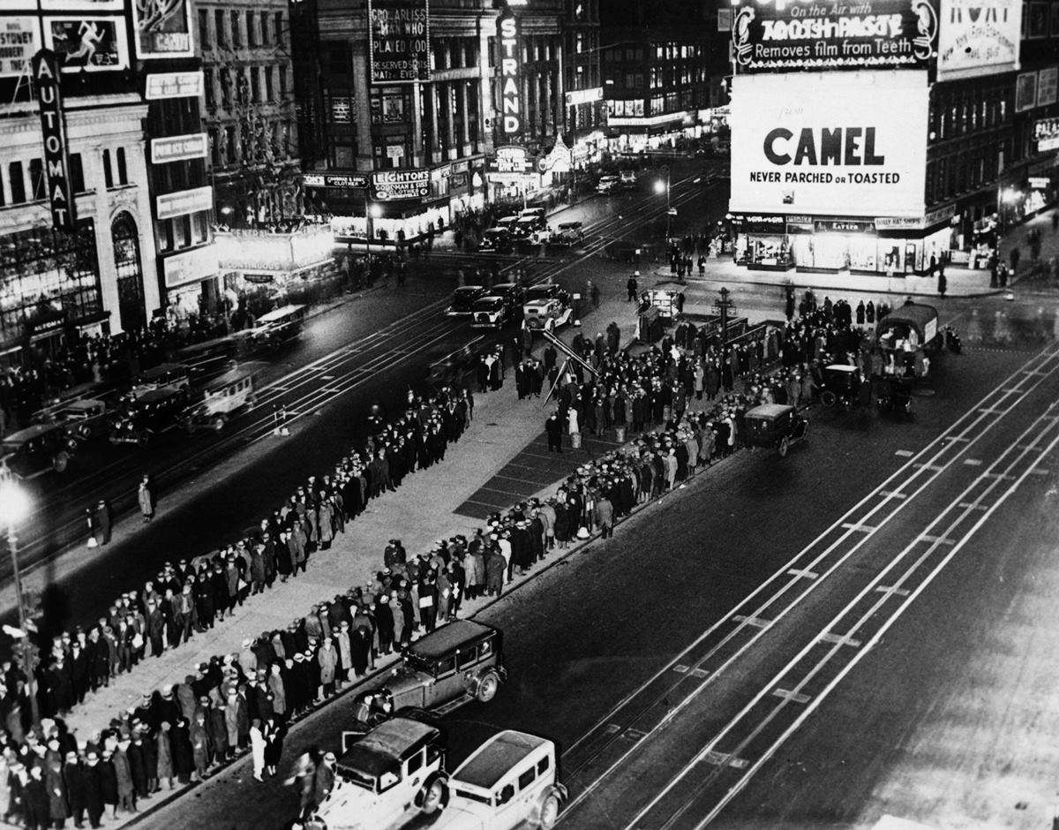
Queues for free food in Times Square. 1933
However bitter the irony, shortly before the Great Depression, the propagandists of capital were loudly proclaiming to the world that monopolies were good for the economy, because they eliminated the inherent competition of industries, lack of planning, etc., inherent in the era of industrial capitalism. [3].
2.3 The Modern Financial Crisis of 2007-2009.
In the era of monopolistic capitalism, the financial sector becomes especially important. This was already evident at the beginning of the twentieth century, in the example of the Great Depression. A century later, the financial character of overproduction crises became even more pronounced.
With the collapse of the world system of socialism, capitalism entered a period of relative stabilization. The emergence, due to the collapse of the USSR and the Eastern bloc, of new markets, the devastation of production facilities in the former Soviet Union, the access to unlimited resources in the hands of capital - stimulated the development of capitalist economies.
The victory of capitalism over communism allowed Western governments to roll back social policies. The doctrine of "neoliberalism" was increasingly attacking the economic well-being of American workers, as the graph below [4] clearly shows. As the degradation of socialism entered an acute phase, the relative and absolute impoverishment of the proletariat in the United States accelerated manifold.
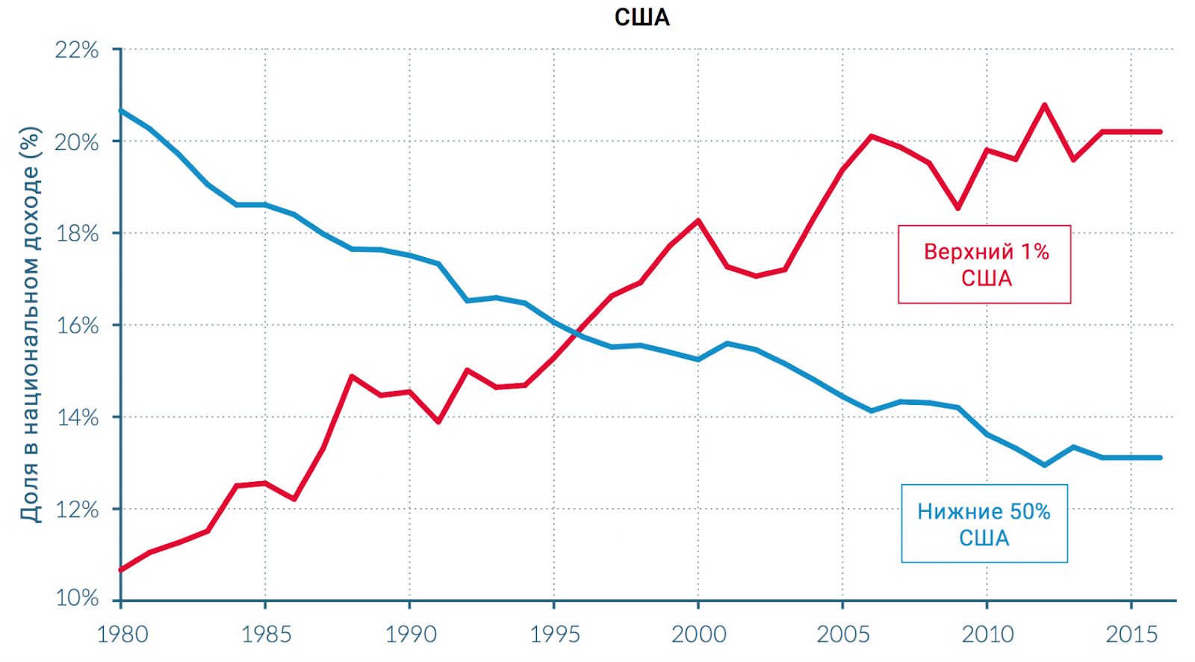
The share of national income attributable to the richest 1% and the poorest 50% of the U.S. population.
Capitalism got a break, but by the 2000's. the solvency of the population of the strongest capitalist country had fallen so low that the people were not able to consume all the goods produced. This disproportion between produced goods and solvent demand was particularly acute in the construction industry.
This problem was solved by cheap lending to an increasingly large segment of the population, especially in the area of mortgages. Cheap and unsecured credit for housing became an incentive for even greater expansion of production. Often, because of the high growth rate of housing prices, the purchase of such goods was speculative in nature. From 2004 to 2006, real estate prices increased at an average rate of 10% per year, leading to a doubling of home prices by 2007.
The huge amount of unsecured money in the economy could not be a perpetual engine for the endless expansion of production. Over time, it became obvious that the population could not pay back loans, even if they were cheap. Prices stopped rising, a gradual recession began.
Starting in 2006, real estate prices began to fall. According to Standard & Poor's, the fall was 20% of the market value in 2006. At the same time the Federal Reserve raised the Federal Funds rate from 1 to 5.25%.
The drop in home values and the rise in the cost of credit led to the fact that many borrowers simply refused to pay interest on loans, as it was not profitable for them - the market value of housing did not cover the loans. A series of defaults followed, which led to the collapse of the securities market, the mortgage market, and the bankruptcy of many financial companies.
World GDP by 2009 declined by 5.8% from the 2007 level. According to the ILO, the global unemployment rate increased by 0.8% compared to 2008, amounting to 6.6%. Naturally, this affected not only the advanced capitalist countries, but also the so-called "developing countries.
The crisis had a strong impact on the countries of Latin America and Asia. According to ECOSOC, from 2008 to 2009, Latin America and the Caribbean recorded a decline in GDP of 1.9 percent, or 3 percent per capita. The decline in economic growth was reflected in the employment structure of the population, increasing unemployment to 8.3%. At the same time, foreign direct investment fell by 39.1%.
Asian countries are particularly dependent on the international environment; the drop in demand in Western markets led to a reduction in production there. There was a sharp decline in agricultural prices, for example, cereal prices fell by as much as 50%. GDP in the region fell from 6.8% to 4.1%, which naturally increased unemployment [5].

3. Socialism and the Elimination of Crises of Overproduction
The crisis of overproduction, as we have found out, is an inherent property of capitalism. Bourgeois governments can postpone the crisis through cautious financial and banking policies and a system of state support. But they cannot overcome economic crises at all, as we have seen in modern history.
Hence, to get rid of crises it is necessary to eliminate their root cause. The transition to a socialist mode of production organization must be accomplished.

3.1 What is socialism?
One of the features of socialism is collectivised production in the hands of the workers' state, which means the disappearance of private property and capitalist exploitation.
Since production is entirely in the hands of the workers' state, it becomes possible to manage the economy through simple administration and scientific planning.
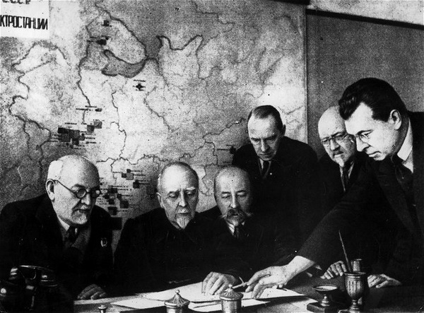
Meeting of the GOELRO Committee to develop a plan of electrification of the RSFSR. Moscow. 1920
Competition between individual producers disappears, and information about the state of the economy ceases to be a "trade secret". It becomes possible to collect and analyse information about the state of the entire economy and use it to calculate material production.
Now it is not the spontaneous rise or fall of prices, not the competition of individual market participants that act as indicators and instruments for the redirection of social labour from one branch to another - but the simple observation of production, based on the needs of society.
Moreover, socialist planning enables the gradual and purposeful development of the most socially important sectors of production, which ultimately leads to a consistent improvement in the quality of life of the workers.
Through the controlled development of the economy there arises the very possibility of using labour and material resources rationally.
The generalization of production, the elimination of the basic capitalist contradiction (between the public nature of labour and the private appropriation of its results), and scientific economic planning lead to the elimination of anarchy of production, which means the end of the vicious cycle of capitalist economic development, in which the phase of unrestrained, spontaneous accumulation is replaced by the phase of recession and depression.
A new era in human history is dawning in which the producers regain control of production and have the right to determine its tasks, relying first and foremost on their own material interests. The experience of the Soviet Union is a case in point.

3.2 The Successes of Socialism in the USSR
While the capitalist world was undergoing an economic crisis on an unprecedented scale, the Soviet government was building socialism and laying the foundation for future victories. The time of Stalin's industrialization, or - as it was officially called - socialist restructuring, still remains the period of the greatest economic breakthrough in modern history.
The USSR pioneered a scientific approach to planning throughout the economy.
Economic development was divided into five-year plans. The first five-year plan took place in 1928-1932. Its goals were to re-equip old enterprises, launch new ones, increase the output of resources, and emphasize heavy engineering.
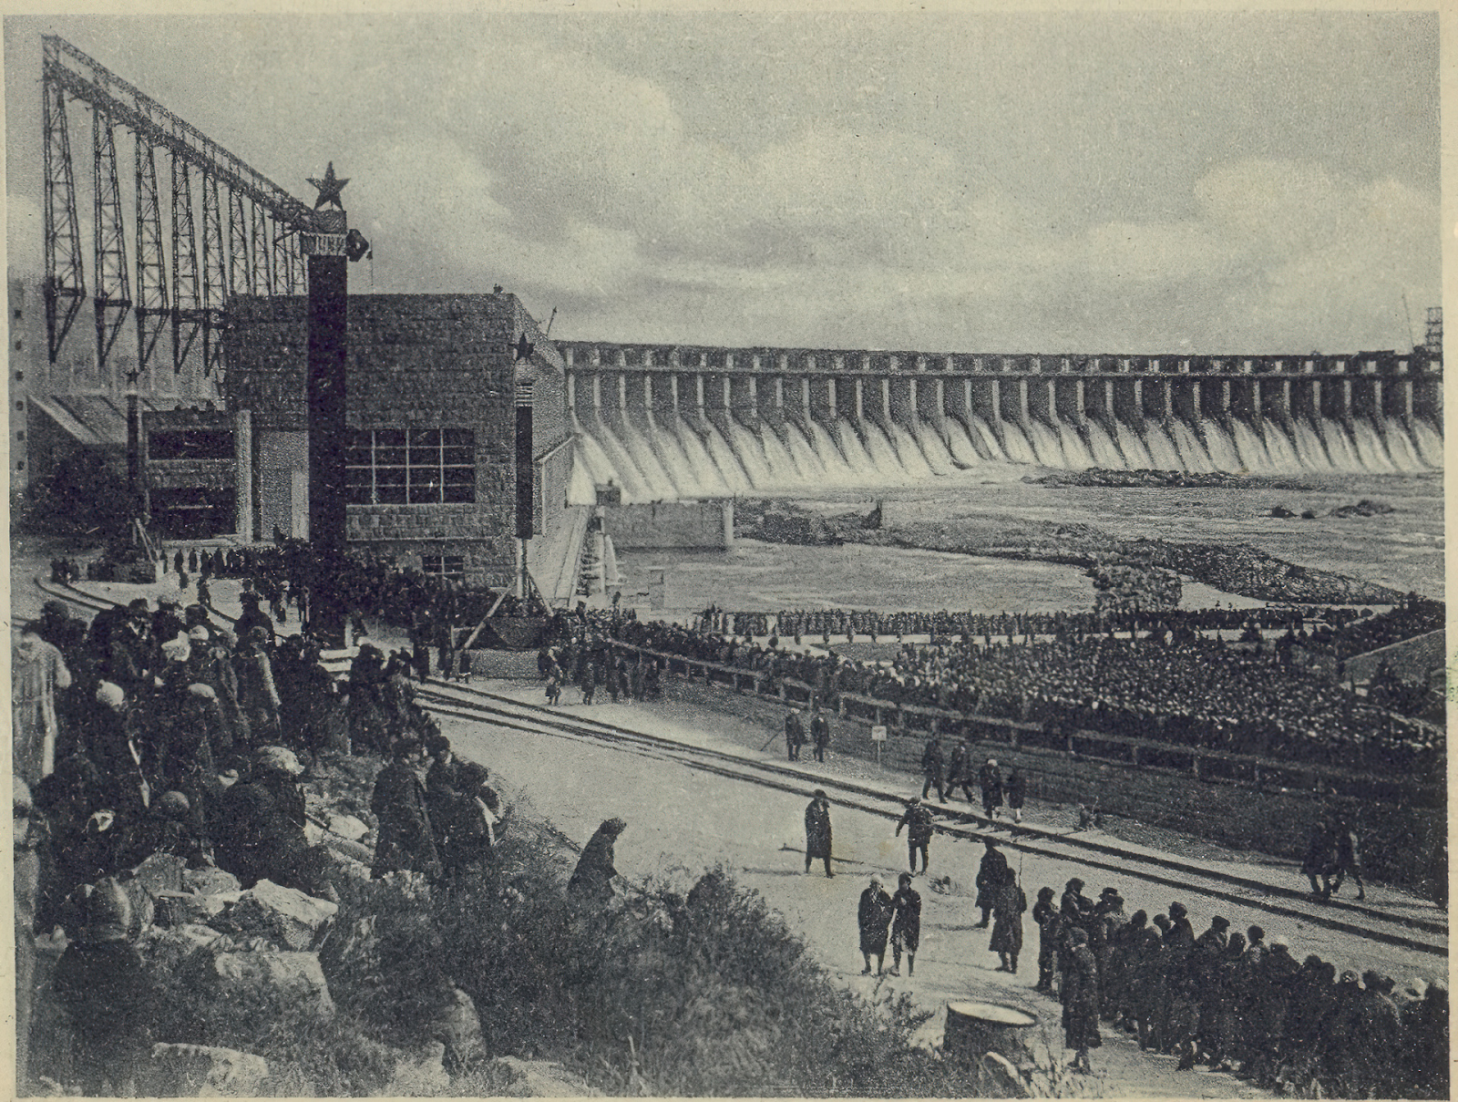
Dnieper Hydropower Plant. Rally on the opening day of October 10, 1932.
Thus, the production of iron, steel, coal, oil and other products necessary for more complex production increased by 1.5-2.5 times, the production of cars increased from 0.8 thousand pieces per year to 23.9 thousand pieces per year.
All in all, 500 new factories were erected and taking into account the power stations, mines and oil plants, there were more than 1500 factories. The capacity of the existing plants was also increased.
The USSR had problems with the implementation of the first five-year plan because of the lack of qualified specialists. The Soviet Union needed about 435 thousand qualified specialists, while there were only 66 thousand available. Universal elementary education was introduced, 7-year education in the cities and a large number of foreign specialists were attracted.
Despite the high rate of industrial construction, five-day workweeks were introduced, institutions of higher education were built, unemployment disappeared as a phenomenon, and the number of workers increased by 12.5 million [6].
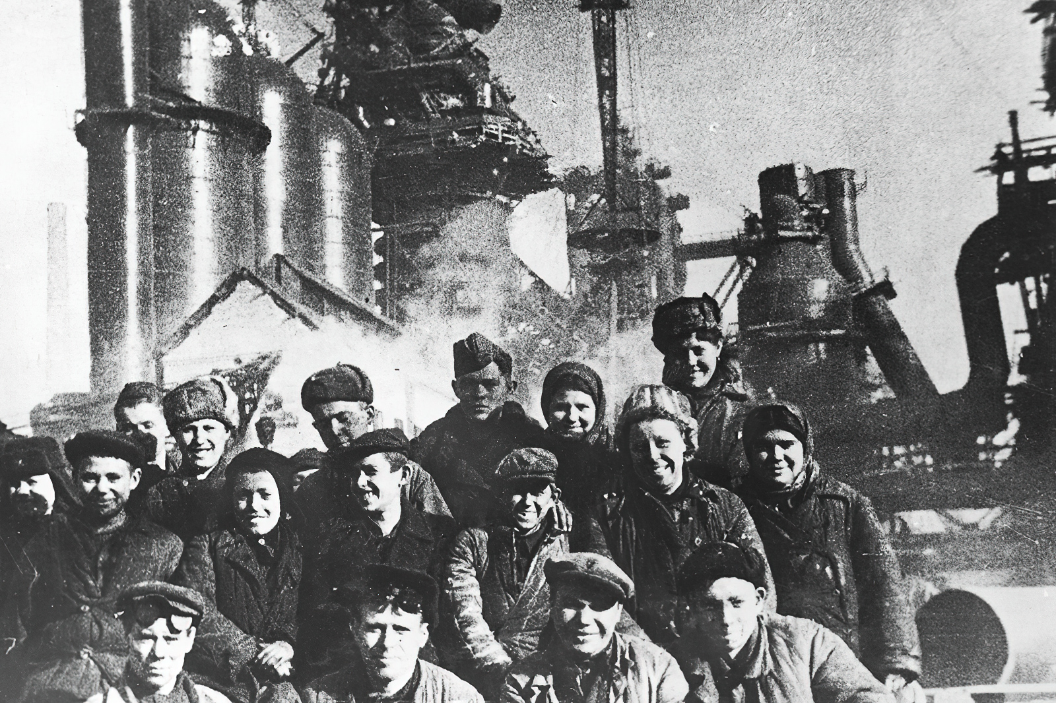
Builders of Magnitka
During the second five-year plan 4,500 new enterprises were built, the growth of industrial production doubled. The use of machinery in agriculture grew. For two five-year plans almost from scratch were created tractor, petrochemical, aviation industry.
Of course, industrialization in the Soviet Union was not without problems. Soviet power inherited from the tsarist Russia an underdeveloped, backward from advanced countries economic basis, significantly destroyed during the Civil War. Exhibited not only the general economic backwardness, but also the lack of experience in conducting such a large-scale modernization.
Therefore, it is obvious that mistakes and shortcomings were made during industrialization. In general, "socialist restructuring", as well as any modernization in Russia before that, was carried out with incredible effort of the people.
However, the fact of unprecedented pace of economic development, rapid development of the country's economy, changing its appearance remains undeniable. The centuries-old backwardness and underdevelopment of Russia and the other Eastern countries that were part of the USSR, became in the Stalin years as a relic of the past as the tsarist despotism. Such a rapid transformation of the USSR was only possible thanks to socialism and Soviet power.

Conclusion
In this article we have tried to explain why overproduction crises are a flaw in the system of capitalism itself. Speculation and overestimation of the possibilities of the economy are continually generated by the anarchy of production and capital's desire for constant expansion.
Of course, each crisis of overproduction has its own unique characteristics. The crises occur with varying degrees of intensity, but they are always inevitable and always caused by capitalism itself.
Unfortunately, it is not always clear behind the numbers what exactly a decrease in production by a few tens of percent or the collapse of the stock exchange means. Meanwhile, behind them lie the tragedies of millions of people whose lives are destroyed by hunger, unemployment, impoverishment, destruction and war. All this is beautifully portrayed in the best examples of fiction or cinema, but in this case we need not go far, just look out the window or watch the news to see how the movement of capitalism is reflected in the lives of working people.
As we have seen in the USSR, there is a way out of the vicious circle of the economic cycle of capitalism. The scientific planning of production, the socialization of industry, and the Communist Party at the head of the people are the ingredients of a cure that can save the man of labour from the impoverishment that occurs every few years.
Sources
1. К. V. Ostrovitianov. Political Economy - Moscow : Gospolitizdat, 1954. - p. 640.
2. The World Economic Crisis Will Rise in 2020 and Hit Russia - October 9, 2019.
3. I. A. Trachtenberg. Monetary Crises - Academy of Sciences of the USSR, 1963. - p. 733.
4. The rich get richer, the poor get poorer - January 30, 2018.
5. E. E. Babaeva. The global financial crisis of 2008-2009. Causes and consequences for the world economy. - Economics and management in the XXI century: development trends. 2014 г. -p. 5.
6.D. Petrovsky. Reconstruction of the Technical School and the Five-Year Personnel Plan - Leningrad : State Technical Publishing House, 1930. - p.12.

Original article

