How Poor Did an Average Russian Become After 2022?
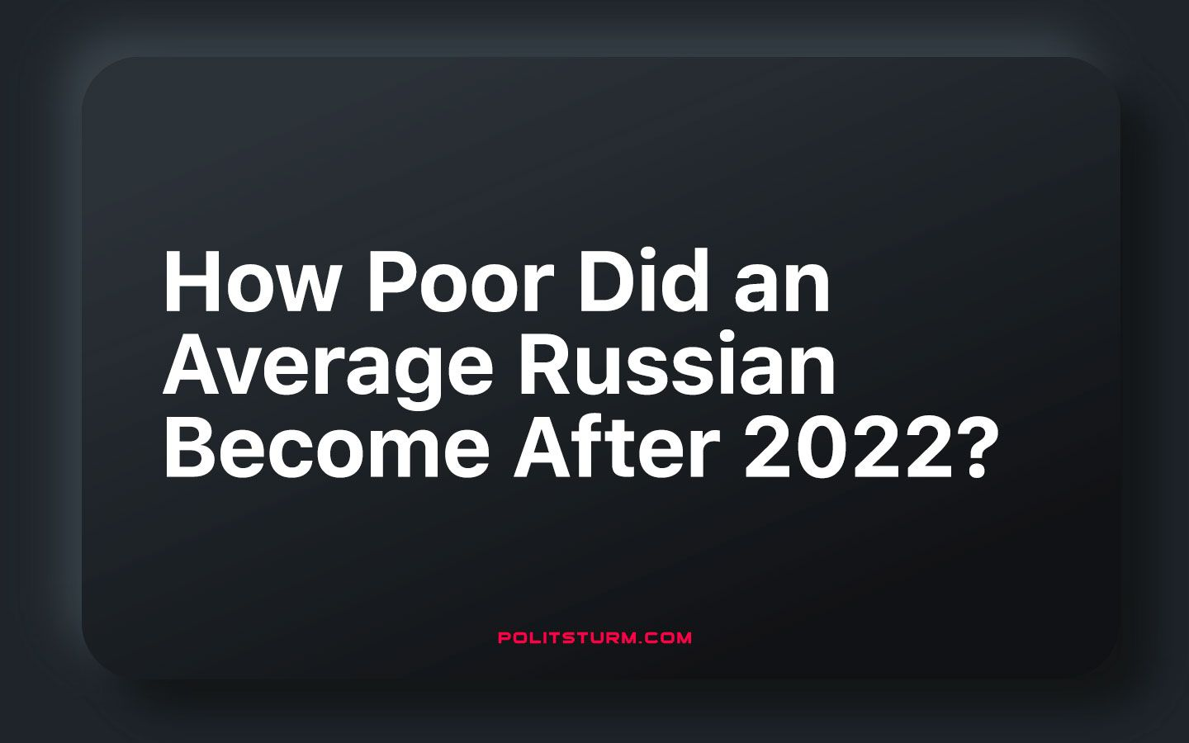

Original article
2023-09-18
12 min read

Since the escalation of the Ukrainian crisis and the following imposition of Anti-Russian sanctions, the Russian population was doomed for irreversible changes of their financial situation. With all their might, authorities are trying to prove that the well-being of Russian citizens has remained at the same pre-2022 level. So has the financial situation of the Russians changed? We’ll try to figure it out in this article.

I. The financial situation dynamics until 2022
Purchasing power. According to the Federal State Statistics Service, from 2011 to 2014 the growth in purchasing power was the largest in the post-Soviet period. The situation changes after the annexation of Crimea in 2014. According to the same statistics, it can be seen that the level of well-being falls in the period from 2015 to 2022. During this period, purchasing power has decreased in relation to beef, rice and cereals. In 2015, people could buy 98 kg of beef on average. In 2022 this value decreased to 97 kg. We see a similar picture with rice and cereals - so if in 2015 Russians could afford to buy 458 kg of rice and 726 kg of cereals on average, in 2022 these values are 417 kg and 619 kg respectively.
Even the existing growth of welfare was provided by pre-crisis years as indicated by article written back in 2014
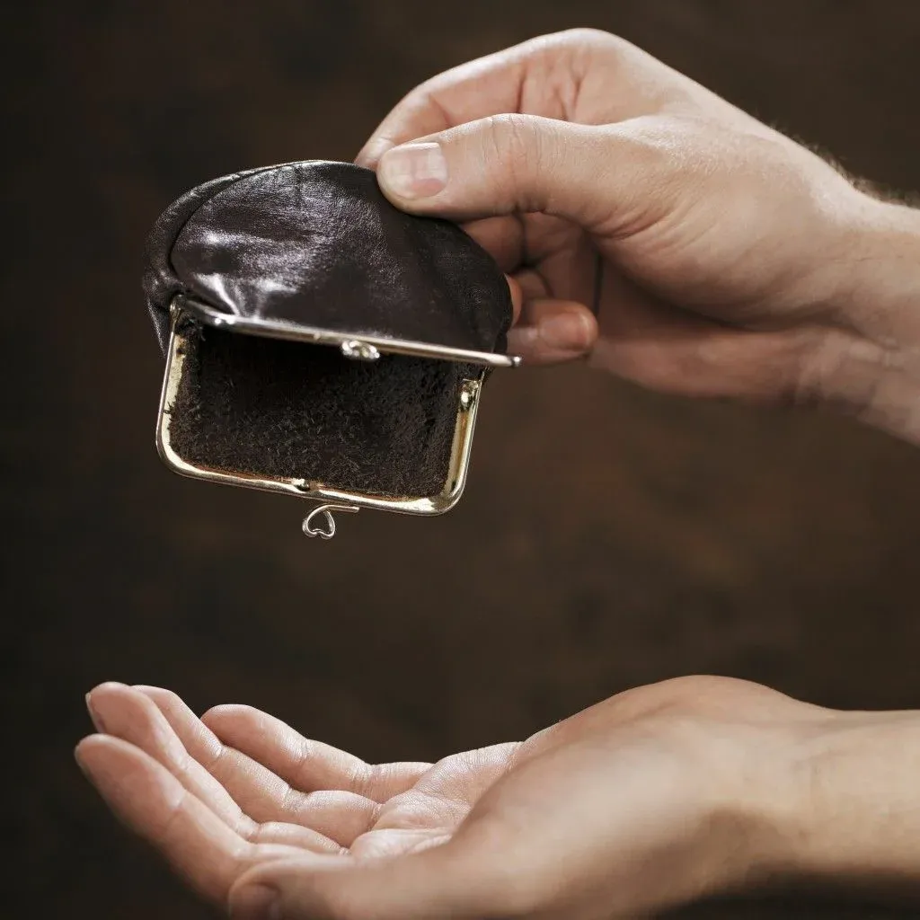
In subsequent years, the decline in prosperity was accompanied by an increase in the level of poverty – by 2020 it had increased by more than 20%. At that time, revenues, according to RBC, "at the end of 2020, decreased by 3.5%".
For a number of years, a steady increase in income has not been achieved, which cannot be said about expenses, which have been growing smoothly over the past 10 years. This is happening against the backdrop of higher wages and social benefits. The decline in the well-being of the population has been a steady trend in Russia for many years.
It is impossible not to mention the time when Russia was experiencing the effects of COVID-19 pandemic. According to RBC, "the purchasing power of the population's income has fallen to a minimum since 2011". It was a serious blow to the financial situation of the population, unprecedented in the last 20 years.
In general, before the hostilities in Ukraine the decline in the level of well-being was relatively stable, sharp changes occurred only during the quarantine period. Although the level of income was decreasing, it was barely noticeable as was the increase in the number of citizens below the poverty line. A similar picture was also observed with the growth of salaries.

II. During the ‘SMO’
After February 24, citizens faced sharp and significant price increase which had not been seen before. It undermined the already difficult position of the Russians, forced them to take additional loans and save on consumption. A similar situation was observed during the quarantine period, when purchasing power decreased significantly, but in those years Western companies did not leave Russia, and there was no sanctions pressure.
According to “Nezavisimaya Gazeta”, “on the eve of 2023, the real incomes of Russians fell by 6.5% below the pre-crisis level of 2013.” What else can be said if the purchasing power of the population has significantly decreased by 2022. This demonstrates that "eight years ago, for 27.4 thousand rubles it was possible, for example, to buy 742 kg of granulated sugar, and today for 36 thousand rubles you can afford only 540 kg of sugar."
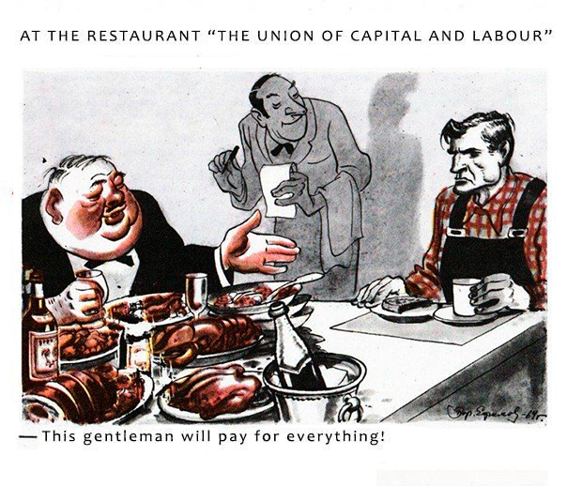
Soviet Caricature: "Union of Labor and Capital"
According to SKB Kontur analytics, “prices for vegetables increased by an average of 4%. If we talk about the types of vegetables separately, then their price increase is as follows: the cost of cabbage increased by 6%, onions - by 97%, carrots - by 3%, cucumbers - by 2%, tomatoes - by 8%, potatoes - by 9% ”.
Fruit consumption has dropped by a quarter, poultry has replaced pork. From the above data, it follows that people have switched to a regime of serious savings, cutting costs as much as possible.
But not everyone can afford to live frugally, someone simply has nothing to save, which has pushed people to begin taking microloans and credits more often. Thus, the level of debt load increased from 49% to 55%, and the amount of debt to banks became more than 25 trillion rubles showing an increase of 1.5 trillion over the year. Russians fall into debt bondage, from which it is not always possible to get out.
People are forced to take out loans that are too much for themselves in order to upgrade household appliances and get their children ready for school. This spending is by no means on luxury goods, but on the contrary these are fixed expenses for natural needs. Those who did without loans had to tighten their belts as well - they had to cut costs by 7%. Spendings have exceeded those during the pandemic period.
The fall in income and financial situation is so serious that the government once again resorted to a favorite trick: changing the criteria for assessing poverty. The essence of this amendment is that “now, instead of the subsistence minimum, a new indicator called “poverty line” will be used.
The meaning of the new indicator is that, regardless of prices in the region, those who receive wages below a certain level will be considered poor. There is no need to talk about the difference in pricing from region to region. This measure is yet another populist move to show the "efficiency" of the government.
This reform did not remain aloof from the "people's" representatives. The State Duma deputy was indignant at such an attitude to the issue and complained that "the fight against poverty must begin with its objective assessment, according to the real size of the consumer basket". There is no end to the hypocrisy, because he and similar dissatisfied deputies impeccably vote for all possible proposals of the United Russia party.
No matter how hard the authorities try, they cannot hide the radical impoverishment of the population. So, according to Golikova, “nine regions of Russia did not achieve poverty reduction targets in 2022,” and “an increase in the level of poverty was noted in 4 Russian regions.”

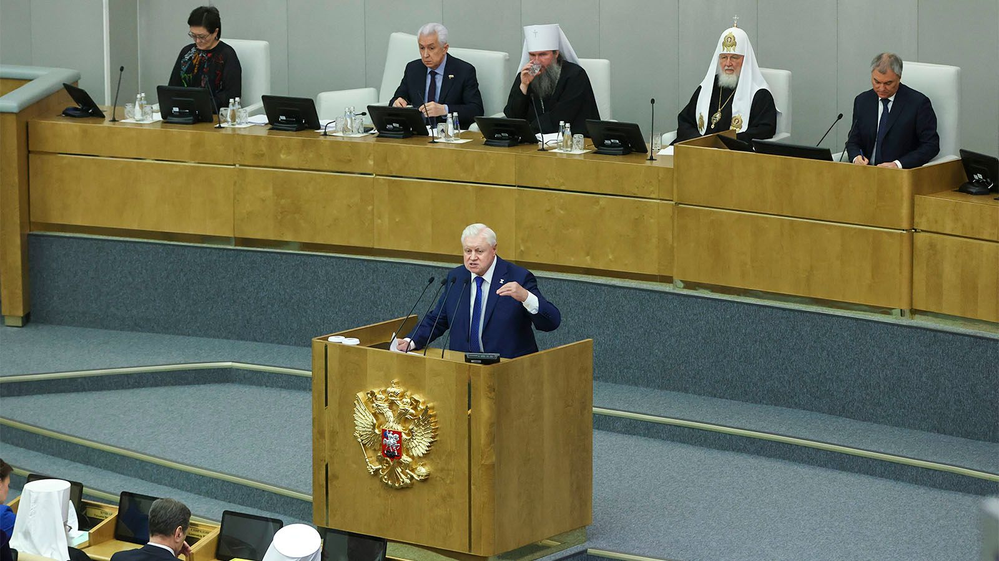
Plenary session of the State Duma
But even in those regions where welfare has become higher, it turned out to be more in the reports of officials than in practice. The situation is similar with poverty – they say that the number of poor is decreasing, but in fact it is growing.
But what do the Russians themselves think about their well-being? The feeling of well-being among two-thirds of respondents has weakened. In August 2022, more than half of the citizens assessed their financial situation as satisfactory, and in April these figures fell to 43%. Due to the invasion of Ukraine, the welfare of Russians has become worse, taking into account the fact that it has been declining for at least the last 10 years.
The deterioration of living conditions forced people to spend savings, economize even more on products and take additional loans, microloans.
We were told that "Russia will adequately withstand the consequences of European unilateral restrictive measures and will remain a reliable trading partner in the international arena". Indeed, trade with Western countries has not stopped, but there are serious questions about "resilience" against sanctions.
To ensure "resilience", the government has taken a number of measures, including: indexation of pensions, additional payments for children, increased payments in case of death at work.
It is not difficult to notice that instead of a real solution to problems with low pensions, low-income families, mortality at work, decisions are made that do not solve the problem, but only slightly mitigate its consequences. The population is getting poorer year after year and the state does not intend to change the current situation. The government, and this can be said with all evidence, is not coping with the responsibility assigned to it.
Instead of a general increase in welfare, we are witnessing a deterioration in the financial situation, for which the authorities are taking cosmetic measures, traditionally throwing money instead of systematic reforms.

III. Future prospects
After the start of Ukrainian crisis, the population faced an unprecedented drop in welfare: economizing on food and the use of savings became the norm of life. If earlier Russians could save at least a small part of their salary, now it is almost impossible. The situation of an ordinary citizen has worsened at times, but this is not the end, because prices do not even think to stop in their growth.
The bourgeois government, which has repeatedly stated that Russia is "resistant" to sanctions, is implementing half-measures that are not designed to stop the fall in income. Being not capable of radical self-education, the government is forced to resort to demagoguery and symbolic social payments that do not seriously change the situation .
But this does not at all show success in the confrontation with Western sanctions pressure, as evidenced by the decline in the standard of living of the population, which has only gotten worse after the start of its own and is unlikely to ever return even to the previous, pre-crisis level.

A caricature on Western society from the magazine "Crocodile". The 1970s.
All this leads to a deepening of the crisis and does not bode well, the decline in income will continue in the future.
This situation clearly illustrates what was warned against in Soviet times. The impoverishment of the population is the result of the elimination of socialism and the restoration of capitalism. The Soviet government prioritized all—round improvement of the welfare of the population, but now the opposite is happening - the government is trying to squeeze the last juices out of the workers by taking populist measures to reduce social tension.
Sources
Taimyr Telegraph - “The State Duma questioned the data of Rosstat on the level of poverty in Russia” from May 5, 2023
RIA Novosti - “Russia will adequately withstand the consequences of new European sanctions, the Foreign Ministry said” from June 2, 2022
RIA Novosti - “Indexation of pensions in 2023: dates, amounts, recalculation procedure” from April 25, 2023
BBC NEWS - “Russia introduces new poverty rules, 2.8 million fewer poor” from December 6, 2021
Information Agency "AIS" - “The reduction in the expenses of Russians became the largest since the covid” from December 14, 2022
"Rossiyskaya Gazeta" - “Russians have become more likely to take microloans for urgent needs” from January 19, 2023
SKB Kontur - “How much did the prices of consumer basket goods increase in March and what is now bought more often” from April 13, 2022
“Taimyr Telegraph” - “A third of Russians began to save more on products” -from November 29, 2022
“Polygon” - “These eight years: how the average Russian's well-being has changed since 2014” from August 1, 2022
RBC - “How the life of Russians has changed in a year since the start of the lockdown” from March 30, 2021
Federal State Statistics Service (Rosstat) - “Purchasing power of average per capita monetary income of the population per month” from May 3, 2023
“Finmarket” - “Real incomes of Russians are declining for the eighth year in a row” from February 5, 2021
RBC - “What has become of the Russian economy for the year of the military operation in Ukraine” from February 24, 2023
“Nezavisimaya Gazeta” - “Russians-2023 are 6.5% poorer than Russians-2013” from February 9, 2023
NEW RETAL - “How the welfare of Russians has changed since 2000” from October 31, 2014
TASS - “More than a third of Russians surveyed rated their financial situation as good or excellent” from April 25, 2023
“Anketolog” - “How do Russians assess their financial situation today? Research” from August 21, 2022
LENTA RU - “Assessed the impact of 2022 on the feeling of well-being among Russians” from January 23, 2023
“Expert Yug” - “We are getting poorer”: how to reduce poverty when real incomes fall” from April 12, 2023
Vedomosti - “Golikova: nine regions did not achieve poverty reduction indicators in 2022” from May 19, 2023
Vedomosti - “The purchasing power of Russians' incomes has decreased” from August 4, 2021
“Krasnaya vesna” – “Unemployment has risen significantly in Russia in 2020” from January 28, 2021
RBC - “Experts pointed to a record decline in the purchasing power of Russians” from September 4, 2020
VTB - “New payments for children” from February 22, 2023

Original article

