How Does China Subjugate Belarus?
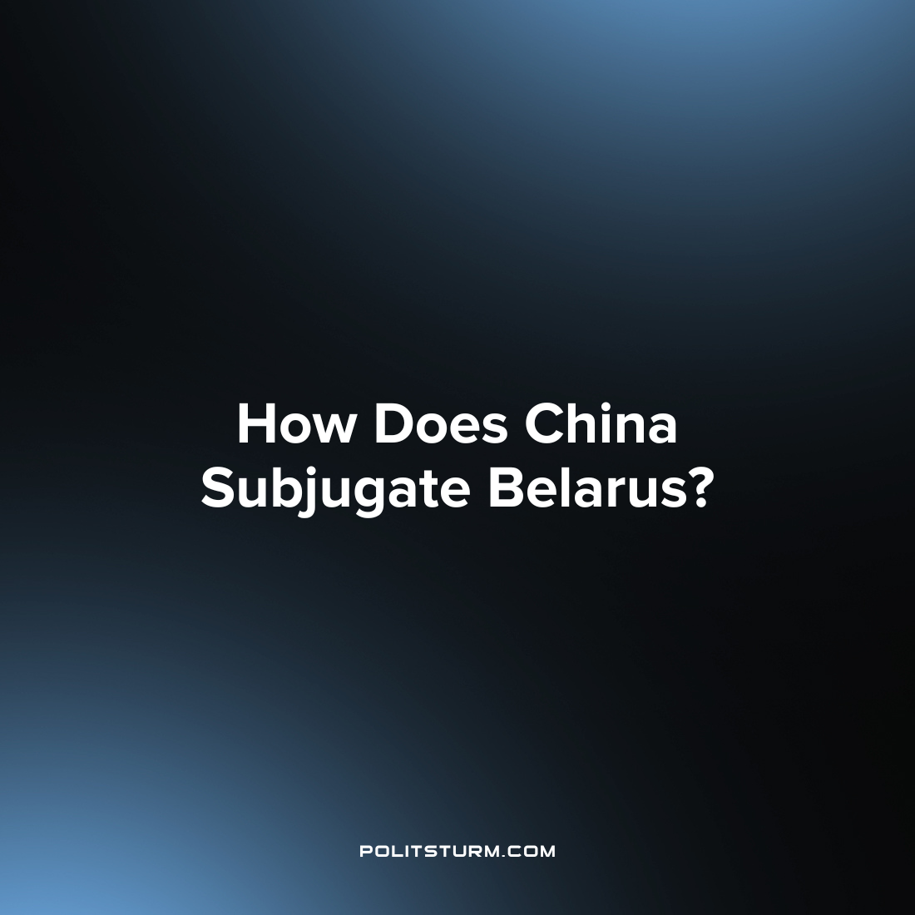

Original article
2023-05-30
4 min read

President of Belarus Alexander Lukashenko paid a visit to China in early March. During the trip, the leaders of the two countries met, ending with the typical statements about strengthening cooperation between the states.
The negotiations resulted in the adoption of a joint statement on the basic principles of the development of exemplary relations of strategic partnership between the countries.
Indeed, in recent years it has been possible to observe the consistent strengthening of Belarusian-Chinese relations. Does this mean that Belarus is becoming a puppet in the hands of Chinese imperialism?

I. The Importance of Belarus for China
A serious impulse to strengthen international relations between the two countries was the Ukrainian crisis of 2014, before which China intended to make Ukraine part of the northern transit corridor necessary for the smooth export of Chinese goods to Europe. But after Maidan, China decided to redirect and increase trade flows through Belarus.
Container traffic through Belarus has been growing continuously in recent years, and in 2021 reached record values, despite the pandemic raging at that time.
However, there are other reasons for strengthening the Belarusian-Chinese "friendship". It is important to note that one of the main elements of interaction between the two countries is lending. That is why in 2015 the Chinese side created new preferential credit lines for the Republic of Belarus.
In 2015, Belarus received $528.1 million from China, in 2016 – $446.9 million, in 2017 – $306.6 million, in 2018 – $509.2 million. And in 2019, the Ministry of Finance of Belarus and the Shanghai branch of the China Development Bank signed an agreement on an urgent loan in the amount of $500 million, which was planned to be spent on servicing the external debt of Belarus.
In total, over 30 years of diplomatic relations, the volume of investments into the Belarusian economy from China has exceeded $2.6 billion, of which $1.1 billion is direct (where investors receive a significant share in the enterprise and the right to participate in business management).
To date, with the financial support of Chinese banks, about 30 major investment projects are being implemented or have already been implemented in Belarus in fields including industry, energy and transportation.
Thus, with the help of Chinese investments, a major joint industrial project of the two countries is being implemented — the Great Stone Industrial Park, a 112 square kilometer complex near Minsk.
Some researchers also suggest that a serious advantage for Belarus is the geographic location of the country and the technologies left to it from the USSR or transferred by the Russian Federation.
Vasily Kashin, head of the International military-political and military-economic Problems sector at HSE University, claims that the Republic of Belarus, among others, transmitted data which helped China establish independent production of mobile complexes for intercontinental ballistic missiles and a number of other types of military equipment.

II. What are the Risks of Chinese loans and investments?
It is necessary to understand that today Chinese capital is a serious contender for the place of the world hegemon. That is why China is pursuing an expansionist policy in a large number of countries around the world: both in Asia and Africa, and in the European region.
So, in 2021, the American research laboratory AidData analyzed more than 13,000 Chinese projects in 165 countries over the past 20 years. All these projects are part of the international initiative of the People's Republic of China "One Belt and One Road", and the amount of "hidden" debts on them, according to researchers, amounted to $385 billion.
At the time of publication of the study, for 42 countries such credit obligations to China already exceeded 10% of their GDP. On average, the volume of "hidden" debts was about 6% of GDP.
China allocates huge amounts of money for various investment projects in developing countries. For example, during the period from 2017 to 2019, the Friendship bridge in Malta, the Addis Ababa railway in Djibouti, a port terminal in Malaysia, as well as the first generator block of Pakistan's largest hydroelectric power station were built.
The countries that the PRC has entered into debt bondage play an important role in strengthening Chinese imperialism, because with their help, the PRC not only expands its economic influence, but also receives strategically necessary resources.
For example, in 2017, China leased a deep-water port of Sri Lanka for 99 years, which is a convenient base not only for commercial, but also for military vessels, due to the fact that the country owes China $8 billion.
A similar picture can be seen in Africa, where China is expanding its influence by building infrastructure facilities, issuing loans and supplying cheap goods. For example, Zambia has transferred all its energy and transport infrastructure to Chinese companies due to debts to the PRC.
It is not difficult to notice the familiar handwriting. China, in exchange for large investment projects and multibillion-dollar loans, drives the country into unaffordable debts and uses it to expand its influence.
Even loans to Belarus are issued on the same terms as during the expansion of the PRC in Central Asia: it is necessary that at least half of the funds go to pay for the services of Chinese contractors and the purchase of Chinese equipment.
There is no reason to doubt that Belarus will face the same fate as other states "enslaved" by China.

III. Chinese Imperialism
Until now, many representatives of the so-called "left movement" and ordinary people are convinced that China is the "socialist flagship of the world", opposing Western capital in the interests of workers.
However, the arguments of the defenders of socialism "with Chinese characteristics" are broken by the unsightly reality. China is intensifying the exploitation of workers with financial capital, providing the latter with unprecedented profit growth.
The PRC is seizing an increasing number of new markets, enslaving smaller countries for access to cheap raw materials and technologies, gaining a strategic advantage in confrontation with other imperialist powers and exporting capital. All these facts lead to the unequivocal conclusion that modern China is one of the largest imperialists, using red banners only to disguise its capitalist essence.
The Republic of Belarus, like the Russian Federation, is just another puppet that Chinese capital, following the typical imperialist policy of subjugating weaker countries for the sake of increasing profits, as well as increasing economic and military power in the armed confrontation with Western imperialism.
Sources:
Arguments and Facts — "China will give Belarus a loan of about $ 500 million" dated December 16, 2019.
Rambler — "Loans, weapons, Silk Road. How is China becoming an indispensable partner of Belarus?" dated June 8, 2021
Trans.info — "Transit from China to Europe via Russia and Belarus is continuously growing. How did container traffic reach such a volume?" dated August 24, 2021.
Forbes — "$385 billion of hidden debts: How China drove poor countries into a debt trap" from October 4, 2021
Belta — "Belarus and China signed almost four dozen agreements and contracts worth $3.5 billion during Lukashenka's state visit" dated March 2, 2023.
Izvestia — "To the Celestial Empire and back: Lukashenko flew to a meeting with Xi Jinping" from March 2, 2023
SB.by — "Results of the President's state visit to China. We are placing important political and economic accents" from March 3, 2023.

Original article

