Historic Dutch Bridge to Be Dismantled for Jeff Bezos’ Super-Yacht
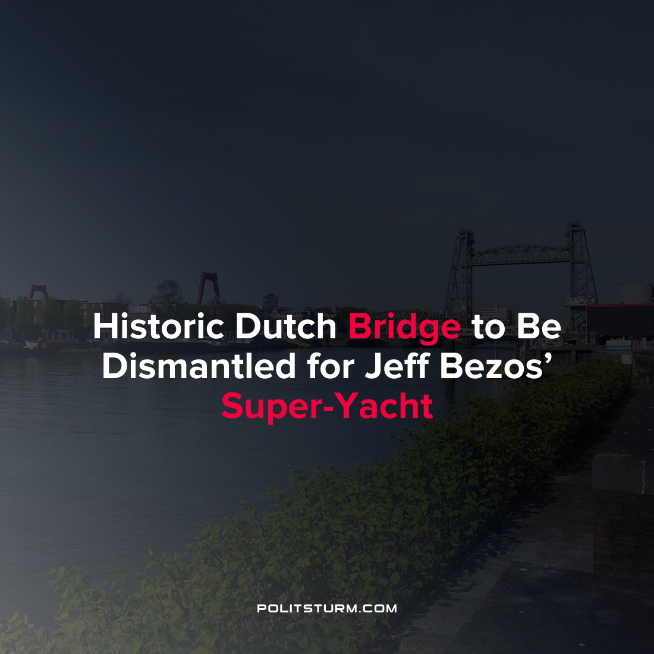

Original article
2022-02-04
1 min read

U.S. billionaire Jeff Bezos recently purchased a $500 million super-yacht from Oceanco. However, it faces an interesting delivery problem. In order to get the yacht to the sea, Bezos is paying for the dismantling of a historic bridge in the Dutch city of Rotterdam which is blocking the yacht’s passage to the sea. Dutch city officials have already agreed to dismantle the Koningshaven Bridge.
Some Dutch residents have come out in support of the dismantling of the historic bridge under the auspices that it will create an economic benefit for the community.
I think it’s fine. Let Bezos pay a high price. It creates work. I only see upsides…If it is paid for and everybody makes some money, don’t complain”, said resident Ria van den Vousten when asked about the matter.
The dismantling of the bridge is another example of how local, state, and national governments operate to serve the interests of the capitalist class. All over the world politicians will bend over backwards to accommodate the oligarchs, in this case under the “rationality” that the socially useless activity will create some sort of marginal economic benefit for the community. The absurdity of the situation is just another example that bourgeois democracy is a dictatorship of the oligarchs, namely the dictatorship of the bourgeoisie.
Source: 1

Original article

