Highest Unemployment Rate in U.S. History?
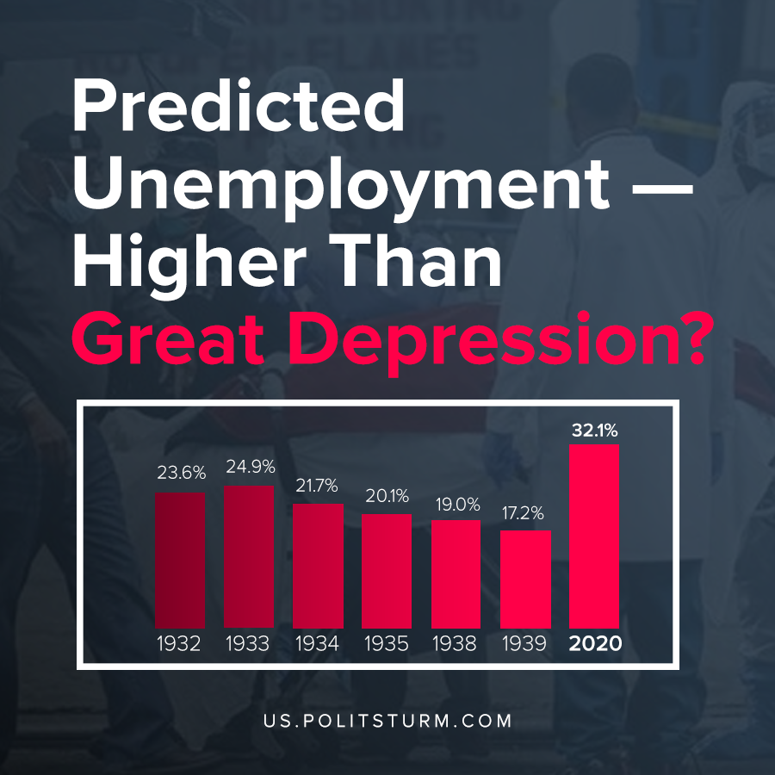

Original article
2020-04-07

According to Statista, the unemployment rate is going to be the highest in the history of the United States. Even higher, than during Great Depression.

Original article

