Half of US Families With Children At Risk of Poverty
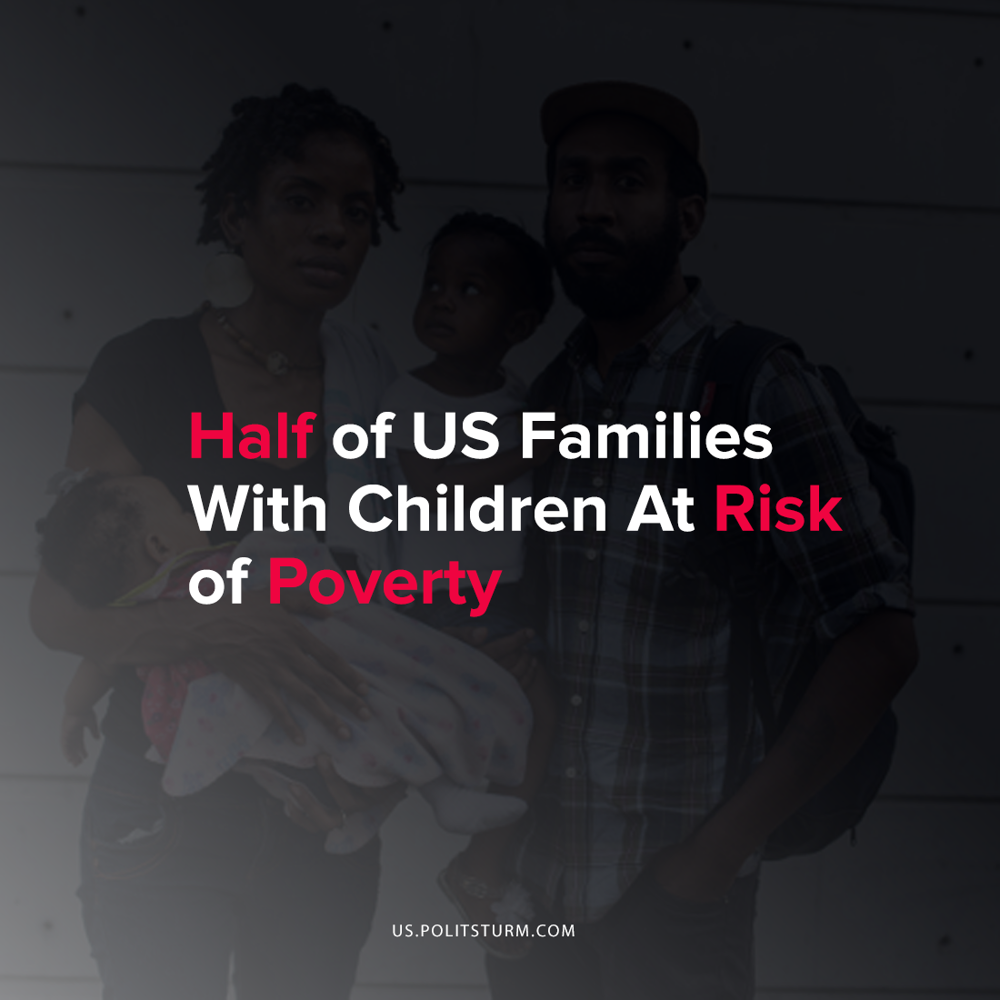

Original article
2021-12-02
1 min read

According to new research conducted by Wen-Jui Han of New York University, children of parents with precarious employment are significantly more likely to fall into poverty. The study followed approximately 10,700 families with children born in 2000 or later and examined the relation between the parental work characteristics and family poverty.
Precarious employment includes low wage work, non-standard work hours and job insecurity and increases the probability of a family living in poverty. When children experience poverty in the first six years of their life they are more likely to remain in poverty throughout their entire lives and receive low quality education.
The researchers concluded that almost half of American families with young children are at risk of falling into poverty before the children reach kindergarten.
“One of the most pronounced changes in the lives of children in recent decades has been the dramatic increase in the share of parents who are employed, but with more precarious jobs…These changes in parental work have brought instability to children’s lives, with potentially dire consequences”, the researchers concluded.
Under the capitalist economic system capitalists maximize profits and try to minimize the associated costs of production, including labor. Low wages and unstable employment condemn workers and their families to poverty while the oligarchs reap the profits and do not have to consider nor experience any of the societal consequences.
Source: 1

Original article

