Greta Thunberg and 600 children file lawsuit against the Swedish government
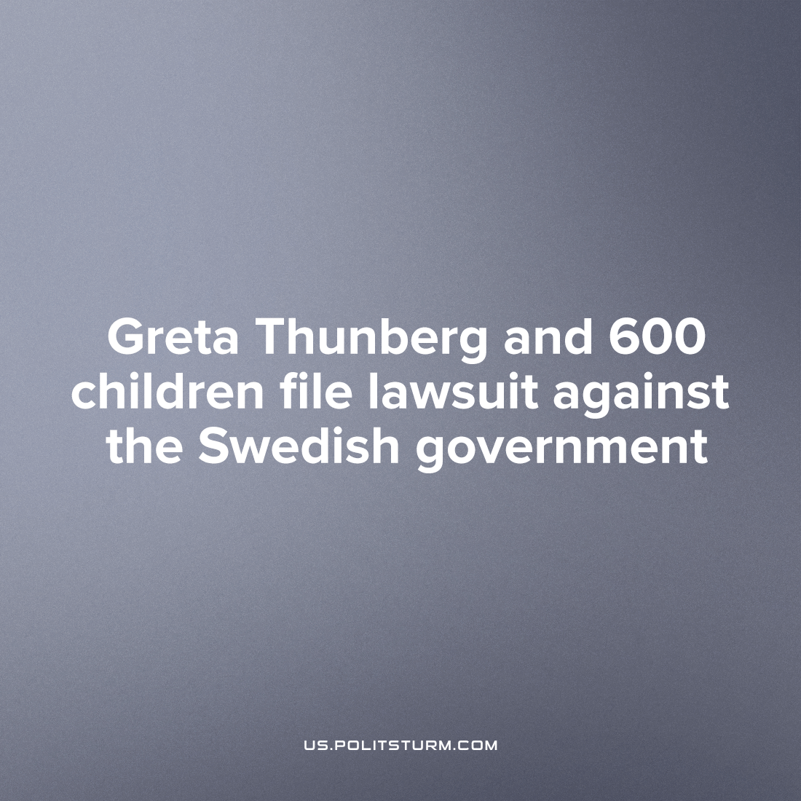

Original article
2022-12-15
1 min read

Prominent eco-activist Greta Thunberg and 635 Swedish children and teenagers filed a lawsuit against the Swedish government on November 24th. The reason was Sweden's inadequate climate policy, and to create a public stunt hoping to draw support for the fight in the legal arena against the looming catastrophe which troubles a great many people.
The plaintiffs demand the court recognize current climate policy by the Swedish government as a failure, even criminal. More precisely,their suit accuses the government of an inability to fulfil its constitutional obligations to promote sustainable development and create a healthy environment for current and future generations. They charge that this violates the most basic human rights enshrined in the European Convention on Human Rights of 1950.
"When the state carries out climate policy that threatens our human rights, it breaks the law," explained 19 year old Thunberg on her Twitter page.
It would seem that these children are motivated by a sincere desire to improve climatic conditions and prevent an ecological catastrophe. However, their attempts to change the policy of the bourgeois states are misled and doomed to failure for several reasons. Firstly, the environmental activists filed a lawsuit in court, which, by definition, is part of the bourgeois state apparatus and thus protects the interests of said state. Secondly, they hope they can resolve the problem by convincing the "good" politicians in government to listen to their concerns and take action to solve them.
However, bourgeois states do not act at all in the interests of their surrounding environment or the well-being of ordinary workers but in the interests of national monopolies. Their foremost aim is to ensure the conditions where these monopolies can increase their profits, and so even fund activists like Thunberg to promote their green technologies investments (often of petroleum capitalists) and liberal, capitalist ideas of "progress" on the climate issue. Only a socialist state can truly ensure a sustainable climate policy, with state-owned production and planning beyond the goals of private gain, while ensuring a decent standard of living. All of this can finally be in the interest of all people living on the Earth.
Sources: 1, 2, 3, 4

Original article

