Google Limits Results for RT and Sputnik
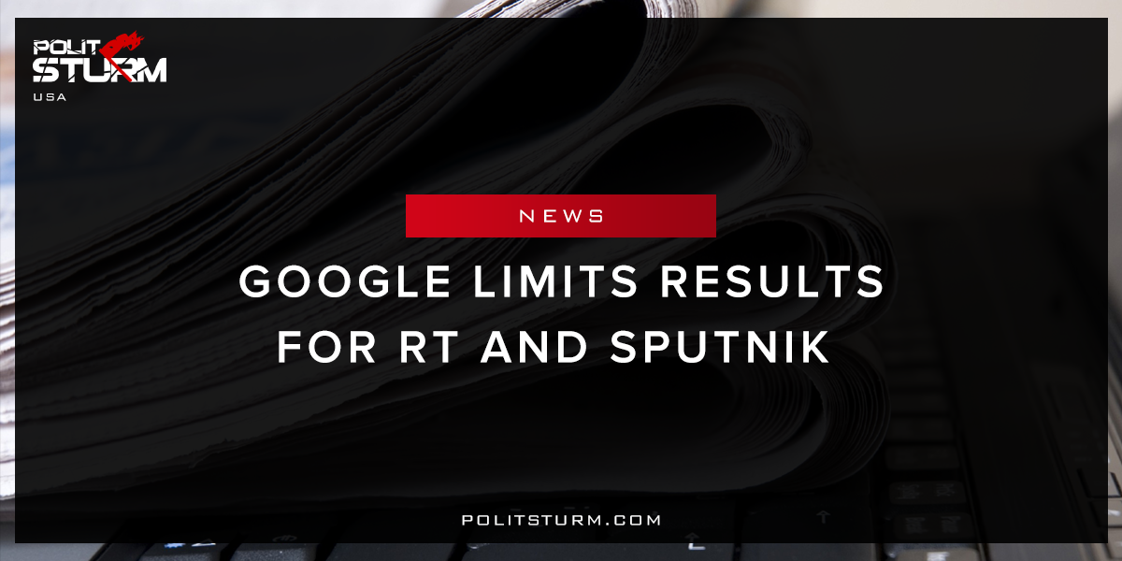

Original article
2017-11-22
1 min read

Google Limits Results for RT and Sputnik
Google will “derank” stories from two of Russia’s largest news outlets, according to Eric Schmidt, executive chairman of Google parent Alphabet. The Alphabet chairman said the search engine’s algorithms will be used to limit the reach of RT (Russia Today) and Sputnik, the BBC reported Tuesday. He made the comment Saturday at the Halifax International Security Forum in Canada while discussing the spread of propaganda and fake news.
“We are working on … deranking those kinds of sites. It’s basically RT and Sputnik are the two,” Schmidt said during a Q&A at the forum. “We are well aware of it. We are trying to engineer the system to prevent it. We don’t want to ban the sites. It’s not how we operate.”
Politsturm: Internet-search giant Google will be implementing a new ranking system that will limit results from Russia Today and Sputnik. The organization claims that it is doing so to limit “propaganda” and “fake news”. It is quite evident that Google is targeting sites that present a critical analysis of US policy in opposition to the mainstream media. Why does Google need to repress the search results from these sites?
The mainstream media has constantly downplayed the failure of the capitalist mode of production. The recovery of the stock market and property values are interpreted as “economic recovery” by these sources. There is an obvious disconnect between the narratives presented by the media and people’s own experiences.The media only presents the views of the economic elite, while the working people look elsewhere for information. This attempt by Google to limit search results is nothing more than a political attempt to silence the dissent of Americans and capitalize on nationalistic, anti-Russian sentiment.
Source

Original article

