GM To Lay Off 4,000 Workers
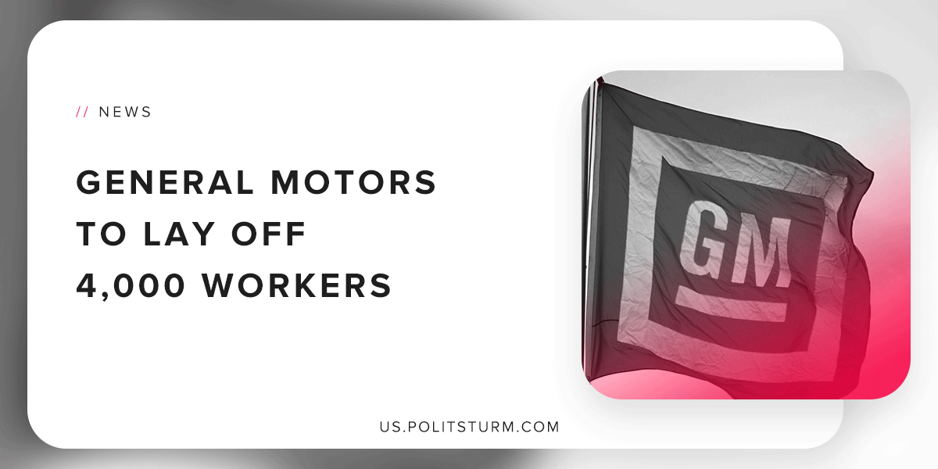

Original article
2019-02-03
1 min read

GM is expected to lay off 4,000 workers after previously announcing it would be reducing its North American workforce by 14,000. The layoffs are expected to begin in the first quarter of 2019.
Pat Morrissey, a spokesman for General Motors, said that the exact timing of the layoffs was not announced, but that the employees are the “first priority”.
Employees who will be affected by the cuts have a different perspective on the matter.
“Everyone’s waiting for the ax to fall,” said one employee in Detroit. “You don’t know if you should plan ahead for anything or not?”
General Motors estimates that the cuts will save approximately $2 billion in labor costs. The interests of the workers and the capitalist class are diametrically opposed. Whereas the workers will be deprived of wages that are necessary to survive, the profits of the capitalist class are bolstered.
General Motors was a recipient of $49.5 billion bailout in 2009, which in total cost the American taxpayer $11.2 billion in losses.
“The goal of Treasury’s investment in GM was never to make a profit, but to help save the American auto industry, and by any measure that effort was successful,” said the former Treasury spokesman.
As the company survived bankruptcy and was bailed out by the government, the capitalist executives are cutting labor costs and laying workers off en masse. Stock prices have recovered and the capitalist class is actually benefiting from this perverse situation.
Under a planned, socialist society it would be possible to eliminate the unemployment of labor and workers would not be at the mercy of the capitalist class. Capitalist enterprises are not necessary to “provide jobs”, but rather wage workers are necessary to produce and reproduce profits for the capitalist class under capitalism. Only the elimination of the capitalist economic system will resolve this absurd situation for the GM workers.
Sources: 1 2

Original article

