GM Terminated Health Care Coverage During Strike
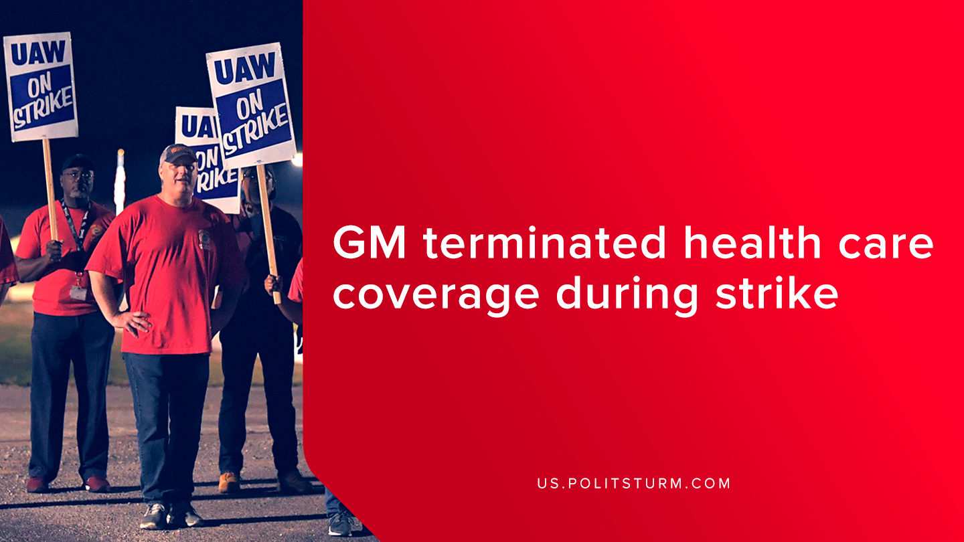

Original article
2019-09-22
1 min read

GM terminated health care coverage for more than 48,000 United Auto Worker union members and their families during the middle of a strike. The workers have been striking over wages, benefits, and job security concerns after the expiration of the most recent collective bargaining agreement.
The company made the decision without consulting the union on Monday night to terminate the worker’s health care coverage immediately.
At the beginning of the strike, GM released a press statement in which the company said, “Negotiations have resumed. Our goal remains to reach an agreement that builds a stronger future for our employees and our business.”
The fact of the matter is that the interests of the workers and the capitalists stand in opposition. Building a “stronger future for the business” entails the maximization of profits for investors which are produced at the expense of the global working class.
Due to the prizatized nature of U.S healthcare and the lack of affordable healthcare, the act of canceling healthcare coverage is a threat to the workers. This act is just one act of intensifying class struggle as the strike continues.
Sources: 1, 2

Original article

