GM Auto Workers Strike
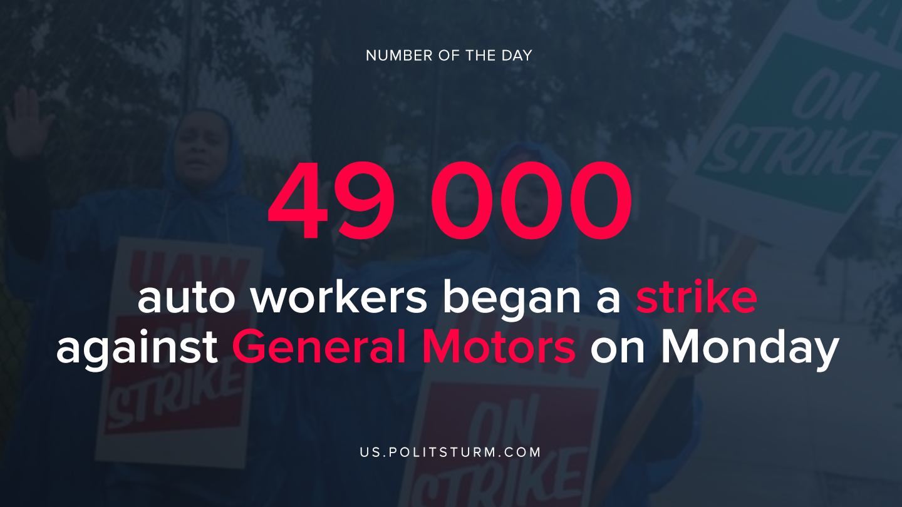

Original article
2019-09-16

The union and the company could not agree on a new collective agreement. This will be the first nationwide strike of General Motors auto workers in 12 years.

Original article

