Global Real Wages Fall 0.9%
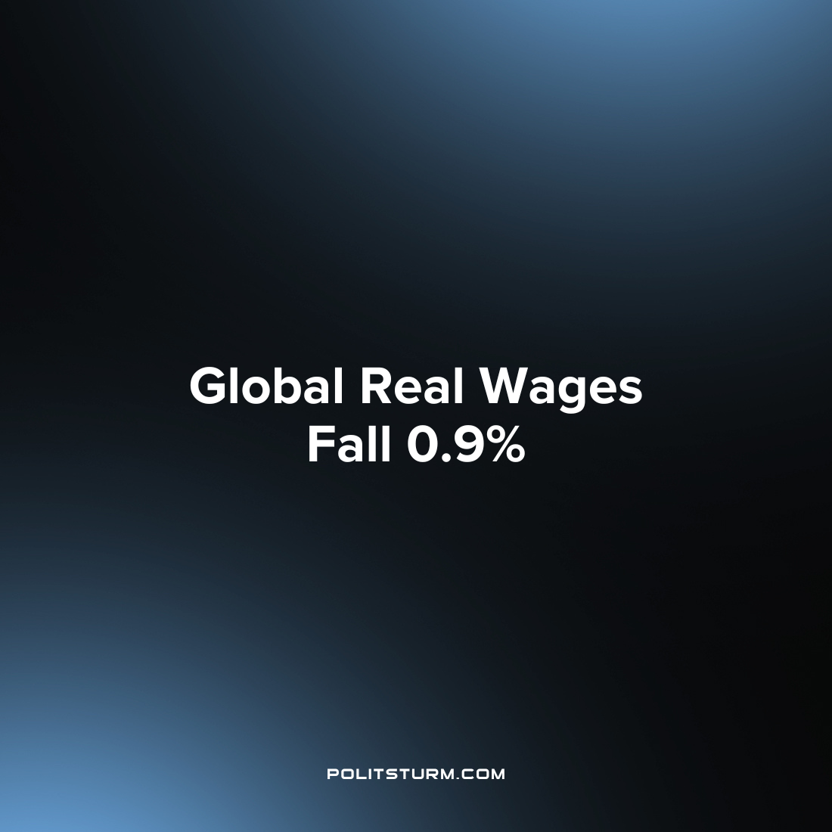

Original article
2022-12-07
1 min read

The International Labor Organization (ILO) warned of a dire situation for workers globally in a new report. The report found that global monthly real wages fell by 0.9% in the first half of this year. This data is significant because it is the first instance of global monthly wages falling in real terms this century according to the ILO.
“Income inequality and poverty will rise if the purchasing power of the lowest paid is not maintained,” he said. “In addition, a much-needed post-pandemic recovery could be put at risk. This could fuel further social unrest across the world and undermine the goal of achieving prosperity and peace for all” said ILO Director General Gilbert F. Houngbo.
However, the relation of the negative position that workers are now in was not directly associated with the capitalist economic system in the ILO report. In fact, the report did not even mention capitalism once, instead focusing on some of the byproducts of capitalism of the special military operation and unstable prices. In order to understand the dire position of workers globally it is necessary to connect the unstable prices, stagnant wages, and war to the class struggle of the workers and the economic system of capitalism. And it is equally important to organize not on the basis of simply bettering the position of workers under capitalism, but the abolition of capital which is the root cause of income inequality and countless other derivative effects.
Source: 1 2

Original article

