Germany Rearms Their Military
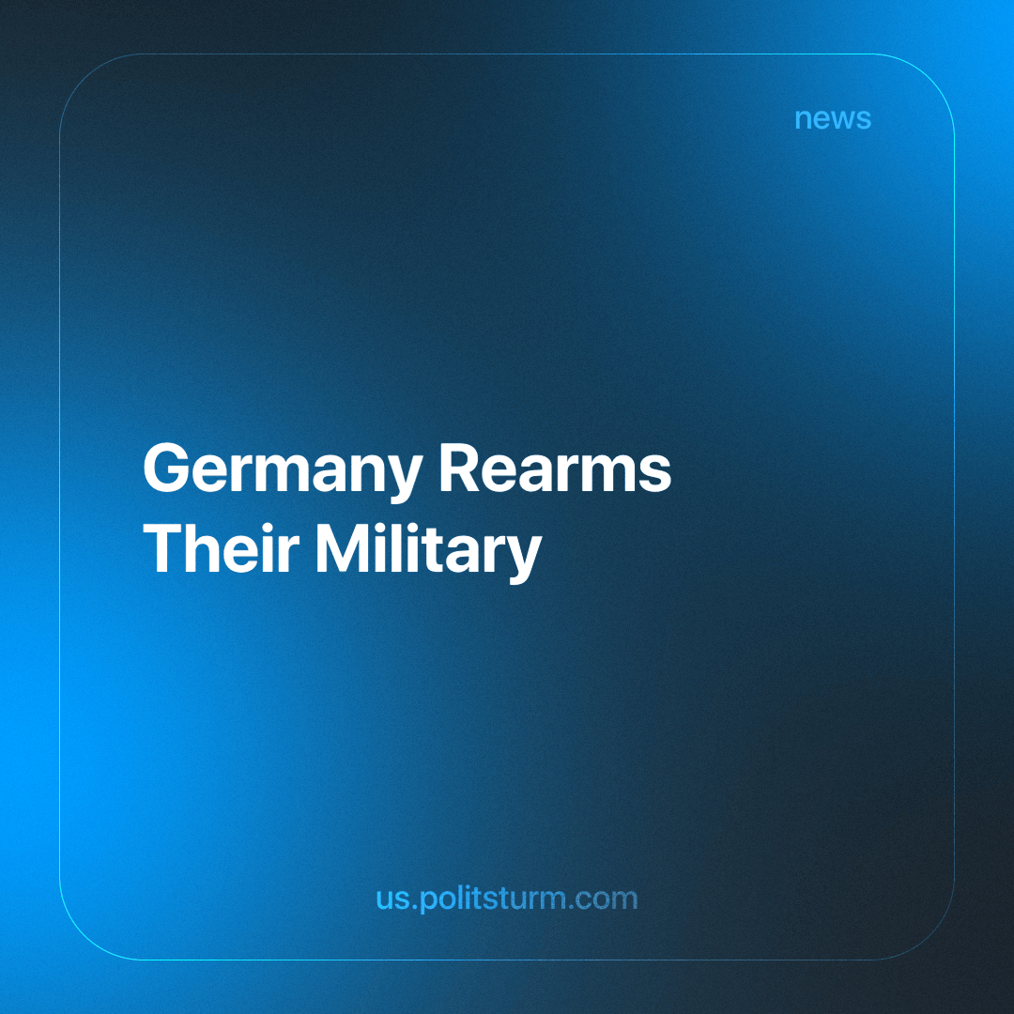

Original article
2023-12-07
2 min read

The current events in Ukraine are “forcing” Germany to turn its military into a powerful and well-financed fighting force focused on defending the country and NATO allies, Germany's chancellor said on Friday.
"Today, nobody can seriously doubt what we in Germany have been avoiding for a long time, namely that we need a powerful Bundeswehr," Olaf Scholz said on the second day of a political-military conference presenting the deep change in Berlin's strategic thinking.
"Our peace order is in danger," he warned, also mentioning the war between Hamas and Israel and adding that Germany needs "a long-term, permanent change of course." Indicating a change in policy.
But to defend Germany and its allies, the German military, or Bundeswehr, “needs to be upgraded for this. Only a Bundeswehr that is so strong … can ultimately prevent the worst from happening,” said Defense Minister Boris Pistorius. “We need a Bundeswehr that can defend itself and wage war to defend our security and our freedom.”
The call for militarization by the capitalists of Germany to protect its interests and expand them to support Israel has raised deep concern among the working class. The recent increase in aggressive politics and funding of wars from the German capitalists is reminiscent of the deeply concerning-past regime of Nazi Germany. The minds of millions are hearing the roar of the German capitalist's propaganda and funding of militarism.
With a recent increase in expenditures to recent conflicts, the German government has already spent much on the conflict in Ukraine and Palestine, with a recent 100 billion dollar fund to refortify Ukraine.
Funding these ongoing conflicts has caused only the ongoing destruction of the working class in Ukraine and Russia; expanding expenditure will certainly lead to engulfing the current Israel-Palestine war with German capitalist interests. Continuing the funding and opening new revenue to the German military-industrial complex while certainly guaranteeing the suffering of many, whose lives will be ruined by the tanks and bombs of fellow workers, for the profit of a few.
The continued intensified conflicts can only be resolved with the overthrow of the capitalists by a communist organization that leads the working class with a vanguard to oversee the disposal of the capitalists and their never-ending wars.
Sources:
https://www.politico.eu/article/germany-war-military-bundeswehr-defense-nato/

Original article

