German Inflation Highest Since 1949
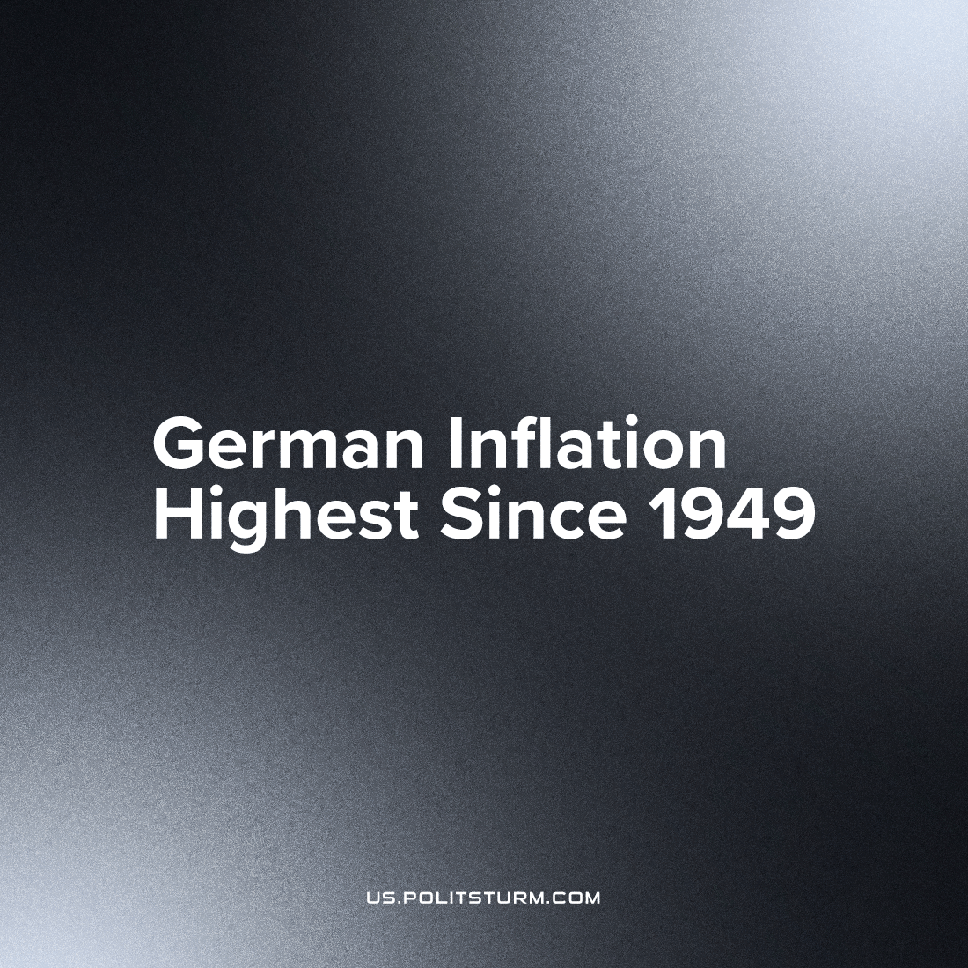

Original article
2022-10-27
1 min read

Germany is experiencing one of the most acute economic crises of the last century. For the first time since 1949, the country’s inflation rate reached double digits – in September 2022, the total annual inflation in Germany reached 10.9%.
In certain sectors, inflation has reached even higher levels. Food prices, for instance, have risen by 19% over the past year. Prices for imports to Germany increased by an average of 33% and for domestic production – by 45%. Compared to the previous year, gas and electricity prices in the domestic market increased by more than 200%.
Against the background of historically high inflation, the state decided to eliminate subsidies for public transport and fuel, further complicating the life of the working class.
Due to high energy inflation, many large manufacturing companies such as Siemens and Volkswagen have decided to move their factories abroad. It allows entrepreneurs to have better energy prices but will exacerbate the economic crisis in Germany itself. This way, the capitalists increase their profits at the expense of the working class of their own and other countries.
“We are currently experiencing an energy crisis in Europe which is increasingly becoming an economic crisis and also a social crisis. ,” said German Economy Minister Robert Habeck.
As a reason of this crisis the Minister of Finance called the military operations in Ukraine and the cessation of energy supplies from Russia to Europe. However, the causes of economic problems must be sought not in conditional historical events but the capitalist system as a whole. As long as capitalism exists and the bourgeois class exploits the working class for profit, crisis and wars are inevitable.
Sources: 1, 2, 3

Original article

