German Industrialists Undermine EU Efforts to Ban Cancerous "Forever Chemicals"
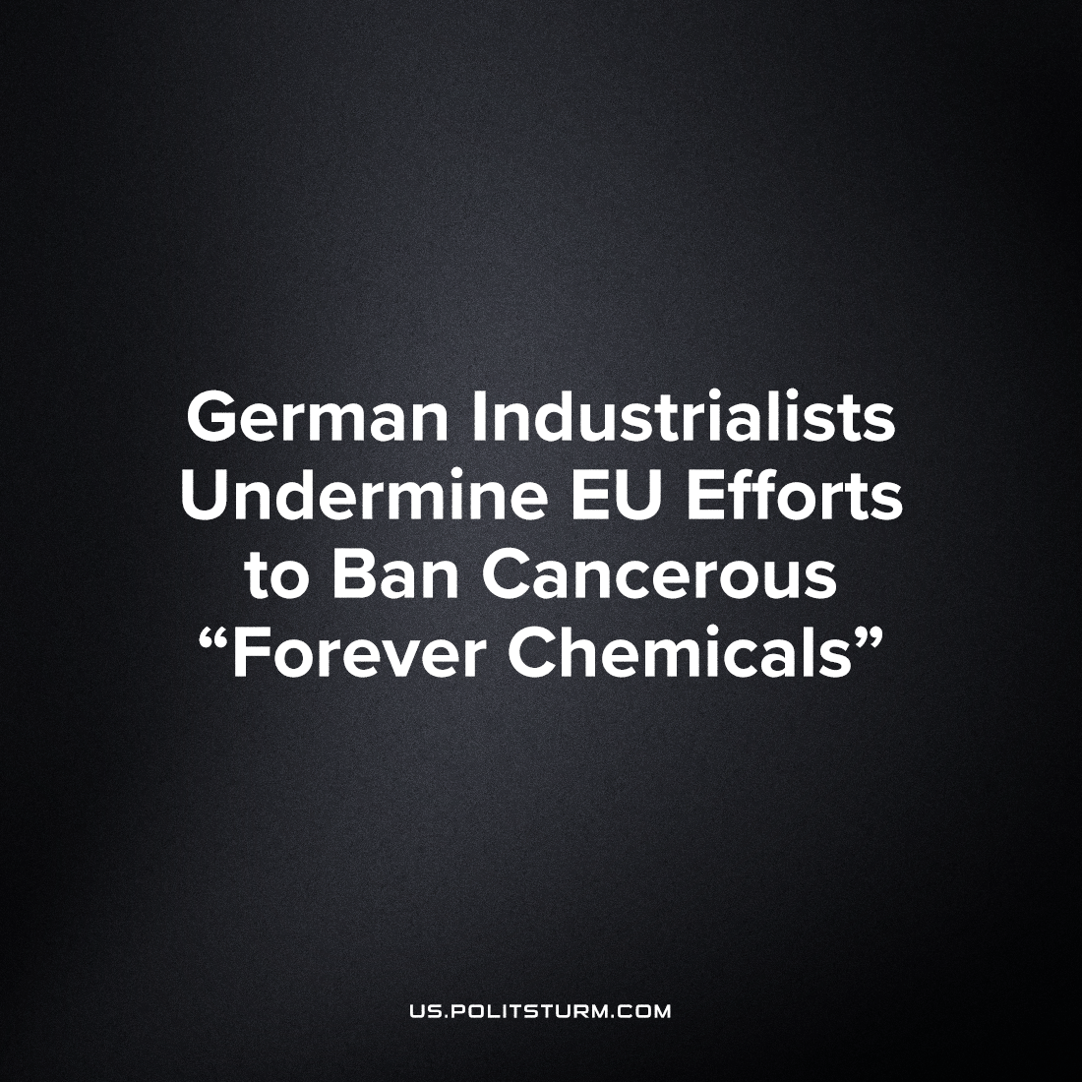

Original article
2023-07-31
2 min read

A plan in the European Union to ban toxic so-called “forever chemical" which appear as common pollutants in soil and water, has been failing to meet its targets of the 2030's, as German Engineering Association VDMA, which represents more than 3600 companies, campaigned against the regulatory process.
This proposal seeks to ban 7000 forms of the perfluorochemicals (PFAS, per/polyfluoroalkyl substances, etc.), commonly referred to as "forever chemicals," because they do not chemically decompose as they pass through substances and the human body. These chemicals are now found in every system of the water cycle on earth, moving into the most pristine environments - from the most anti-pollution nations under capitalism to the snow of Antartica. Their extensive use throughout the past century has led to widespread contamination, with almost all Americans found to have traces of PFAS in their bloodstreams, as per a US government study. In the body, they have been tied to increasing prevelance of cancer in affected fish, animals and human beings.
The German Engineering Association argues that these chemicals are a necessary tool for fire-prevention, without which many modern industrial processes would immediately become hazardous. In practice, this ban would truly bring about a total overhaul of modern production, and the recall with a total lack of replacement for countless products, particularly 'fire-proof' ones needed for many important activites like fire-fighting and industry. The German association here represents those German chemical companies whose profits rely on the patents and constant fabrication of these materials, which are present in the production of nearly every kind of commodity of modern capitalism.
This is not the first time when capitalists have undermined the efforts for environmental protections under capitalism. Recently, German capitalists successfully pressured the EU to push back its ban on combustion engines past 2035 as it would have directly affected the profits of the sizable German automotive monopolies.
Even in 'progressive', 'socialist' Germany, the hypocrisy of liberal politics are blatant. The supposed “allies of the working class” and “protectors of the environment" in European Parliament are subject to the interests of the monopoly corporations of Germany.
Only Socialism, with economic planning and state intervention, where means of production are collectively owned by the workers, can guarantee a transition to a green future without sacrificing lives to rectify the damage of the climate crises.
Source: 1

Original article

