German Far-Right Rallies More Than Triple In Early 2023
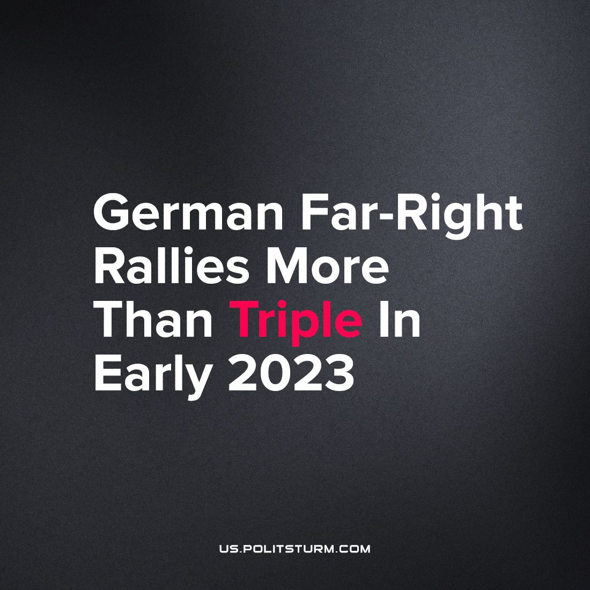

Original article
2023-10-04
1 min read

Rallies by far-right extremist groups in Germany increased to over triple in 2023 compared to the previous year, according to information from the German Interior Ministry released recently.
Officials counted 110 marches by neo-Nazi or other far-right groups between January and June this year, surpassing the 35 over the same period in 2022.
Among the organizers of these demonstrations was the small party Free Saxony, labeled as having proven extreme right-wing aspirations by Saxony's State Office for the Protection of the Constitution (LfV). Another Organizer is the Third Way party, considered a neo-Nazi group by the (LfV), was also involved in the marches.
Recently we reported about multiple far-right groups and parties increasing their popularity across Europe and even winning the elections, like in Finland or in Italy.
In Germany, far-right AfD, “Alternative for Germany”, well-known for its’ Nazi whitewashing, is among the major powers. Historically, the German government had many connections with the Nazi Party. The West German government had many people in office that were former Nazis. The former conservative Christian Social Union (CSU) agitator, Richard Jaeger, had been part of Hitler's paramilitary organization, the SA, ever since 1933. These former Nazi party members even include the likes of the most powerful people in their government. The former Chancellor, Kurt Georg Kiesinger, was a member of the NSDAP since 1933 and worked in the Ministry of Propaganda led by infamous Goebbels.
Moreover, less than a year ago a coup d’état attempt was revealed in Germany, when the “Patriotic Union” group, involving some former Bundeswehr members, attempted to overthrow the government and proclaim the “German Empire”.
Capitalist ideologists often claim that far-rights become stronger only as a response to the growing communist movement. However, the German communists aren’t organized as a single strong movement. The far-right movements are created and function with capitalist support. Only strong communist vanguard party, based on Marxist-Leninist theory, can build a strong alternative to the ruling class.
Source
https://www.dw.com/en/germany-far-right-neo-nazi-marches-more-than-triple-in-first-half-of-2023/a-66547749
https://www.spiegel.de/international/germany/from-dictatorship-to-democracy-the-role-ex-nazis-played-in-early-west-germany-a-810207.html

Original article

