German Far-Right Party Sees Major Advances
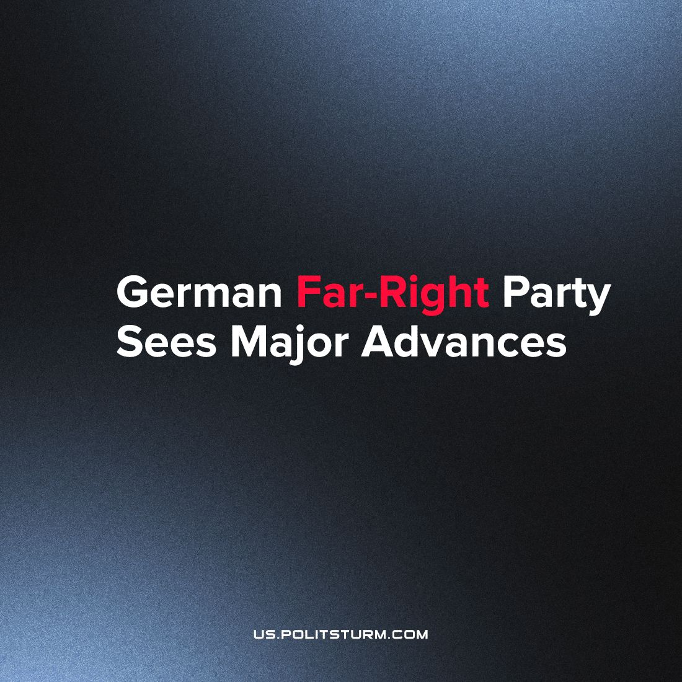

Original article
2023-07-17
1 min read

Current polling shows Alternative für Deutschland (AfD) is the second-most popular party after the conservative CDU at 20% and 28% respectively. In June of this year, the party which is often tied to Nazi-apologism elected its first representative to local office in a district administrator position in Sonneberg. The rise of a far-right, anti-immigration party in Germany will have vast repercussions for all of Europe.
The rise has been fueled by rising anti-immigration sentiment and dissatisfaction among the former citizens of the German Democratic Republic facing deprivation, underinvestment and social exclusion in the years since the predatory integration of the region into the West German state began. The citizens, who used to enjoy social and economic rights more robust than in the capitalist west, have fallen prey to the machinations of xenophobic political forces offering foreigners as scapegoats for their privation. This has been augmented since 2015 when Germany took in a large number of Syrian refugees during the European Refugee Crisis. However, immigration alone doesn’t explain the rise in support for right-wing extremists. The rise came in the aftermath of both the Eurozone crisis and the recent global economic crisis in the wake of the pandemic that drove the working-class into further poverty.
Put in this context, the rise in the popularity of the AfD is due to the fear the German workers have for their livelihoods; rising inflation; dissatisfaction with mainstream parties; higher energy bills etc. The popularity of the AfD is, therefore, a expression of an inevitable development from the periodic crises that occur under capitalism. The ascendency of the AfD demonstrates the dire need for a militant workers’ movement to oppose the future actions of the party.

Original article

