German Energy Crisis
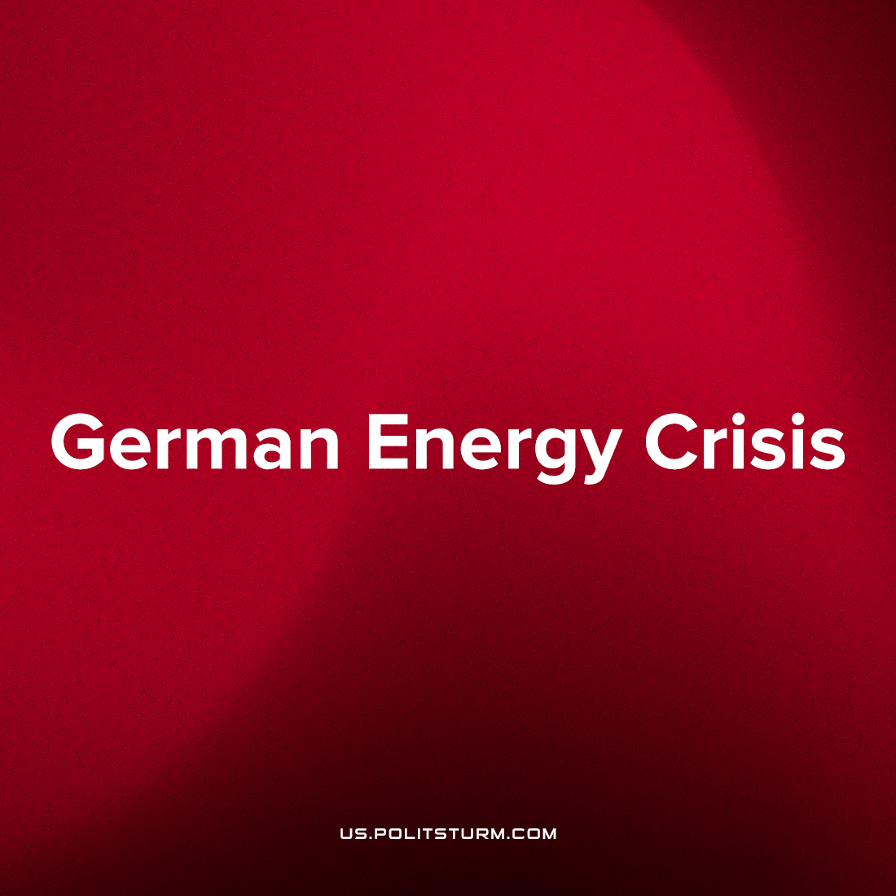

Original article
2023-03-14
2 min read

According to Bloomberg, there is a looming energy crisis in Germany;
“Germany has set aside more than €260 billion ($275 billion) to deal with the immediate risks of an energy crisis triggered by Russia’s war in Ukraine”
Though German industry now faces the risk of insufficient power generation, its three last nuclear power plants will be shut in April. It would seem like German monopolies and the Bundestag do not plan for the future at all, which Bloomberg credits to the agenda of certain political representatives:
“At the heart of Germany’s dilemma lies political plans to phase out certain energy sources without clearly setting out the path to replace them.”
Error loading image
Long-term planning is not possible in a capitalist economic system, which develops following the maximum private profit, and modern Germany is a great example of this. Their only plan holds the highest disregard for the fulfillment of social needs: a scheme of private enrichment of the biggest capitalist monopolies, in this case favoring the noxious capital of the coal, oil and gas cartels. In 2019, Germany declared subsidies for the coal industry until 2038 [2], and today is actively destroying its existing electrical plants without a plan of replacement.
The decisions of energy-sector capitalists just follow current market prices. When they can sell coal and oil at high prices there is no need for them to invest in renewable energy [3], [4], [5]. Conversely, when their prices (and profits) are low, the rhetoric of the great energy monopolists dramatically changes to preach about saving the climate and renewable energy sources. Evidently, they don’t really care about the damage they are inflicting to our climate and biosphere and are solely concerned with amassing ever yet greater profit.
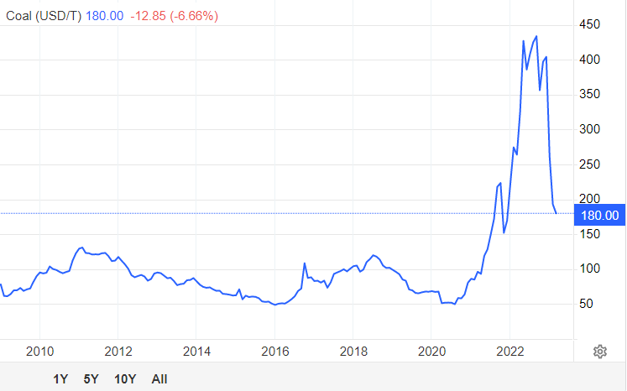
Coal futures
In these circumstances long-term planning is obviously impossible. The rapid change in prices dictates the need for an equally rapid change in their plans. That is why Bundestag have no plan to replace coal and oil power plants. Therefore it will not be easy for Germany to avoid an energy crisis. And the results of it are already seen: “BASF SE’s plans to cut 2,600 jobs as it faces strains from the energy crisis is a sign of the urgency. The chemical giant’s operations in Germany swung to a loss during the second half, and it’s now closing a number of energy-intensive factories, including two ammonia plants and related fertilizer facilities, resulting in 700 job cuts at its main Ludwigshafen site” [1]
The serious political, economy, climate problems that we face can only be solved by conscious and scientific planning and the efforts of a united humanity bereft of class division. The fruits of the work of billions of working people is privately appropriated by a handful of billionaires who drive production into a world-consuming oblivion against the interests and wishes of the masses of society. The capitalist economic system, which is based on self enrichment and competition cannot overcome global crises, because their resolution is always unprofitable for class of capitalists.
Sources:
- https://www.bloomberg.com/news/articles/2023-02-25/germany-faces-1-trillion-challenge-to-plug-massive-power-gap?srnd=premium
- https://odi.org/en/publications/g20-coal-subsidies-germany/
- https://seekingalpha.com/article/4353922-shell-talks-good-game-on-renewable-energy-needs-to-put-money-where-mouth-is
- https://www.reuters.com/business/energy/bp-profits-soar-record-28-bln-dividend-increased-2023-02-07/
- https://www.bloomberg.com/news/articles/2023-02-10/exxon-retreats-from-major-climate-effort-to-make-biofuels-from-algae

Original article

