Natural Gas Sank to Pre-Ukraine Conflict Prices
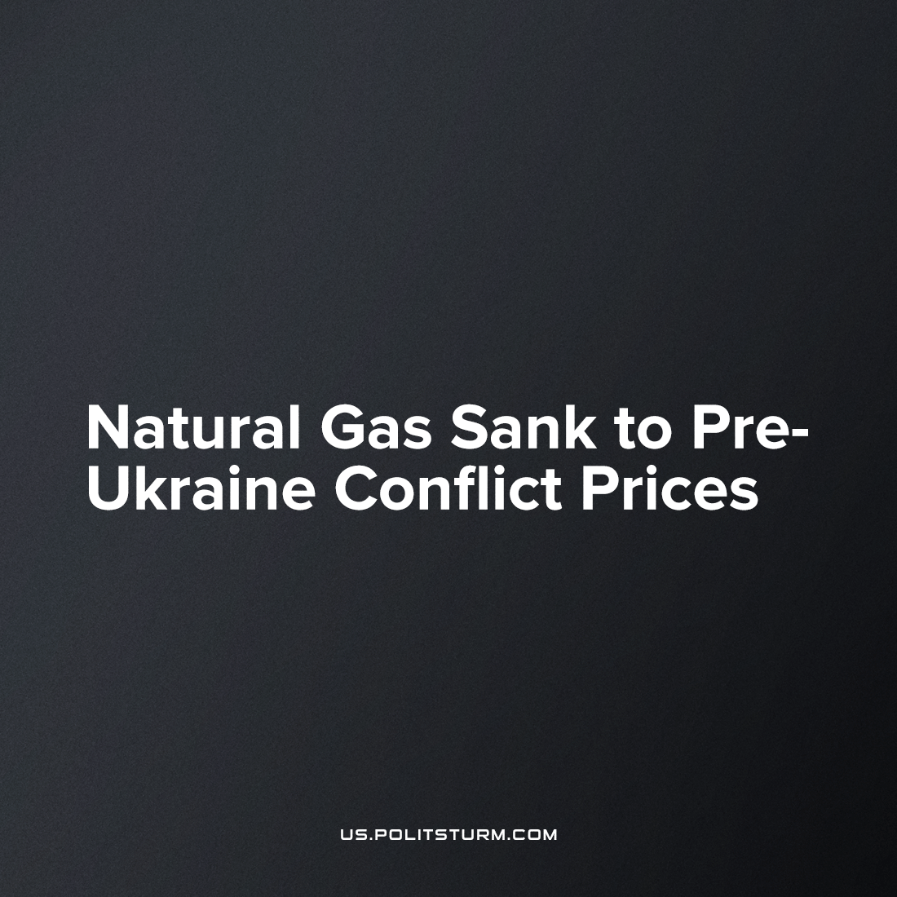

Original article
2023-01-14
2 min read

According to CNBC, Dutch TTF Natural Gas Futures reached their bottom price - 81.91$ per MWh. [1],[2]. Such a price was only seen before the Russian-Ukrainian conflict disrupted supply and caused a hike in energy prices which led to crisis and misery throughout the world.
The explanation is the sudden increase in supply of natural gas in the European market. Bloomberg reports Russia is initiating a diesel export boom at the beginning of the year [3]. This is confirmed by Russian news sources Russian Business Consulting (RBC) [4] and Oil Capital [5]. Leader of 'Transneft', one of the biggest Russian oil exporters, said his company has already received applications for gas import from Poland and Germany [4]. It seems like despite political confrontations and starting chaos all participants of world crude market do not refuse a profitable trade. Even if it fuels their opponent, with either the gas or cash that it needs.
This is of course a temporary situation, used by capitalist market speculators.
Supply will not remain high: the European Union will ban the import of Russian oil products at the beginning of February. According to Oil Capital [5] the only opportunity for oil companies to keep export level unchanged is to increase Ukrainian pipeline supplies. This pipeline was built in 1964 and remains open despite today’s complications. For world capitalism, there are no insurmountable limits found in its own conflicts and political confrontations. Trade is a necessary part of capital turnover, which means trade can never stop in either peace or war.
Error loading image
Another contribution towards low prices is made by the unseasonably warm winter weather in much of northwest Europe, which meant lower demand. This cushions the forced decrease in consumption caused by workers' impoverishment and capitalists' decreased production under the current economic recession.
After winter, the region will have to refill gas reserves with little to no deliveries from Russia, intensifying competition for tankers of the fuel. Even with more facilities to import liquefied natural gas coming online, the market is expected to remain tight until 2026. However, tighter markets mean higher prices for the increasingly-marginal reserves, with dwindling deposits in Norway and the Netherlands, of natural gas available to major European cities in pipelines.
The current market situation shows that all capitalistic countries are directed to a single goal – maximization of profit. From one side, Russia transfers gas and oil for its opponents using every possible avenue, including its 'Friendship, with Ukraine, while on the other side the EU continues to buy cheap crude, extract greater profit from their working class on the market's fluctuating margins, and further financially speculate on the military situation in Eastern Europe.
Does it all mean war is only an instrument of capitalism?
Sources: 1, 2, 3, 4, 5

Original article

