G20 Considers Global Wealth Tax
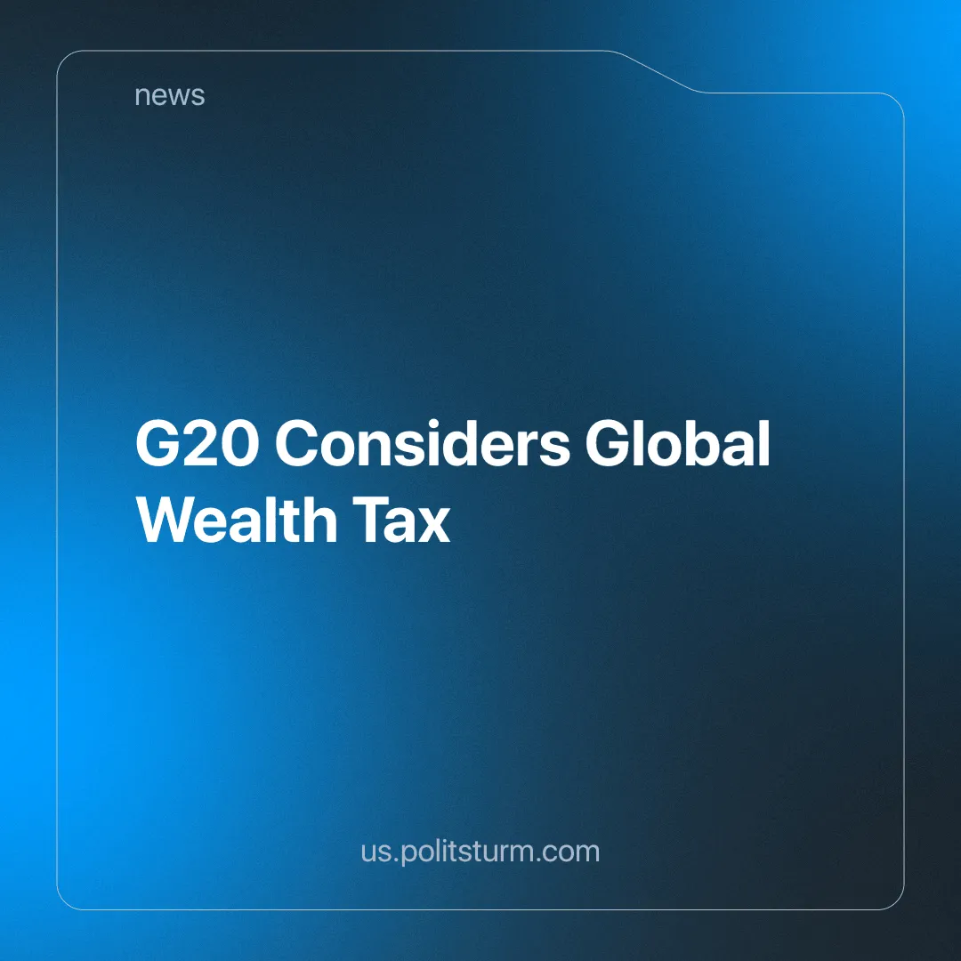

Original article
2024-09-06
4 min read

The "Tax Justice Network" (an advocacy group of researchers and activists that attempt to combat tax avoidance, tax competition and tax havens) says a global wealth tax similar to Spain's could raise trillions for countries that implement it.
The study comes as a G20 summit in Brazil is debating the introduction of a global wealth tax to tackle the hypermobile super-rich who easily avoid paying tax. France, Germany, Spain and South Africa have also expressed support for the idea [1].
Spain's Social Democratic prime minister, Pedro Sánchez, introduced a temporary "solidarity tax" at the end of 2022 that applies to individuals with a net worth of more than €3 million ($3.3 million). This affects the 0.5% richest households in Spain.
Tax Justice pointed out that applying a similar tax to the world's richest households, at a rate of just 1.7% to 3.5%, would raise around $2.1tn. They also pointed out that this money could be used to support a transition to clean energy production.
There has been a growing number of countries calling for higher taxes, including some far-right governments such as Italy's, which has doubled its 'flat tax' on foreign income from €100,000 to €200,000 ($111,000 to $222,000). The minister of economy said that Italy was now against the idea of countries competing with each other to offer "fiscal favours" to the wealthy [2].
Even many millionaires and billionaires have called for higher taxes on their wealth. 250 of them signed an open letter sent to the World Economic Forum in Davos, Switzerland. Their message was "Tax our extreme wealth" [3].
Does this represent a shift in global politics? What are the intentions behind these statements and policies? Have billionaires had a change of heart?
Consider the fact that the global wealth tax is currently only a proposal. It has not been implemented and is only being discussed. Actual implementation, if it were to happen, could take many years, and although there has been a global shift towards supporting such a project, it will still face fierce opposition from the many uncooperative states and capitalists.
Global leaders and capitalists have noticed growing popular outrage as the cost of living rises around the world and the burden of keeping a dying system afloat falls on the shoulders of the working class.
One response to the growing tensions and revolutionary sentiments of the working class is to try to divert them by blaming various nationalities, ethnicities or minorities for worsening conditions. This tendency paves the way for fascism by splitting the workers' movement and starting the justification for the state's use of open and terrorist violence, and we have written about the tendency of countries to turn far-right before.
But the capitalist class isn't monolithic. It is made up of many different groups that exist in competition with each other, and while they all unite in their wish to increase exploitation, make higher profits and take a greater share of social wealth, they also have different strategies for maintaining this dynamic.
The billionaires who signed the above open letter are trying to address social grievances by increasing the tax on the wealthy. This does not damage their position within the capitalist class dynamic, and in fact, only strengthens it. It tricks the working class into believing that a "fairer capitalism" is possible, that can permanently be made bearable for the masses. In addition, as they are the very wealthiest capitalists, they can weather higher taxes, while small and middle capitalists will be more easily ruined by such fluctuations, centralising more wealth in the hands of the aforementioned billionaires.
This has been done in many countries before through the use of the welfare state, and by making some concessions to the working class with the tax money it stifles their revolutionary movement and keeps it in its exploited position. At the same time, the government is composed of and freely bought and sold by capitalists (through lobbyists, the "revolving door" etc.), and so a lot, if not the majority, of tax money anyways finds its way back into the clutches of capital - through subsidies, grants and loopholes.
But it's precisely because the ruling class is not monolithic that its own plans to introduce a global wealth tax are unlikely to succeed. While it may be implemented in one country or another, capitalists can only exist in competition with each other. To reduce or slow down their profits is to let their competitor win and risk losing their position as exploiters and falling into the ranks of the working class - the exploited class. And that is why an all-encompassing global tax on wealth is unlikely to be accepted by all in the ranks of the capitalists. And so long as some do not accept it, tax havens will exist.
Lula, the president of Brazil, is pushing for this tax in an attempt to gain popularity at home as well. He hopes that nice speeches about solving global problems will make him look like a leader in the fight against climate change and inequality and that he has a strong global projection, hopefully mitigating his falling popularity [5]. This is the case for all the countries supporting this project.
Increasing wealth taxes is not the answer. The real problem is that there is a propertied class that exploits those who do not own the means of production and have no other means of living except by selling their ability to work. This propertied class will seek to increase its profits and exploitation, even if it significantly decreases the habitability of our planet via pollution and climate change.
To really stop the deterioration of living conditions, end all imperialist wars and stop climate change, a socialist system is needed. Green capitalism or fair capitalism is a myth and not a real solution.
A rationally planned socialist economy is capable of functioning in such a way that there is no more exploitation of man by man. The means of production are collectively owned and directed towards human development and the satisfaction of our needs. A centrally planned economy is capable of functioning in such a way that people can live a good life with access to modern amenities, and material and cultural requirements, while resource usage is provisioned and calculated to be sustainable.
To achieve this socialist system, a strong communist party with strict adherence to Marxist-Leninist principles is needed to lead the working class towards this goal. Join Politsturm and help work towards the building of communist parties that can lead the struggle for socialism.
Sources:
[1] The Guardian —“‘A historic step’: G20 discusses plans for global minimum tax on billionaires” — 29/01/2024
[2] The Guardian — “No more fiscal favours? Calls to tax super-rich gain traction around world” — 12/08/2024
[3] CNBC — “Mega-rich renew call on global leaders at Davos to ‘tax our extreme wealth’” — 17/01/2024
[4] Our World in Data — “Tracking global data on electric vehicles” — 02/2024
[5] CNN Brasil — “Pesquisas mostram queda de popularidade do governo Lula” — 09/03/2024

Original article

