Funding Cuts Reduce Public Health Jobs By 20%
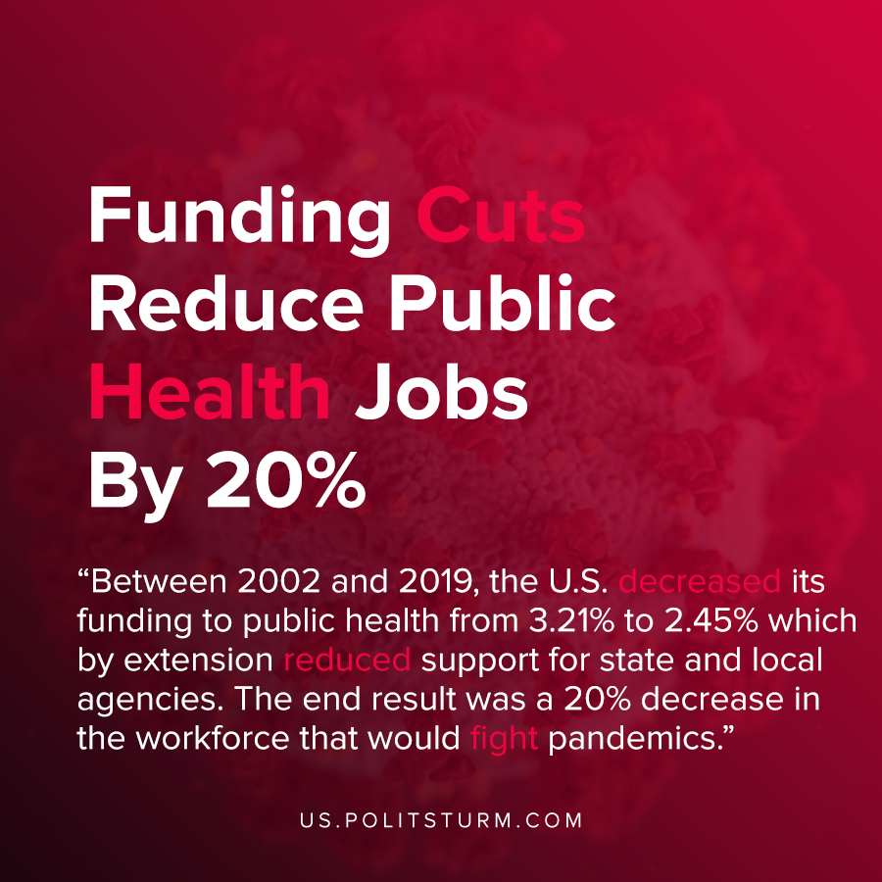

Original article
2021-02-12
1 min read

A new report issued by the Lancet Commission on Public Policy and Health studied the impact of public policy on health outcomes. The report found that the Trump administration “weakened public health infrastructure and the Affordable Care Act’s (ACA) coverage expansions—(which) has caused tens of thousands of unnecessary deaths”.
Even before the pandemic the number of Americans without insurance was increasing by millions. The report also notes the context by which the United States was unprepared to fight a pandemic.
Between 2002 and 2019, the U.S. decreased its funding to public health from 3.21% to 2.45% which by extension reduced support for state and local agencies. The end result was a 20% decrease in the workforce that would fight pandemics.
The report details how the United States life expectancies are lower than other OECD countries and that U.S. healthcare has never been adequate for public health.
While large numbers of Americans needlessly die and remain uninsured, the government passed tax cuts to aid major corporations and the wealthy.

“Market-oriented health policies shifted medical resources toward high-income people, burdened the middle class with unaffordable out-of-pocket costs and deployed public money to stimulate the corporate takeover of vital health resources”, the report notes.
The market-oriented, capitalist economic system in the United States is failing the majority of the population because it is structured to benefit the oligarchs.
Source: 1

Original article

