French Energy Workers' Strike Enters 3rd Week
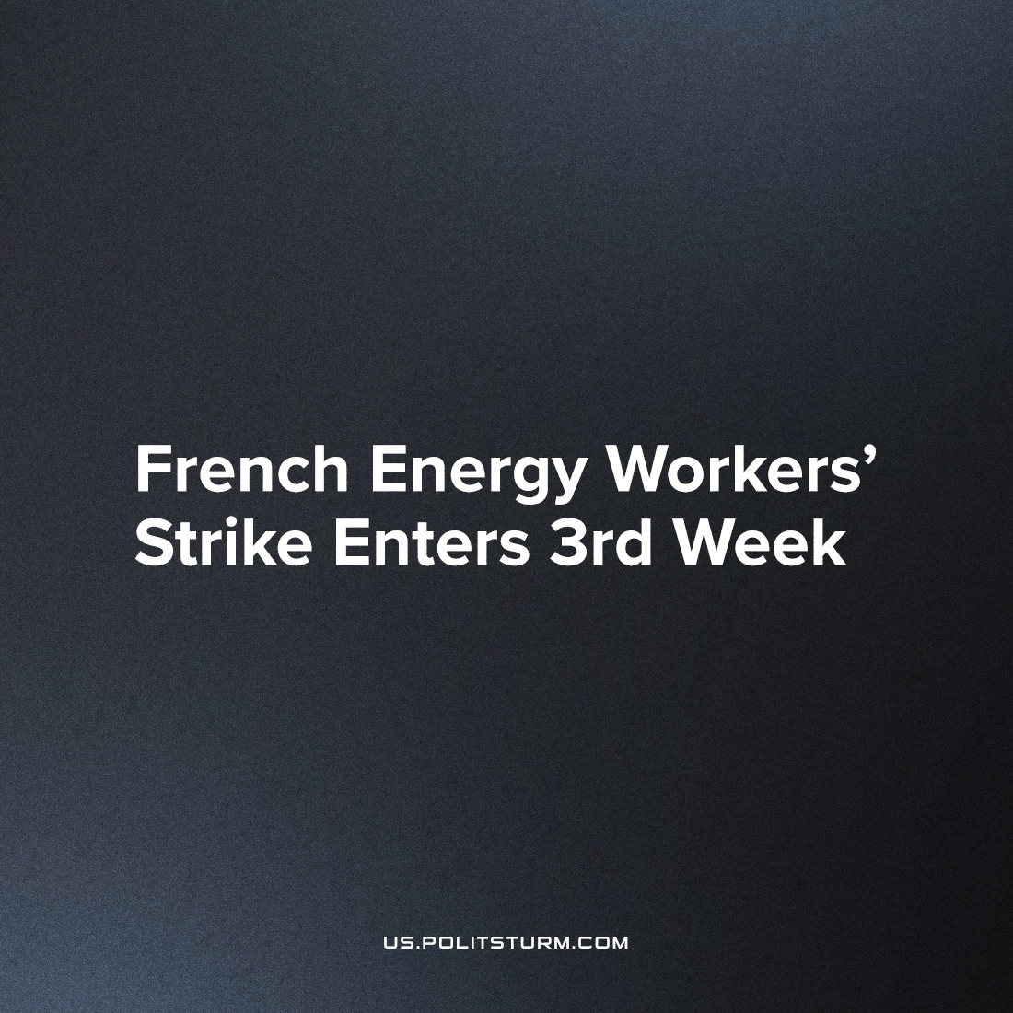

Original article
2022-10-17
2 min read

French trade union Confédération Générale du Travail (CGT) brings together employees of the major energy companies TotalEnergies and ExxonMobil, and on September 27th, 2022, they struck in a major labor stoppage – which they reaffirmed in a vote last week. The reason for the strike was company management’s refusal to increase employees’ salaries against the backdrop of rising inflation in the country. While living conditions for workers are rapidly deteriorating, the owners and investors of large energy companies continue to reap dizzying profits. For TotalEnergies, the earned profit amounted to €18 billion last year. The company paid out €8 billion in dividends to investors but couldn’t find money to index employee salaries to inflation.
No longer able to maintain their previous standard of living, employees at TotalEnergies and other major energy companies in France now demand a salary increase of at least 10% as a condition for returning to work.
A strike by workers in the oil and gas industry has led to major disruptions at petrol stations across France. About a third of gas stations in the country are experiencing an acute shortage of fuel, particularly diesel. Unprecedented long lines of cars queue up at gas stations, waiting for hours at many places to fill their fuel tanks.
The French government is resorting to emergency measures to resolve the crisis. Last week, a limit was set for the purchase of gasoline at 50 euros, or 20 litres. Despite these measures, many gas stations in the country run out of fuel by noon daily.
On Thursday, October 13, nuclear workers joined the strike oil workers. The CGT trade union went on strike at 6 French nuclear power plants, including Gravelines, the most powerful nuclear power plant in Western Europe. The striking employees reduced the power of this reactor from the usual 900 MWs to 300 MWs. As a result of these interruptions, the owners of the energy company EDF were forced to postpone repairs to the reactors, which were scheduled for last weekend. A longer nuclear strike could significantly exacerbate power supply problems in France and throughout Europe.
Now, in times of crisis, it becomes especially clear how untenable the capitalist system is. Living conditions for the working people are deteriorating, while the big capitalists are getting richer still, profiting from the labour of hired workers. Workers in strategic industries, like energy, have great power.
Organizing workers into trade unions allows them to fight for concessions from capital, for the correction of certain current shortcomings and for improvements in living and working conditions. However, the complete elimination of the problems of capitalism is possible only with the elimination of the contradiction between labour and capital and the establishment of socialism.
Source: 1, 2

Original article

